2019 Osaka-Castle
NTT ASTC Sprint Triathlon Asian Cup and
East Asian Championships

ATHLETE GUIDE

General Information
Introduction | P3
Key Dates | P3
Key Contact | P3
Contact Details | P3
Venue
Venue | P4
Access | P4
Bike Mechanic Service | P4
Medical Service | P4
Athletes Lounge | P4
Accommodation / Transportation
Accommodation | P5
Transportation | P5
Bank | P5
Training Information
Training | P6
Course Familiarization | P7
General Traffic Rule | P7,8
Competition Information
Competition Schedule | P9
Competition Rules | P9
Information about The FOP | P10
Course Map | P11

General Information

Introduction

The purpose of the Athletes Guide is to ensure that all Elite Athletes and Team Leaders are well informed about all procedures regarding the 2019 Osaka-Castle NTT ASTC Sprint Asian Cup and East Asian Championships. Please keep in mind that this information can be changed and the final race information will be provided to the athletes and the team managers at the athletes’ briefing.

Key Dates

Activities | Date | Time | Location
Elite Athletes Briefing | Saturday 21 Sep | 14:30-15:20 | Enkei-HALL
Elite Men Competition | Sunday 22 Sep | 08:00- | Venue
Elite Women Competition | Sunday 22 Sep | 09:35- | Venue

Key Contacts

ITU Technical Delegate | Andrew Tai(TPE) | tai620322@hotmail.com
LOC Office Coordinator | Kosuke Furugo | furugo@opan.jp  +81-90-8944-1146

Contact Details

Japan Triathlon Union (JTU)
Address | #708, Japan Sport Olympic Square 4-2 Kasumigaoka-machi, Shinju-ku Tokyo,160-0013,Japan
Tel | +81-3-5786-0515
Fax | +81-3-5786-0516
E-mail | jtuoffice01@jtu.or.jp
Web | http://www.jtu.or.jp

Venue

Venue

The venue is located in Osaka Castle Park, Osaka.

Osaka Castle Park
https://osakacastlepark.jp/foreinger/english.html

Access

http://www.osakacastle.net/english/access/index.html

Bike Mechanic Service

“SHIMANO” will offer a comprehensive bike mechanic support on 21st and 22nd September at Enkei-HALL and the venue.

Date / Time | Venue
Saturday 21 September 12:00-17:00  Sunday 22 September 7:00-15:00 | Enkei-HALL  Venue(Osaka Castle Park)

Medical Services

First Aid and Emergency Medical Services will be available at the venue on 22 September before and during the competition hours. A medical tent will be set provided on site at Osaka Castle Park.
The medical services available at the venue are free of charge. Athletes should make sure that they have an appropriate medical insurance.

Athletes Lounge
Athletes lounge is located in Osaka Castle Park. Sealed bottles of water will be offered to athletes before and after the race in the athlete lounge.

Accommodation / Transportation

Accommodation

The official hotel of the race is “Hotel New Otani Osaka”, located 1km from the venue.
Hotel reservation website: https://va.apollon.nta.co.jp/osaka_triathlon2018en/

Hotel New Otani Osaka | 1-4-1 Shiromi, Chuo-ku, Osaka Japan 540-8578  TEL. +81-6-6941-1111  FAX. +81-6-6941-9769  Website : http://www.hotelnewotaniosaka.jp/en-gb/

Transportation

Pick-up service is available from Kansai International Airport to the official hotel: Hotel New Otani Osaka.
To arrange local airport pick-up service, please fill out below links form
https://docs.google.com/forms/d/1k3SiPxDzKPUIX0NB7UuoxkurmKNxWBL_ygqSAAc1XBw/edit

For public transportation from KIX and ITM airports, please refer to the airport information websites. It will cost 1,000 to 2,000 JPY by bus or train

Bank

SEVEN-ELEVEN Bank Business Park East ATMs
〒540-0001 2 Shiromi Chuo-ku, Osaka
Number of ATMs : 1 Open Hours : 24 hours Three minutes walk from New Otani Hotel

TWIN 21 ATMs 〒540-0001 2 Shiromi Chuo-ku, Osaka
Number of ATMs : 1 Open Hours : 7:00 to 23:00 Three minutes walk from New Otani Hotel

SEVEN-ELEVEN JR Morinomiya ATMs
〒540-0003 1 Morinomiyachuo Chuo-ku, Osaka
Number of ATMs : 2 Open Hours : 24 hours Three minutes walk from the swim start venue

Training

Swim Training
Athletes can use the swimming pool (25m×3 lanes) at “OSAKA POOL” from 10 am to 1 pm on September 18th, 19th and 20th . In order to move to the swim training venue, you are advised to use the pickup service.
Please give your name, country and race number when making the reservation.
You must be at the designated place and time to use the pickup service (see below).
In the venue, there is a dressing room. You must wear a swim cap and goggles, and follow the instructions from the staff. Diving into the pool is strictly prohibited.

OSAKA POOL
http://www.yahataya-park.jp/wp/wp-content/themes/yahataya/common2/dl/brochure_pool.pdf

Pick up service
Pick up service
From Hotel New Otani Osaka to “Osaka Pool”
9:30 & 10:30 departing from Hotel New Otani Osaka
(2nd departure time may be delayed due to traffic condition)

From Swimming Pool to Hotel
12:00 & 14:00 departing from “Osaka Pool” Lobby

Course Familiarization

Swim
Athletes are permitted to swim along swim course for course familiarization on 21st September.
Location: East Outer Moat at Osaka Castle Park
Time: 11:00 – 12:00, Saturday, 21st September

Bike
There is no familiarization time for bike.
If you want to ride on the road for course familiarization, you must follow the traffic rule of Japan.

Athletes are not permitted to ride inside Osaka Castle Park except on the race day.

Run
There is no familiarization time for run.
If you want to run on the road for course familiarization, you must follow the traffic rule of Japan.

General Traffic Rule
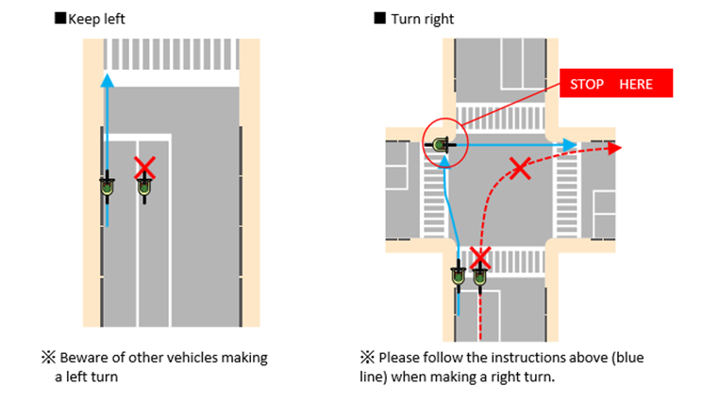
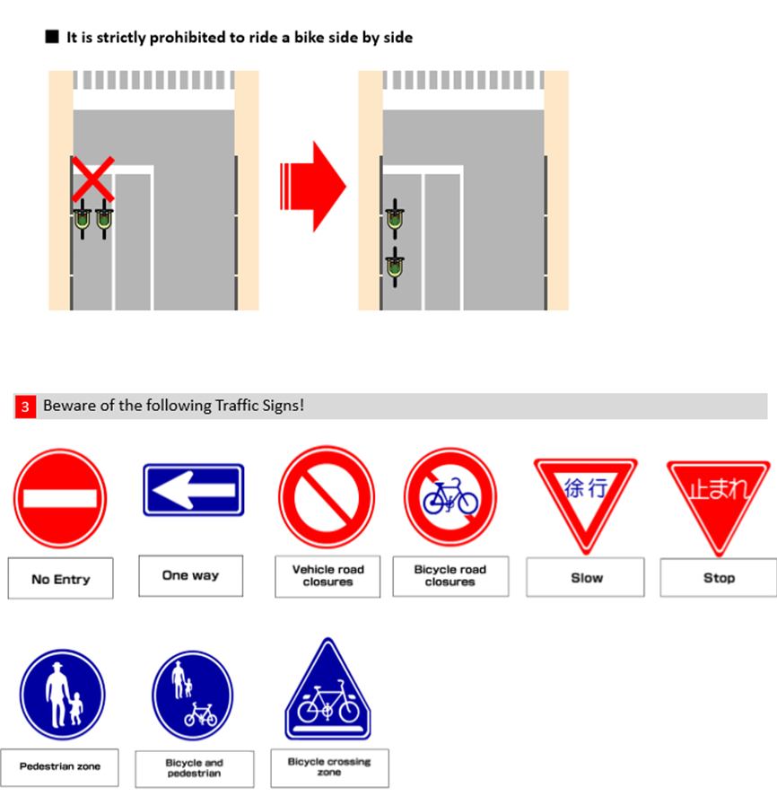

Competition Schedule

Time / Date | Event | Venue
Sat, 21 Sep
11:00 – 12:00 | Swim Familiarization | East Outer Moat at Osaka Castle Park
12:00 - 17:00 | Mechanic Service | Enkei-HALL
13:30 - 14:30 | Athlete Registration and Uniform check | Enkei-HALL
14:30 - 15:20 | Athlete Briefing | Enkei-HALL
15:20 - 15:50 | Press Conference | Enkei-HALL
Sun, 22 Sep
06:30 - 07:15 | Elite Men Registration | Athlete Lounge
06:40 - 07:30 | Elite Men Transition open | Transition
07:00 - 07:40 | Elite Men Swim Warm Up | Swim Course
07:50 - 08:00 | Elite Men Start Ceremony | Start Area
08:00 - | Elite Men Start | Venue
08:10 - 08:50 | Elite Women Registration | Athlete Lounge
08:50 - 09:10 | Elite Women Transition open  *Elite Women are able to check in transition area after Elite Men T2 finished. | Transition
08:50 - 09:15 | Elite Women Swim Warm Up | Swim Course
09:25 - 09:35 | Elite Women Start Ceremony | Start Area
09:35 - | Elite Women Start | Venue
12:00 - | Medal Ceremony | EXPO Area

S
Competition Rules

Competition Rules
The race will comply with the latest competition rules of the International Triathlon Union.
https://www.triathlon.org/uploads/docs/itusport_competition-rules_2018.pdf

Information about The FOP

Swim Course
Pontoon start. The water temperature in September is expected to be 26～28℃.
0.75km x 1lap

Bike Course
Generally flat and technical course.
5laps Total 20km

Wheel Station
1 wheel station will be located along the bike course (team and neutral).
Officially provided wheels are as follows;
4x 700c front wheel /4x 700c 11 cassette Shimano rear wheels
2x 700c 10 cassette Shimano rear wheels /2x 700c 10 cassette Campagnolo rear wheels
Team wheels are to be brought and deposited by coaches/athletes at the wheel station.
Opening hour: 9/22 6:40-7:30
Pick up time: 10:30-11:00

Run Course
Generally flat course. Please confirm the U-turn Points beforehand.
2laps Total 5KM

Penalty Box
The penalty box will be located on the run course. Please confirm the location beforehand.

Aid Stations
The aid stations are located on the run course ; Sealed bottles of water will be provided.

Weather Conditions
Osaka is humid and hot in September. Temperatures in September is expected to be the range from 22℃ to 29℃.

Results
All the results will be available at ITU ́s official website: www.triathlon.org.

Protests and Appeals
Standard procedures will be followed according to the ITU competition rules.

Course Map

Course Map
Swim 0.75 km: 0.75km x 1 lap
Bike 20 km: 0.17km + (3.93km x 5laps ) + 0.18km
Run 5 km: 0.32km + ( 2.2km x 2laps ) + 0.28km

