2021 Watamu Zone 2 and 4 Africa Triathlon Championships
Dear All,

We would like to welcome you to Watamu, Kenya for the 2021 Zone 2 and 4 Africa Triathlon Championships at Watamu, Kenya

Kindly note that all the updates will be updated here.

For any request or inquiry, kindly reach us through: secgen@triathlonkenya.org

Race Fee/ Hotel / Transportation/ Travel PCR Payments:
Location: Turtle Bay Beach Resort
Date: 15,16,17,18 July 2021
Time: 14:00 to 16:00
Please bring a printed passport copy with you. Knowing that all payment will be in cash.
And you should pay and book the Department PCR first.

Travel/Department COVID-19 Test:
Location: Turtle Bay Beach Resort
Date: 15,16,17,18 July 2021
Time: 14:00 to 16:00. Kindly be on time. Please bring a printed passport copy with you
Receive the results the following day from 15:00 to 17:00

At Race COVID-19 Test:
Location: Turtle Bay Beach Resort
Date: 15th and 16th July 2021
Time: 14:00 to 16:00. Kindly be on time. Please bring a printed passport copy with you

Full Start list World Triathlon website

Swimming Course Familiarization: Location: Turtle Bay beach resort
Date: Friday, 16 July 2021
Time: 8:00 – 9.30

Bike/Run Course Familiarization: Location: Turtle Bay beach resort
Date: Friday, 16 July 2021
Time: 11:00 – 12.00

Race Briefing:
Location: Turtle Bay
Friday 16 July 2021
Elite Men/Women/U23: Time: 1730 - 1730
Age Group/Relay: Time: 1730 - 1830

Hotel and Transfer Booking

For hotel booking and transfers, please fill this form for registration using the link below:
https://docs.google.com/forms/d/e/1FAIpQLSfFJmkdLvgCobZ0orVmPVjDDqAljV8MZTpkY3O2vF8_Jtmoaw/viewform?usp=sf_link

Only transfer available for those who are booked at the hotel through the LOC/KTF

Visa Invitation Letter:

For a visa letter, please fill form using this QR Code and send it back to us.

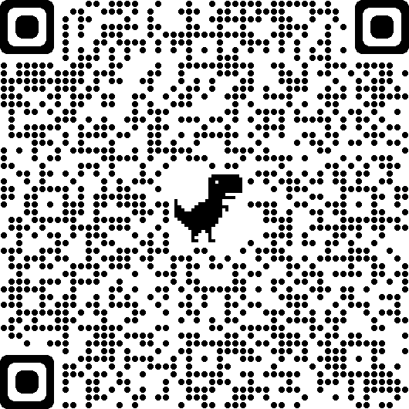

Or use this link
https://drive.google.com/file/d/1a0jLdHuSshAmfLdwvGaVPjRnmP7iDao_/view?usp=sharing
And kindly send us a copy of your passport to expedite the process with the Kenyan authorities

COVID-19 Tests:

For the Pre-Race COVID-19 test, it will take place as the dates indicated below:

Race Day | COVID-19 Test Day
Saturday | Thursday
Sunday | Friday

How to access your World Triathlon Account for a pre-event questionnaire

https://triathlon.org/pre_event_covid_19_screening_guide

Department PCR Test:

Travelers who need to COVID-19 test for their return journey from Kenya can Reserve the service through the Local Organizing Committee.

Cost: $80 USD per single test.
Results will be available in 48hours
Kindly check well the Airlines regulations as some required Antigen test over the PCR.
Please make sure you attend this test in the scheduled time for your National Federation. There will be a medical office in the Watamu’s Turtle Bay Beach Resort hotel

Bike Maintenance Reservation (In case you need maintenance service or a specialist check before the race)

Race Pack Collection Schedule: (Elite/U23): 16TH July 2021

From | To | Group Classification
15:00 | 17:00 | All Triathletes
Kindly be on time. Please show your race fee receipt, ID/Passport and other payment receipt

WATAMU, ZONE 2 AND 4 AFRICA TRIATHLON CHAMPIONSHIP 2021
EVENT SCHEDULE
RACE DAY | TIME | CATEGORY
SAT, JULY 17TH 2021 | 9.00AM | ELITE/U23 MEN
SAT, JULY 17TH 2021 | 9.10AM | ELITE/U23 WOMEN
SUN, JULY 18TH 2021 | 10.00AM | YOUTH/AGE GROUP
SUN, JULY 18TH 2021 | 11.00AM | RELAY

Event Schedule
Friday, July 16, 2021
8:00am - 9:30am - Swim Familiarization
11:00am - 12:00pm - Bike Familiarization (one guided lap only)
3:00pm - 5:00pm - Packet Pick Up (*mandatory)
Friday, July 16, 2021
Race Briefing
5:00pm – 6:00pm - At Turtle Beach Resort
Saturday, July 17, 2021
7:00am - Athlete Lounge Open
7:45am – Elite/U23 Transition Open
8:10am - 8:45am - Elite /U23 Swim Warm Up
8:50am – Elite/U23 Men Introductions
9:00am – Elite/U23 Men Race Start
10:55am - Relay Teams Introductions
11:10am – Relay Teams Race Start

The Event registration fees and payment details are indicated in a Registration Form on these links
International athletes
https://docs.google.com/forms/d/e/1FAIpQLSfFJmkdLvgCobZ0orVmPVjDDqAljV8MZTpkY3O2vF8_Jtmoaw/viewform?usp=sf_link

Local athletes
https://docs.google.com/forms/d/e/1FAIpQLSc82TVuxkrFGUeplED8dhDRJ564IlKCRj7PCgPE0E9JrEB2vQ/viewform?vc=0&c=0&w=1&flr=0

