ATHLETE’S GUIDE
2019 Dnipro ETU Triathlon Junior European Cup

TABLE OF CONTENTS

- GENERAL INFORMATION
  - INTRODUCTION 3
  - KEY DATES
  - KEY CONTACTS
  - CONTACT DETAILS
- VENUE 4
  - RACE VENUE
  - COURSE FAMILIARIZATION
  - ATHLETE’S LOUNGE
  - ELITE ATHLETES’ RACE PACKAGE
  - DOPING CONTROL
  - SECURITY
  - LOC OFFICE
- ACCOMMODATION 5
- TRANSFER AND TRANSPORT 5
- ATHELETE’S SERVICES 6
  - SWIM AND BIKE TRAINING
  - MEDICAL SERVICES
  - BIKE MECHANICAL SERVICE
- COMPETITION SCHEDULE 7
  - ELITE WOMEN
  - ELITE MEN
  - COMPETITION RULES
  - ATHLETE’S BRIEFING
  - TIMING CHIPS
  - RESULTS
  - PROTEST & APPEALS
- ACCREDITATION 8
- USEFUL INFORMATION 8
  - LANGUAGE
  - POPULATION
  - CURRENCY
  - TIME
  - ELECTRICITY
  - WATER
  - TELEPHONE CONNECTIONS
- COURSE MAPS 9

1. GENERAL INFORMATION

  - INTRODUCTION
The purpose of the Athlete’s Guide is to ensure that all athletes, coaches and Team Leaders are well informed about all procedures concerning the Event. The LOC ensures that the information contained in this Guide is correct and up‐to‐date as of the production date. However, athletes, coaches and Team Leaders are advised to check with the event office regarding any changes in information included in this guide.

  - KEY DATES Friday, June 7th:
- Bike course familiarization.
- Swim course familiarization (TBC). Notice! - The buoys are not in Saturday's race position.
- Junior briefing.
- Press conference (TBC).
- Athlete’s race package.
Saturday, June 8th:
  - Dnipro ETU Triathlon Junior European Cup - Women Start.
  - Dnipro ETU Triathlon Junior European Cup - Men Start.
  - Dnipro ETU Triathlon Junior European Cup - Awards Ceremony.
Sunday, June 9th:
  - Dnipro ETU Triathlon Junior Mixed Relay European Cup - Start.
  - Dnipro ETU Triathlon Junior Mixed Relay European Cup - Awards Ceremony.

  - KEY CONTACTS
- Sergey Lysov (lysovsergii@gmail.com ; +380630724273) – Race director.
- Monica Flores Ferreiro and Mariya Charkouskaya-Tarasevich – technical delegates.
- Albina Penya (penyaalbina@gmail.com) - Athlete services manager.
- Svitlana Lishchynska (startdnipro@gmail.com) – event director

  - CONTACT DETAILS
LOC: Dnipropetrovsk Region Triathlon Federation. Address: Naberezhna Peremogy Street, 36-A; 49000, Dnipro – Ukraine. www. dniprotriathlon.com
startdnipro@gmail.com
+380630724273
+380932600441

2.1. RACE VENUE
Ukraine, Dnipro, Sicheslavska Naberezhna St., Festival Wharf.

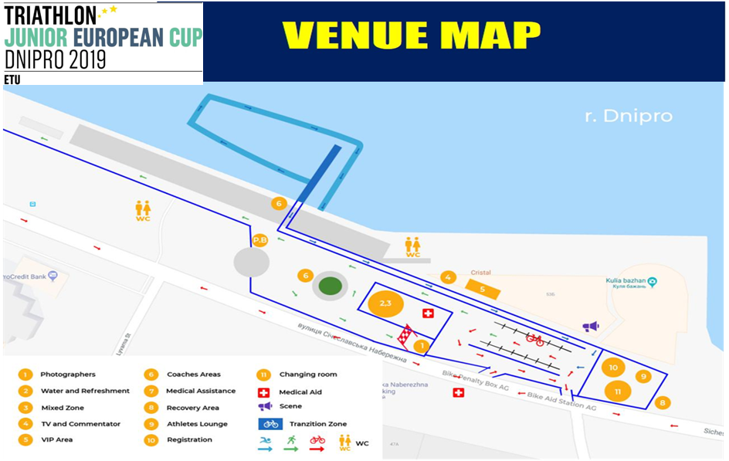

2.2 COURSE FAMILIARIZATION
Friday, June 7th. Sicheslavska Naberezhna St., Festival Wharf.
12:00 - Bike course familiarization (TBC). Athletes will be accompanied by police and ambulances. 13:00 - Swim course familiarization (TBC). Notice! - The buoys are not in Sunday's race position. On the water there will be rescuers and water police.

  - ATHLETE’S LOUNGE
Location: Sicheslavska Naberezhna St., Festival Wharf - close to the race venue and provide toilets, water, fruit and energy drinks
Also recovery zone close to the finish area (with maybe physiotherapist for massage).

  - MIXED RELAY JUNIOR ATHLETES’ RACE PACKAGE
Mixed Relay Junior race packages will be distributed after the briefing. Once member of team could pick the race Package up.

  - DOPING CONTROL
Doping Control will be performed according to the ITU/WADA rules.
The athletes must be carry their identification to the doping control facilities

  - SECURITY
Security will be provide by the government of the city. During the race, the athletes will be accompanied
by the police. In the starting town will be guarded by police forces. On the territory of the race there will
be ambulances. On the water there will be water police, rescuers. 80 volunteers will be involved. The police will guarantee the clousure of roads and the safety of athletes.

  - LOC OFFICE
Dnipropetrovsk Region Triathlon Federation. Address: Naberezhna Peremogy Street, 36-A; 49000, Dnipro – Ukraine. startdnipro@gmail.com Operating time : Monday - Friday 09:00-18:00
+380630724273
+380932600441
3. ACCOMMODATION

LOC provides accommodation at reduced prices in the following hotels: Hotel "Dnepropetrovsk"
Ukraine, Dnipro
Sicheslavska Naberezhna St., 33 dnipro.hotel.dp@gmail.com
+38 (056) 377-95-55
+38 (056) 377-95-56
4. TRANSFER AND TRANSPORT

The LOC will provide transportation from Dnipro’s Airport for the athletes and their Team Officials. Price: transfers from Dnepropetrovsk International Airport (one direction):
- 15€ per person
The transfer back to the airport is the same amount If you have any Transfer queries please contact: Sergey Lysov
Email: lysovsergii@gmail.com Phone: +380 63 072 42 73
Visa information:
For citizens of Belarus - entry into Ukraine is visa-free with a single passport. For citizens of all countries of the former USSR, except Turkmenistan - visa-free, but only on foreign passports (applies to Estonia, Latvia, Lithuania, Moldova, Georgia, Armenia, Azerbaijan, Kazakhstan, Tajikistan, Uzbekistan, Kyrgyzstan). The only country whose citizens can come to Ukraine with an internal passport is Turkey.

Also, citizens of the following countries can come to Ukraine without a visa:
• all countries of the European Union (with the entry on the passports of "non-citizens" of Latvia and Estonia - visa);
• some other European countries: Andorra, Vatican, Iceland, Monaco, Norway, Switzerland, Montenegro, Bosnia-Herzegovina, Serbia, Macedonia, Liechtenstein, San Marino, Albania;
• American countries: USA, Canada, Panama, Paraguay, Argentina, Brazil, Chile, Saint Kitts and Nevis, Antigua and Barbuda, Uruguay;
• Asian countries: South Korea, Japan, Israel, Brunei, Turkey, Hong Kong, United Arab Emirates, Mongolia.
5. ATHELETE’S SERVICES

  - TRAINING FACILITIES
SWIM - Pridneprovskaya State Academy of Civil Engineering and Architecture, address: Chernyshevskogo St. 24-A, Dnipro, Ukraine.
Monday – Friday 7:15 - 9:30; 16:45 – 20:30
Saturday 8:45 – 14:00
Sunday 8:00 – 13:15

BIKE- Sicheslavska Naberezhna St.

RUN - Sicheslavska Naberezhna St; Stadium “Slavutich”, 6 Strelkovoy Divisii St.; Shevchenko Park.

  - MEDICAL SERVICES
First Aid and Emergency Medical Services will be available at the Registration area before and during the training sessions and during the race. There will be First Aid and Emergency Medical Services at the Race Village on competition day.
Medical and Paramedical personnel will be available throughout the race. Several ambulances will be available to provide emergency transfers to a nearby hospital. A medical area will be provided on site at the finish area.
Medical services at the venue are free of charge. Treatment in private hospitals are to be paid by participants. Athletes / teams should make sure that they have appropriate medical insurance. Сlosest hospital: Hospital named after Mechnikov; address: Soborna Square,14.
Emergency telephone number: 103.

  - BIKE MECHANICAL SERVICE Bike partner: “Velik-Rolik”.
Adress: Bogdan Khmelnitsky Avenue, 5; Dnipro – Ukraine.
+38050-133-38-71
+38068-437-16-46
Monday – Friday 10:00 – 19:00
Saturday 10:00 – 16:00
Sunday - weekend.

6. COMPETITION SCHEDULE

  - JUNIOR MIXED RELAY
DAY RACE START END ACTIVITY LOCATION

Friday, June 7th | JMR | 17:30 | 18:00 | Team Managers briefing “Menorah cultural and business center”, address: Ukraine, Dnipro, 4/26 Sholom-Aleichem Street
Friday, June 7th | JMR | 19:00 | 20:00 | Press Conference “Menorah cultural and business center”, address: Ukraine, Dnipro, 4/26 Sholom-Aleichem Street
Sunday, June 9th | JMR | 13:30 | 14:30 | Athlete registration Sicheslavska Naberezhna  St, Festival Wharf
Sunday, June 9th | JMR | 13:30 | 14:30 | Athlete Lounge check in Sicheslavska Naberezhna  St, Festival Wharf
Sunday, June 9th | JMR | 14:00 | 14:45 | TA check in Sicheslavska Naberezhna St, Festival Wharf
Sunday, June 9th | JMR | 14:00 | 14:15 | Swim warm-up Sicheslavska Naberezhna St, Festival Wharf
Sunday, June 9th | JMR | 14:50 | 14:55 | Calling area Sicheslavska Naberezhna St, Festival Wharf
Sunday, June 9th | JMR | 14:55 | 15:00 | Athletes introduction Sicheslavska Naberezhna  St, Festival Wharf
Sunday, June 9th | JMR | 15:00 |  | JUN MIXED RELAY START Sicheslavska Naberezhna St,
Festival Wharf
Sunday, June 9th | JMR | 17:00 | Award Ceremony | Sicheslavska Naberezhna St, Festival Wharf

  - COMPETITION RULES
The event will follow the latest published Competitions Rules of the International Triathlon Union.

  - ATHLETE’S BRIEFING Friday, June 7th
17:00 – Junior briefing. 18:00 - Elite briefing.
“Menorah cultural and business center”, address: Ukraine, Dnipro, 4/26 Sholom-Aleichem Street.
https://goo.gl/maps/HzZGkLCG1GJ2

  - TIMING CHIPS
On race day athletes will be given a timing chip, to be worn on the athletes’ ankle. Athletes will pick up the timing chips before the competitions, during their check-in procedure.

  - RESULTS
Results will be uploaded live at the ITU official website www.triathlon.org. (the source will be specified). All the Results information will be distributed to the Team Leaders at the Information Centre (Sicheslavska Naberezhna St).

  - PROTEST & APPEALS
Standard procedures will be followed according to the ITU Competition Rules
7. ACCREDITATION

The LOC will provide to all the Organizing Committee Members, ITU Technical Officials, Athletes, VIPs, media, technical staff, court personnel, volunteers, etc. with an official Accreditation Card.
Accreditations will be distributed in “Menorah cultural and business center”, address: Ukraine, Dnipro, 4/26 Sholom-Aleichem Street.
Accreditations of Athletes and Coaches will be distributed before the briefing.
Only accredited people will be allowed to access certain venue areas. Accreditation Cards provide access to specific areas of the competition areas.
All accredited people are requested to carry their Accreditation Cards with them at all times and to show them upon request. Accreditation Cards are mandatory to enter the venue.
8. OTHER USEFUL INFORMATION

Could be and is not limited to:

  - LANGUAGE: Russian, Ukrainian, English.

  - POPULATION: Ukrainian, 45 millions.

  - CURRENCY: hryvna.
USD – 28,95.
EUR – 31,25.

  - TIME: Kiev time.

  - ELECTRICITY: 220V.

  - WATER: non-potable water.

  - TELEPHONE CONNECTIONS: +38 (0..)
9. COURSE MAPS
SWIM START

SWIM COURSE
Start procedures: pontoon.
The Race Referee with assistance of Technical Officials, who are assigned to the start, will start each race.
Number of laps: 1.
Average water temperature - 19-21 degrees Celsius.
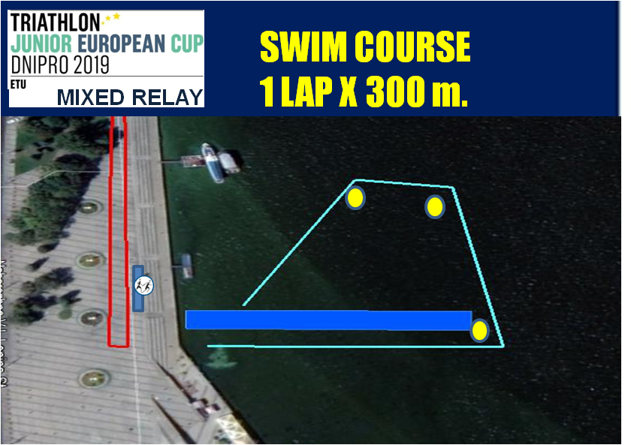

TRANSITION 1
A flow through transition has been developed to keep athletes moving forward. Athletes enter the transition and must deposit swim gear in a bin placed beside the bike racks. Athletes' names and/or numbers are displayed on the top of each bike rack. After the helmet is secures, athletes unrack the bike by moving forward into the centre lane and towards the mount line

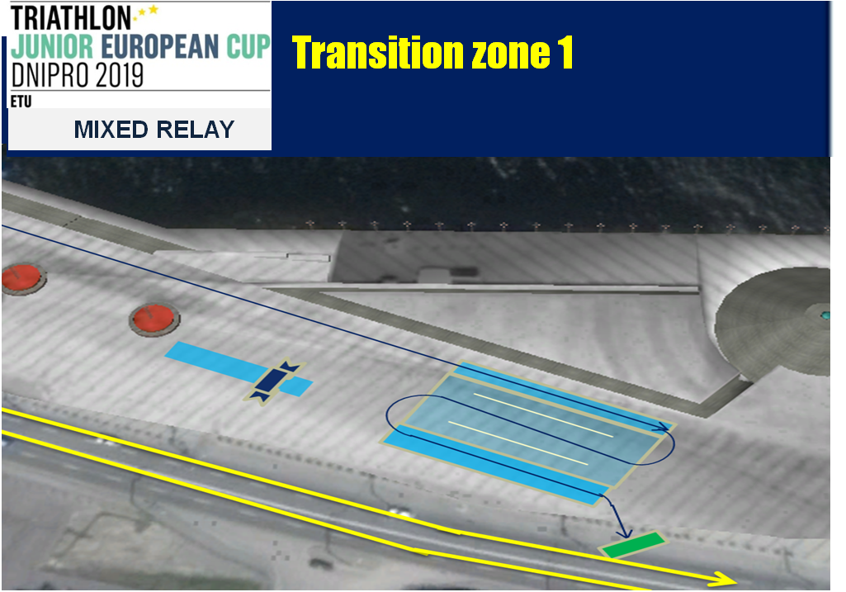

BIKE COURSE
Number of laps: 3.
Hill – 700 metres. 200 m – 7-8% the steepness of the hill; 500 m – 4-5% the steepness of the hill.

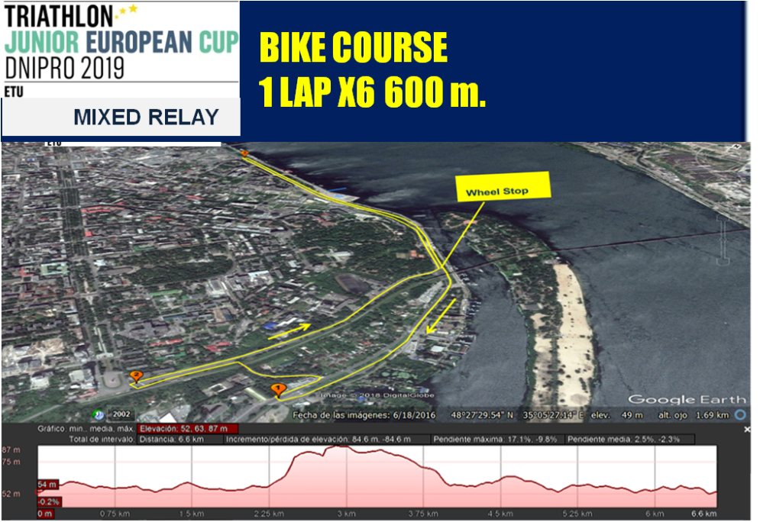
WHEEL STATION
One (1) wheel station will be located on the bike course. The wheels have to be provided by the teams

TRANSITION 2

From the dismount line, please describe the flow of the transition Running shoes may be placed beside the rack or in the bin.

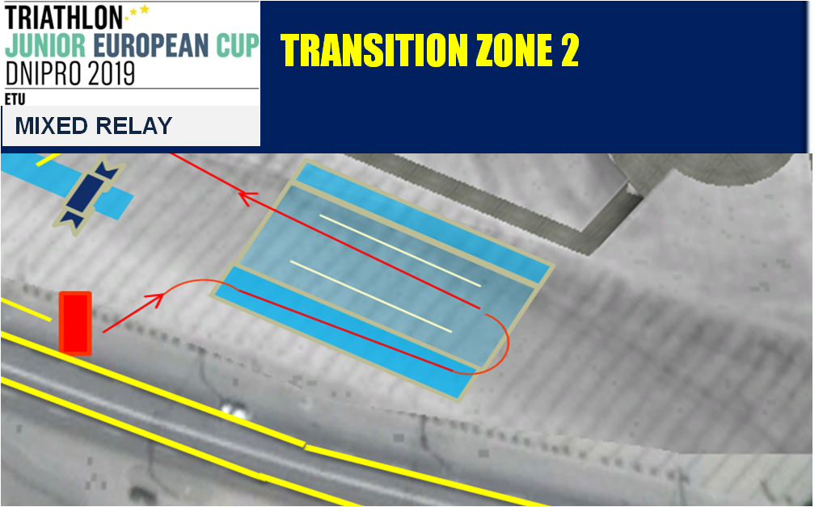

RUN COURSE
Number of laps: 3. Description: flat asphalt.
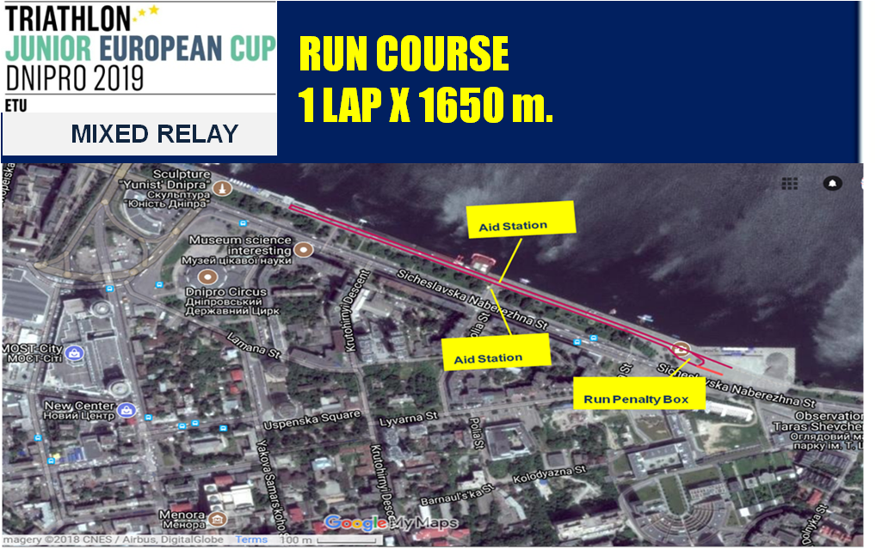
AID STATION
Aid station will be located on the run course.

PENALTY BOX
A penalty box will be located on the run course, at the end of every lap.

RELAY ZONE

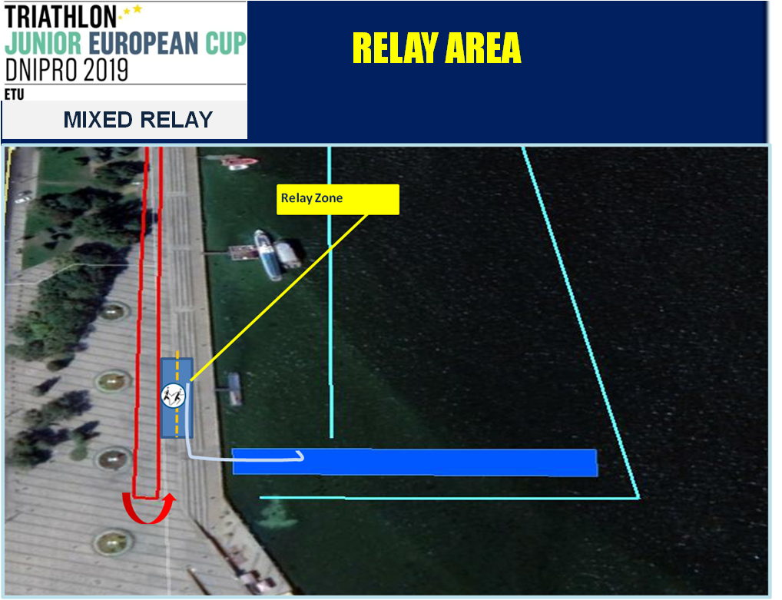

COURSE MAP
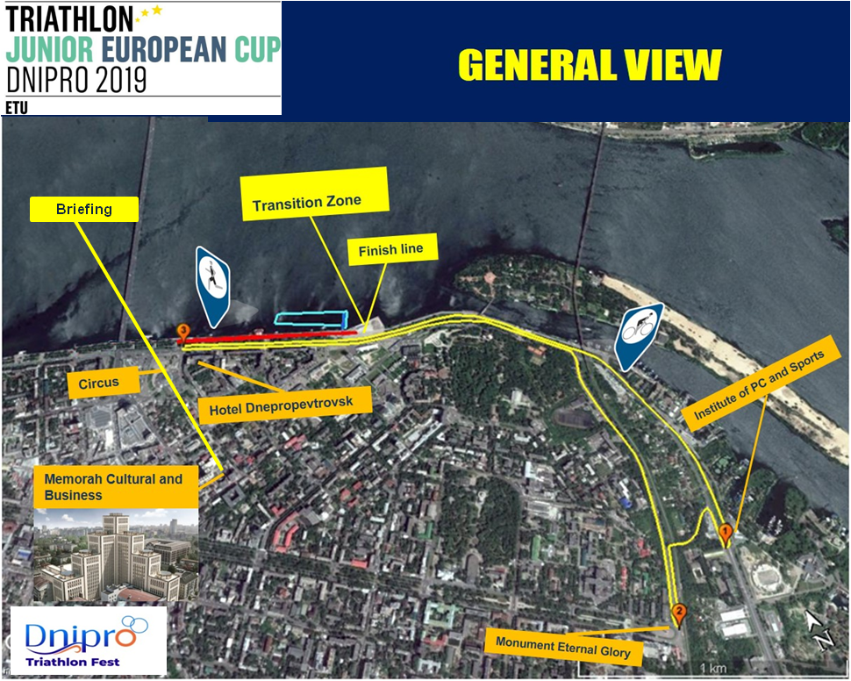
Good luck.

