**ATHLETE’S GUIDE**

**2019 Istanbul ETU Sprint Triathlon**

**Balkan Championships**







TABLE OF CONTENTS

1. GENERAL INFORMATION 3

1.1. INTRODUCTION 3

1.2. CATEGORIES & DISTANCES & AGES 3

1.3. REGISTRATION 3

1.4. KEY DATES 3

1.5. KEY CONTACTS 4

2. VENUE 5

2.1. RACE VENUE 5

2.2 COURSE FAMILIARIZATION 5

2.3 ATHLETES BRIEFING 5

2.3 ATHLETES’ RACE PACKAGE 5

2.4 ATHLETE’S LOUNGE 6

2.5 DOPING CONTROL 6

2.6 WATER QUALITY TEST 6

3. ACCOMMODATION 7

4. TRANSFER AND TRANSPORT 8

5. ATHELETE’S SERVICES 9

5.1. TRAINING FACILITIES 9

5.2. MEDICAL SERVICES 9

5.3. BIKE MECHANICAL SERVICE 9

6. COMPETITION SCHEDULE 10

6.1. COMPETITION RULES 11

6.2. TIMING CHIPS 11

6.3. RESULTS 11

6.4. PROTEST & APPEALS 11

6.5. PRIZE MONEY & ENTRY FEE 11

7. ACCREDITATION 12

8. OTHER USEFUL INFORMATION 12

9. COURSE MAPS 13

|  |
| --- |
| 1. GENERAL INFORMATION |

## 1.1. INTRODUCTION

The purpose of the Athlete’s Guide is to ensure that all athletes, coaches and Team Leaders are well informed about all procedures concerning the Event. The LOC ensures that the information contained in this Guide is correct and up‐to‐date as of the production date. However, athletes, coaches and Team Leaders are advised to check with the event office regarding any changes in information included in this guide.

## 1.2. CATEGORIES & DISTANCES & AGES

|  |  |  |
| --- | --- | --- |
| **Categories** | **Events** | **Ages** |
| Elite | Sprint Triathlon |  |
| Junior | Sprint Triathlon | 15 to 19 years old |
| Youth | Super Sprint Triathlon | 15 to 17 years old |
| M3A/M3B | Aquathlon (400m-2400m) | M3A 14 y. old - M3B 13 y. old |
| M2 | Aquathlon (300m-1200m) | 11 - 12 years old |
| M1 | Aquathlon (200m-600m) | 9 - 10 years old |
| Age Groups | Sprint Triathlon | 20-24/25-29/30-34 etc. |

* M1/M2/M3 category races will be held at national level. However international athletes also welcome. Please note no medal ceremony and ranking for M1 and M2 athletes.

## 1.3. REGISTRATION

Elite registration should be made through ITU login system.

The registration for other categories should be made submitting the form that you may reach through the link below.

[Registration form](https://docs.google.com/forms/d/e/1FAIpQLSc3WATSrjF4uMwbF-eFyw5TGLT38xeIavUnOC4VQ3GPKpVHKQ/viewform)

## 1.4. KEY DATES

02 August 2019 Friday   
14:00-16:00 Registration open and package pick up (Youth, Junior)  
16:00 Youth & Junior briefing (Balkan Championship)  
17:00 Elite briefing & Packets distribution for Elite’s (after briefing)  
  
03 August 2019, Saturday

08:15 Kartal/Istanbul Balkan Championship Start Youth Men   
08:20 Kartal/Istanbul Balkan Championship Start Youth Women   
10:00 Kartal/Istanbul Balkan Championship Start Junior Women   
10:15 Kartal/Istanbul Balkan Championship Start Junior Men  
13:00 Kartal/Istanbul ETU Balkan Championship Start Elite Women  
14:30 Kartal/Istanbul ETU Balkan Championship Start Elite Men

16:30 Award Ceremony  
  
04 August 2019, Sunday

08:30 Kartal/Istanbul Balkan Championship Start Age Groups

11:00 Kartal/Istanbul Balkan Championship Mixed Relay Start   
13:45 Kartal/Istanbul Balkan Championship M1 Aquathlon Start (9-10 years old)  
14:10 Kartal/Istanbul Balkan Championship M2&M3 Aquathlon Start (11-12/13-14 years old)

## 1.5. KEY CONTACTS

**TURKISH TRIATHLON FEDERATION**

Maltepe Mah. Şehit Daniş Tunalıgil Sok. No: 3/15 Çankaya /ANKARA

Tel: +90 312 309 25 70

[turkiyetriatlon@triatlon.org.tr](mailto:turkiyetriatlon@triatlon.org.tr)

[www.triatlon.org.tr](http://www.triatlon.org.tr)

RACE DIRECTOR

Mehmet Zafer Peker

+90 536 353 34 38

[zaferpekers@hotmail.com](mailto:zaferpekers@hotmail.com)

TECHNICAL DELEGATE

Andreas Galanos

[andreas.galanos@gmail.com](mailto:andreas.galanos@gmail.com)

ATHLETE SERVICES MANAGER

Hüseyin Onur Aydemir

+90 507 168 26 58

[onuraydemir@triatlon.org.tr](mailto:onuraydemir@triatlon.org.tr)

|  |
| --- |
| 2. VENUE |

## 2.1. RACE VENUE

Kartal Municipality, Kartal District

KArtal Belediyesi Su Sporları Merkezi

Adress: Orhantepe Mahallesi, Turgut Özal Bulvarı, 34865 Kartal/İstanbul

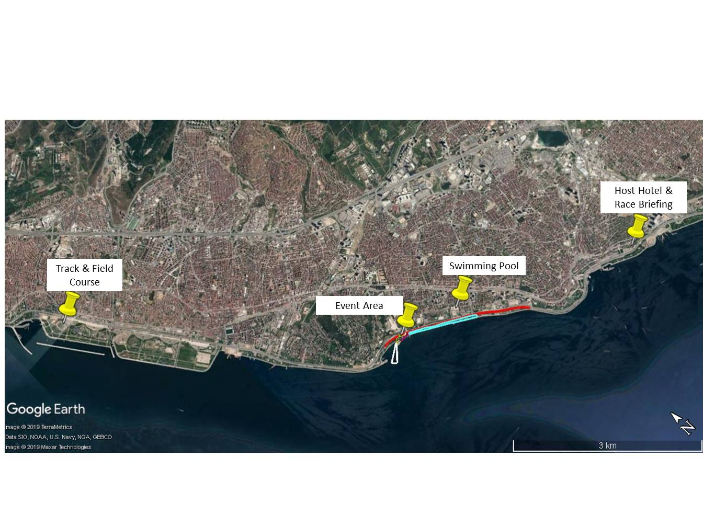

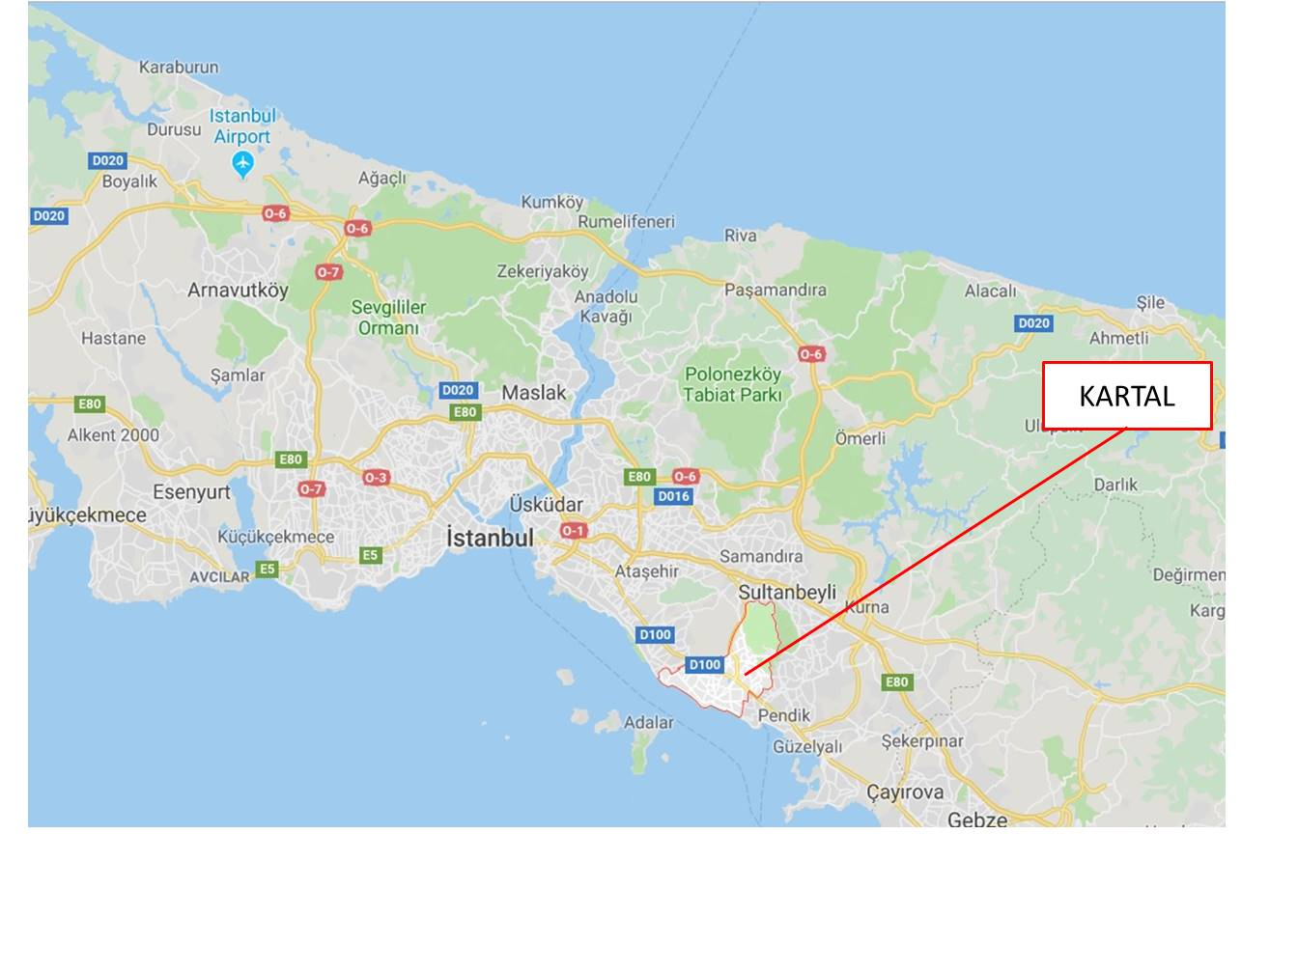

## 2.2 COURSE FAMILIARIZATION

02 August 2019 Friday

14:00- Escorted bike course familiarization (Open to traffic) Transition Area

14:30-15:00 Swim course familiarization

## 2.3 ATHLETES BRIEFING

02 August 2019 Friday

16:00 Youth & Juniors briefing (Balkan Championship)

17:00 Elite briefing

03 August 2019, Saturday

17:00 Briefing for Age Group & Mixed Relay & M1/M2/M3 (Aquathlon)

## 2.3 ATHLETES’ RACE PACKAGE

KNDF Marine Hotel

02.08.2019(Friday)

14:00-16:00 Youth and Junior

18:00 Elite (After the briefing)

03.08.2019(Saturday)

15:00-17:00 Age Group & Mix Relay

## 2.4 ATHLETE’S LOUNGE

There is a possibility to provide at he recovery zone , massage, fruit etc

## 2.5 DOPING CONTROL

Doping tests will be conducted according to ITU/WADA rules. The athletes must carry their identification to the doping control facilities.

## 2.6 WATER QUALITY TEST

Date of the test:

|  |  |  |  |  |  |  |  |
| --- | --- | --- | --- | --- | --- | --- | --- |
|  |  |  |  |  |  |  |  |
|  |  |  |  |  |  |  |  |
|  |  |  |  |  |  |  |  |
|  |  |  |  |  |  |  |  |

|  |
| --- |
| 3. ACCOMMODATION |

**HOST HOTEL:**

**THE KNDF MARINE HOTEL**  
<https://kndfmarinehotel.com/kndf>  
Reservation: [info@kndfmarinehotel.com](mailto:info@kndfmarinehotel.com)  
Adress: Kordonboyu Mahallesi, Ankara Caddesi No:160, Kartal/İstanbul, Türkiye  
Tel: 00902165178293

OTHER ACCOMMODATION:  
İlayda Ateşok  
E-mail: [reservation1@tungatour.com](mailto:reservation1@tungatour.com)  
Phone: +90 542 450 71 34

All options are B&B and 4 or 5 star hotels.

* HOTEL VILLA VANILLA Standart Room/Single 32 € /Double 32 €/Triple 44 €
* ELITE HOTEL KUCUKYALI Standart Room/Single 29 € /Double 35 €/Triple 41 €
* ELITE HOTEL DRAGOS Standart Room/Single 35 € /Double 39 €/Triple 47 €
* THE GRAND MIRA HOTEL Standart Room/Single 37 € /Double 41 €/Triple 51 €
* INERA HOTEL Standart Room/Single 51 €/Double 63 € /Triple 86 €
* RAMADA ENCORE KARTAL Standart Room/Single 40 €/Double 51 €/Triple 63 €
* TITANIC BUSSINESS KARTAL Standart Room/Single 56 € /Double 67 €/Triple 78 €
* CEVAHIR HOTEL ISTANBUL ASIA Standart Room/Single 58 €/Double 63 €/Triple 81 €
* THE GREEN PARK PENDIK Standart Room/Single 68 €/Double 81 € /Triple 99 €
* BURGU ARJAAN BY ROTANA Clasic Studio Room/Single 75 €/Double 75 €/Triple 104 €
* TANGO ARJAAN BY ROTANA Clasic Studio Room/Single 75 €/Double 75 € /Triple104 €
* DIVAN ISTANBUL ASIA Standart Room/Single58 €/Double 99 €/Triple 135 €

|  |
| --- |
| 4. TRANSFER AND TRANSPORT |

Closest Airports

Sabiha Gökçen Airport (20 km to Venue)

İstanbul Airport (65 km to Venue)

Airport transportation is provided with fee.

Contact

İlayda Ateşok  
E-mail: [reservation1@tungatour.com](mailto:reservation1@tungatour.com)  
Phone: +90 542 450 71 34

Transfer fees from Istanbul Airport to Kartal  
VEHICLE TYPE CAPACITY ( Normal ) CAPACITY ( With Bicycle ) UNIT PRICE  
Mercedes Vito 8 pax 4 pax or 5 pax 70 euro  
Minibus 13 pax 8 pax 80 euro  
Minibus 16 pax 10 pax 90 euro  
Midibus 27 pax 18 pax 150 euro  
Midibus 31 pax 20 pax 170 euro  
Bus 45 pax 40 pax 200 euro

Transfer fees from Sabiha Gökcen Airport to Kartal  
VEHICLE TYPE CAPACITY ( Normal ) CAPACITY ( With Bicycle ) UNIT PRICE  
Mercedes Vito 8 pax 4 pax or 5 pax 45 euro  
Minibus 13 pax 8 pax 55 euro  
Minibus 16 pax 10 pax 65 euro  
Midibus 27 pax 18 pax 90 euro  
Midibus 31 pax 20 pax 110 euro  
Bus 45 pax 40 pax 140 euro

|  |
| --- |
| 5. ATHELETE’S SERVICES |

## 5.1. TRAINING FACILITIES

SWIM

Dragosport

Adress: Kartal Migros İçi Yolu Kartal Istanbul Turkey, 34860 kartal/İstanbul

7:00 pm to 8:00 pm (lane per hour 100 TL)

For reservation +90 507 168 26 58

 BIKE

Due to heavy traffic, bike training is not recommended during day times.

RUN



Maltepe Track & Field Course is open to public use for free

Adress: Çınar, Park İçi Yolu, 34841 Maltepe/İstanbul

Also race course might be used for running training.

## 5.2. MEDICAL SERVICES

First Aid and Emergency Medical Services will be available at the Registration area before and during the familiarization sessions and during the race. There will be First Aid and Emergency Medical Services at the Race Village on competition day.

Medical and Paramedical personnel will be available throughout the race. Several ambulances will be available to provide emergency transfers to a nearby hospital. A medical area will be provided on site at the finish area.

Medical services at the venue are free of charge. Treatment in private hospitals is to be paid by participants. Athletes / teams should make sure that they have appropriate medical insurance.

Emergency telephone number: 112

## 5.3. BIKE MECHANICAL SERVICE

Bike Mechanic service will be offered at the race venue on 2nd, 3rd, and 4th of August.

|  |
| --- |
| 6. COMPETITION SCHEDULE |

02 August 2019, Friday

14:00 Escorted bike course familiarization (Open to traffic) Transition Area

14:30 Swim course familiarization 30min

14:00 16:00 Registration open and package pick up

16:00 Youth & Juniors briefing (Balkan Championship)

17:00 Elite briefing

18:00 Pasta Party

03 August 2019, Saturday

06:45 07:15 Athletes Lounge Open and Check in Youth

07:00 08:00 Transition area is open for Youth and Juniors

07:45 08:00 Swim warm up for Youth

08:00 Pre start procedure

08:15 Kartal/Istanbul Balkan Championship Start Youth Men

08:20 Kartal/Istanbul Balkan Championship Start Youth Women

09:00 09:45 Transition area is open for Juniors

09:30 09:45 Swim warm up for Junior Women

09:45 Pre start procedure

10:00 Kartal/Istanbul Balkan Championship Start Junior Women

09:45 10:00 Swim warm up for Junior Men

10:00 Pre start procedure

10:15 Kartal/Istanbul Balkan Championship Start Junior Men

12:00 12:45 Transition area is open for Elite's

12:30 12:45 Swim warm up for Elite Women

12:45 Pre start procedure

13:00 Kartal/Istanbul ETU Balkan Championship Start Elite Women

14:00 14:15 Swim warm up for Elite Men

14:15 Pre start procedure

14:30 Kartal/Istanbul ETU Balkan Championship Start Elite Men

15:00 17:00 Registration open (Age Group & Relay)

16:30 Award Ceramony

17:00 Briefing Age Group & Mixed Relay & M1/M2/M3 (Aquathlon)

18:00 Pasta Party

04 August 2019, Sunday

07:00 08:15 Transition area is open for Age Group

07:45 08:15 Swim warm up for Age Groups

08:30 Kartal/Istanbul Balkan Championship Start Age Groups

10:30 Cut off 2hour (age groups)

10:30 10:50 Transition area open for Mixed Relay

11:00 Kartal/Istanbul Balkan Championship Mixed Relay Start

13:00 Cut off 2hour (Mixed Relay)

13:00 13:40 Transition area open for M1 (9-10 years o.), M2 (11-12 years o.) AQUATHLON

13:45 Kartal/Istanbul Balkan Championship M1 Aquathlon Women Start (9-10 years

14:05 Kartal/Istanbul Balkan Championship M1 Aquathlon Men Start (9-10 years old)

14:25 Kartal/Istanbul Balkan Championship M2 Aquathlon Women Start (11-12 years old)

14:50 Kartal/Istanbul Balkan Championship M2 Aquathlon Men Start (11-12 years old)

15:15 Kartal/Istanbul Balkan Championship M3 Aquathlon Women Start (13-14 years old)

15:45 Award Ceramony

## 6.1. COMPETITION RULES

The event will follow the latest published Competitions Rules of the International Triathlon Union.

## 6.2. TIMING CHIPS

Champion Chip Timing

On race day athletes will be given a timing chip, to be worn on the athletes’ ankle. Athletes will pick up the timing chips before the competitions, during their check-in procedure.

## 6.3. RESULTS

Results will be uploaded live at the ITU official website [www.triathlon.org](http://www.triathlon.org).

## 6.4. PROTEST & APPEALS

Standard procedures will be followed according to the ITU Competition Rules.

## 6.5. PRIZE MONEY & ENTRY FEE

**Total Prize Money 1.800€**

Prize money distribution for elite men and women

**1st. 450 €**

**2nd. 270 €**

**3rd. 180 €**

**Entry Fee:**

Elite’s 50 €, Juniors 40 €, Youth 20 €, Age Group 50 €, M Groups (Aquathlon) 10 €

|  |
| --- |
| 7. ACCREDITATION |

The LOC will provide to all the Organizing Committee Members, ITU Technical Officials, Athletes, VIPs, media, technical staff, , volunteers, etc. with an official Accreditation Card.

Only accredited people will be allowed to access certain venue areas. Accreditation Cards provide access to specific areas of the competition areas.

All accredited people are requested to carry their Accreditation Cards with them at all times and to show them upon request. Accreditation Cards are mandatory to enter the venue.

|  |
| --- |
| 8. OTHER USEFUL INFORMATION |

8.1. LANGUAGE: Turkish

8.2. POPULATION 16.000.000

8.3. CURRENCY:

1€ = 6,600 TL

1$ = 5,800 TL

8.4. TIME GMT +3

8.5 ELECTRICITY: 220 volts

8.6 WATER (Tab water is not drinkable)

8.7 TELEPHONE CONNECTIONS (+90 *** *** ** **)

|  |
| --- |
| 9. COURSE MAPS |

**SWIM COURSE**

Start procedures: Pontoon start

Number of laps: 1 Lap clockwise

Elite, Junior, Age Group Categories 750m

Youth Category: 400m

M3 Category (12-13 Years Old): 400m

M2 Category (11-12 Years Old): 300m

M1 Category (9-10 Years Old): 200m

Average water temperature: 23 Celsius degree

 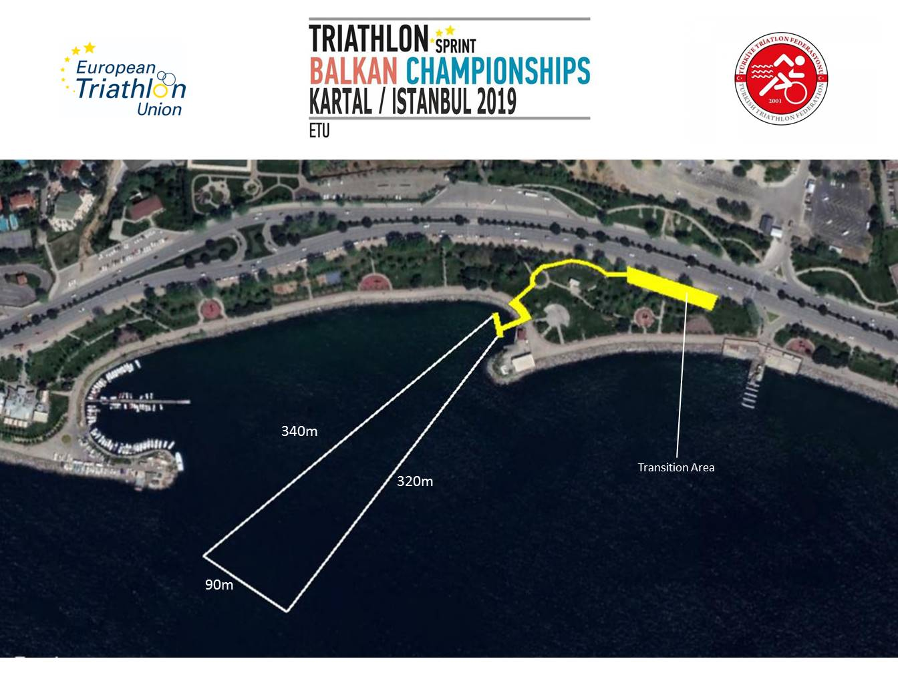



Swim Exit to Transition 1

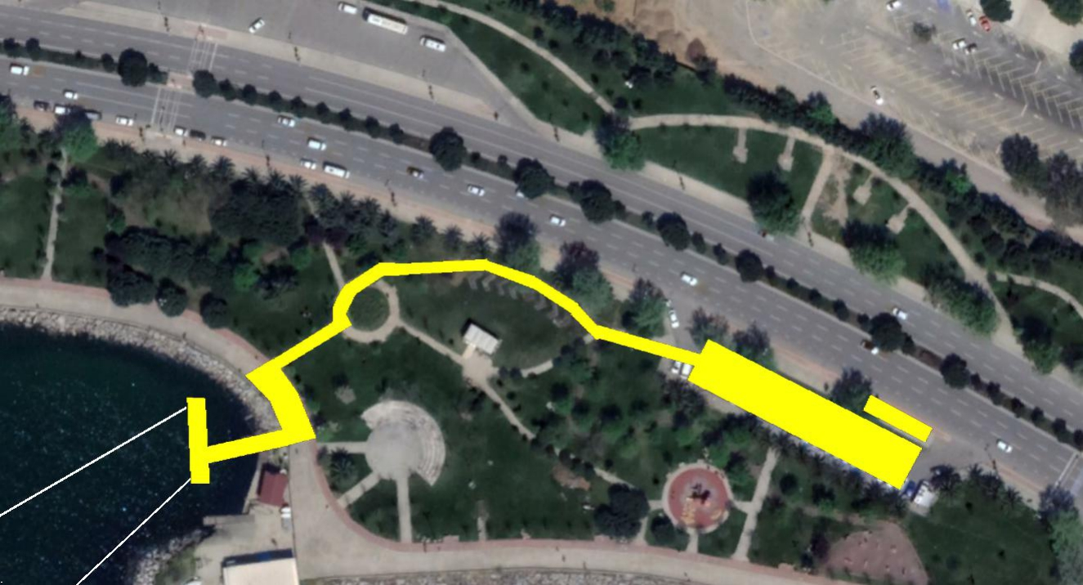

Wheel Station

Transition Area

**TRANSITION**

A flow through transition has been developed to keep athletes moving forward. Athletes enter the transition and must deposit swim gear in a bin placed beside the bike racks. Athletes' names and/or numbers are displayed on the top of each bike rack. After the helmet is secured, athletes unrack the bike by moving forward into the center lane and towards the mount line

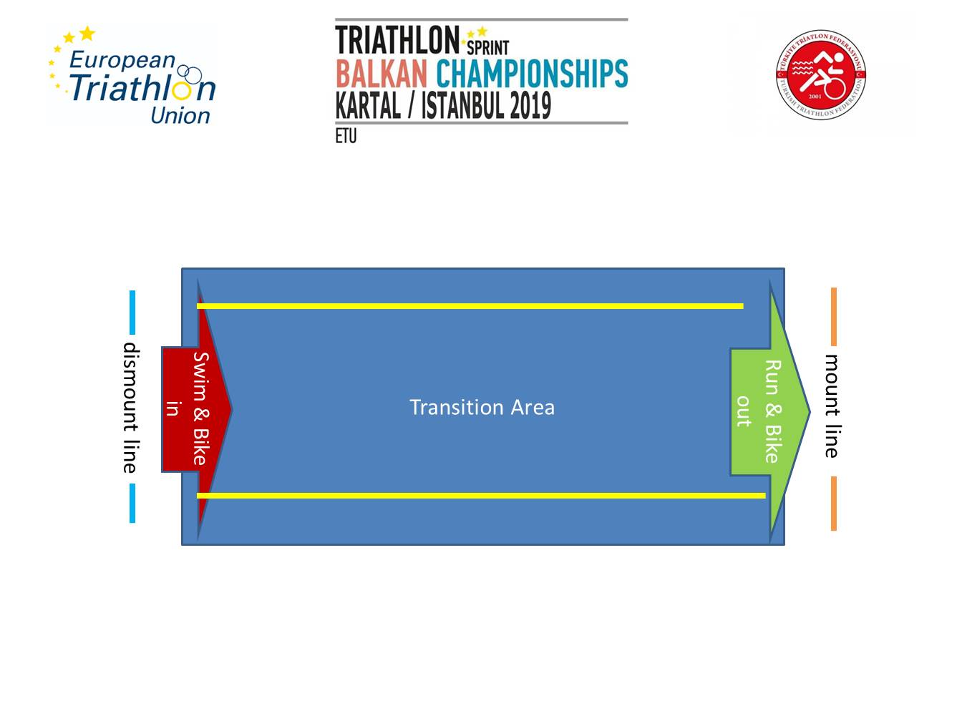

 **BIKE COURSE**

Elite, Junior, Age Group Categories 4x5km

Youth Category 2x5km

It is fast and completely flat course, no technical turns, only “U” turns for the lap.

Wheel station is located close to Transition as shown on map.

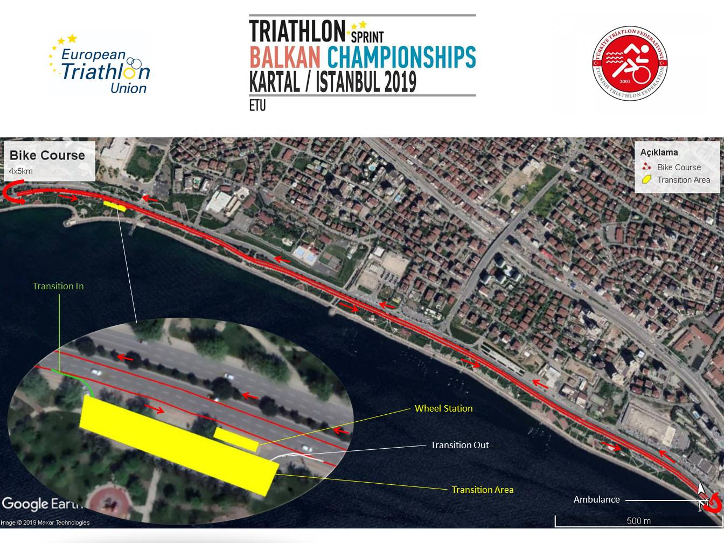

Transition 2

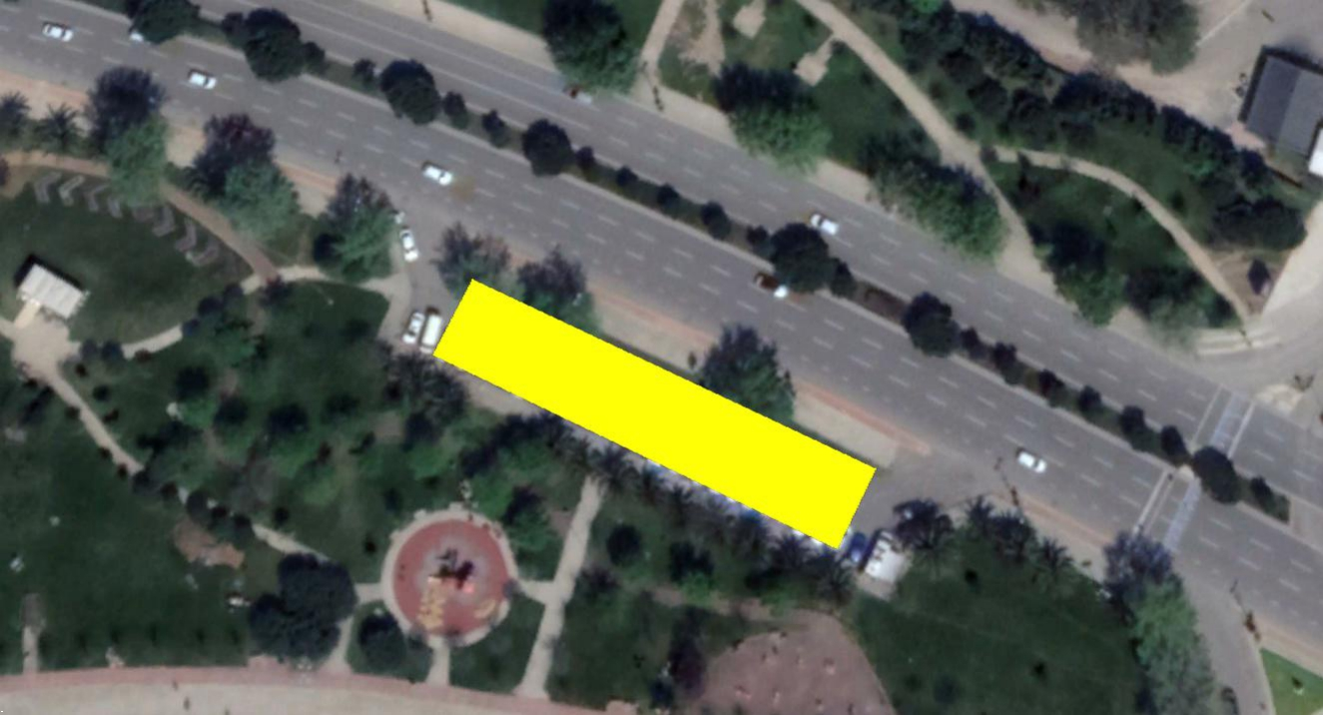

**RUN COURSE**

Elite, Junior, Age Group Categories: 2x 2500m

Youth Category: 1x2500m

M3 Category 2400m

M2 Category (11-12 Years old): 1200m

M1 Category (9-10 Years Old): 600m-

Description: Fully flat

One of the aid stations is located on the far end point of the run course and the other one is at the lap.

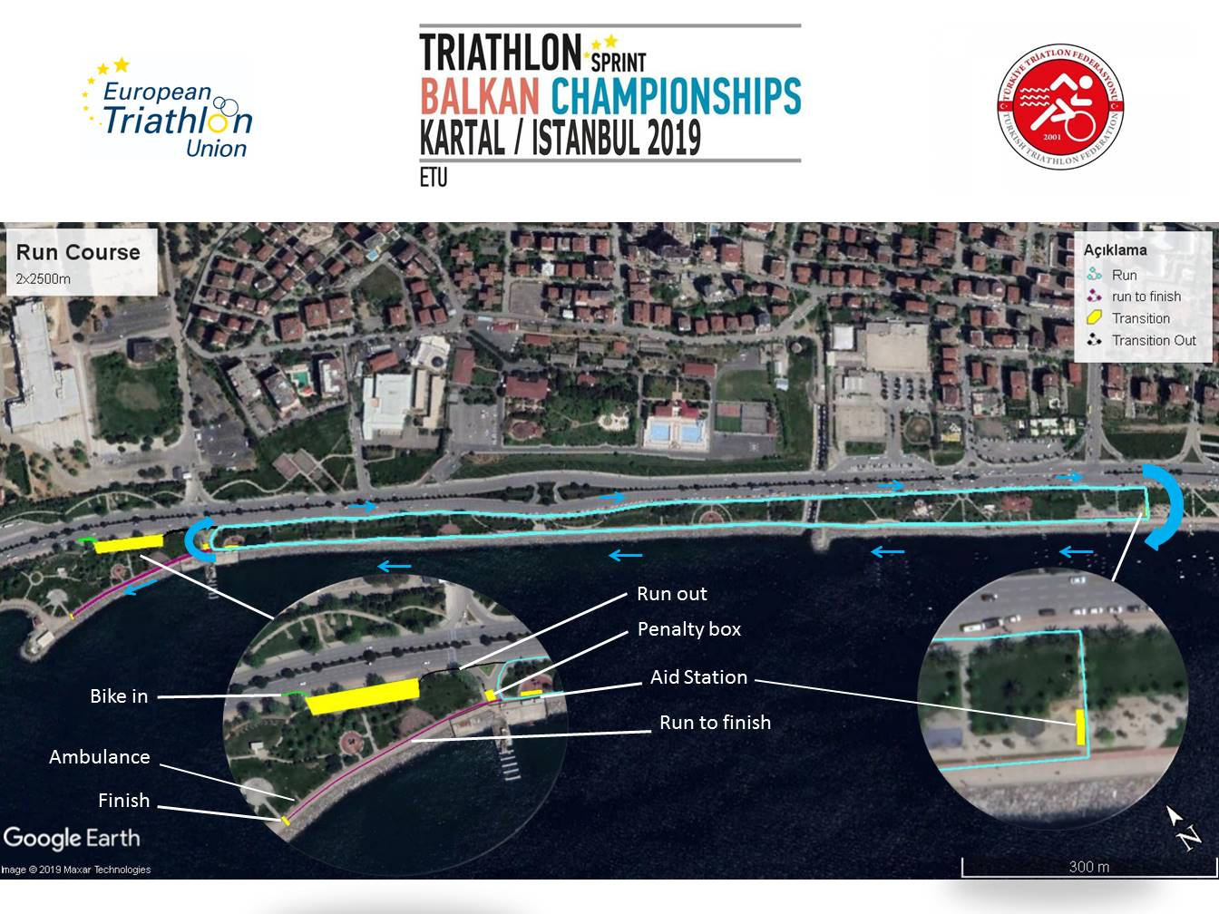

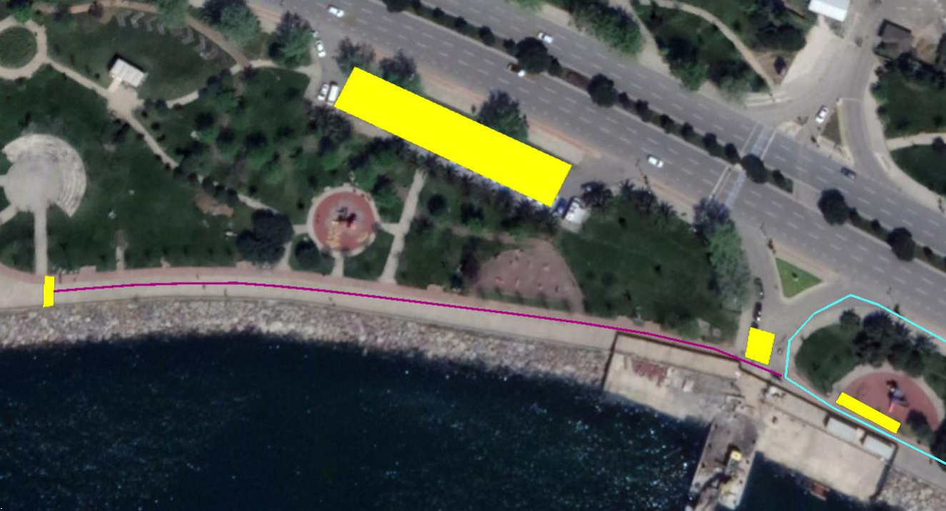

To Finish

To Lap

Aid Station

Penalty Box

FINISH

