**ATHLETE’S GUIDE**

**2018 ETU Triathlon Junior European Cup**

**Zilina, Slovakia**



TABLE OF CONTENTS

1. GENERAL INFORMATION page

1.1. INTRODUCTION 3

1.2. KEY DATES 3

1.3. KEY CONTACTS 3

1.4. CONTACT DETAILS 3

2. VENUE 4

2.1. RACE VENUE 4

2.2. COURSE FAMILIARIZATION 4

2.3. ATHLETE’S LOUNGE 4

2.4. ELITE ATHLETES’ RACE PACKAGE 4

2.5. DOPING CONTROL 5

2.6. SECURITY 5

2.7. LOC OFFICE 5

3. ACCOMMODATION 5

4. TRANSFER AND TRANSPORT 5

5. ATHELETE’S SERVICES 6

5.1. SWIM AND BIKE TRAINING 6

5.2. MEDICAL SERVICES 6

5.3. BIKE MECHANICAL SERVICE 7

6. COMPETITION SCHEDULE 7

6.1. ELITE WOMEN 7

6.2. ELITE MEN 7

6.3. COMPETITION RULES 7

6.4. ATHLETE’S BRIEFING 7

6.5. TIMING CHIPS 8

6.6. RESULTS 8

6.7. PROTEST & APPEALS 8

7. ACCREDITATION 8

8. COURSE MAPS 8

|  |
| --- |
| 1. GENERAL INFORMATION |

**1.1. INTRODUCTION**

The purpose of this Athlete’s Guide is to ensure that all athletes, coaches and Team Leaders are well informed about all procedures concerning the Event. The LOC ensures that the information contained in this Guide is correct and up‐to‐date as of the production date. However, athletes, coaches and Team Leaders are advised to check with the event office regarding any changes in information included in this guide.

**1.2. KEY DATES**

**August 18, Saturday**

14:00 – 17.00 Accreditation to the race River club, Water dam Zilina

15:00 – 18:00 Presentation Junior man and women River club, Water dam Zilina

15:30 – 16:30 Run course familiarization Water dam Zilina

16:00 – 17:30 Bike course familiarization Water dam Zilina

16:30 – 17:30 Swim course familiarization Water dam Zilina

18:00 – 19:00 Race Briefing River club, Water dam Zilina

19:00 – Pasta party River club, Water dam Zilina

**August 19, Sunday**

11:30 – 12:30 Athletes lounge open – All Athletes lounge

12:15 – 12:45 Transition check-in – junior women transition area

12:15 – 12:45 swim warm up – junior women Water dam Zilina

12:50 – Pre start presentation – line up junior women Start area

**13:00 – start ETU European cup junior women**

14:15 – 14:45 Transition check-in – junior men transition area

14:15 – 14:45swim warm up – junior men Water dam Zilina

14:50 – Pre start presentation – line up junior men Start area

**15:00** – **start ETU European cup junior men**

16:15 – 16:45 – transition check-out – All transition area

17:00 – Medal ceremony women and men Medal ceremonies´stand

**1.3. KEY CONTACTS**

Event director: Peter Fiabáne, [fibo@stonline.sk](mailto:fibo@stonline.sk), 00421 903 534 434

Race director: Tomáš Jurkovič, [jurkovic.t@gmail,.com](mailto:jurkovic.t@gmail,.com), 00421 904 457 419

Technical delegate: Petr Mužíček, [petr.muzicek@triatlon.cz](mailto:petr.muzicek@triatlon.cz) , 00420 733 593 335

Athlete services manager: Tomáš Jurkovič, [jurkovic.t@gmail,.com](mailto:jurkovic.t@gmail,.com), 00421 904 457 419

**1.4. CONTACT DETAILS**

Klub plaveckých športov Nereus Žilina, Vysokoškolákov 8, Žilina, 010 08, Slovakia

[nereus@nereus.sk](mailto:nereus@nereus.sk)

00421 904 457 419

|  |
| --- |
| 2. VENUE |

**2.1. RACE VENUE**

Vodné dielo, 013 01 Žilina, Slovensko

<https://www.google.com/maps/place/Vodn%C3%A9+dielo+%C5%BDilina/@49.2149969,18.7754859,17z/data=!3m1!4b1!4m5!3m4!1s0x4714595e8fdfb2b1:0x663e10cba2388c0!8m2!3d49.2149969!4d18.7776746?hl=sk>

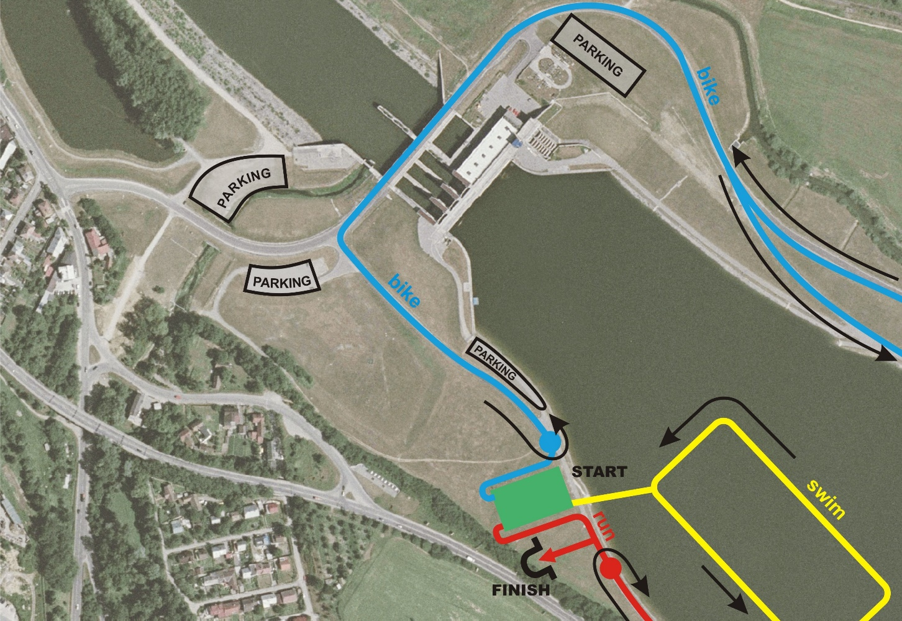

**2.2 COURSE FAMILIARIZATION**

August 18, Saturday

15:30 – 16:30 Run course familiarization Water dam Zilina

16:00 – 17:30 Bike course familiarization Water dam Zilina

16:30 – 17:30 Swim course familiarization Water dam Zilina

**2.3. ATHLETE’S LOUNGE**

Athlete´s lounge is located near the transition area on water dam Zilina. It provides toilet, water and ISO drinks

**2.4. ATHLETES’ RACE PACKAGE**

August 18, Saturday

15:00 – 19:00 race package pick up River club, Water dam Zilina

**2.5. DOPING CONTROL**

Doping tests will be conducted according to ITU/WADA rules. The athletes must carry their identification to the doping control facilities.

**2.6. SECURITY**

Promoter accepts no competitor for responsibility for any injury, and property.

Compete with the existing rules by the ITU for the European junior Cup 2018. Local police of Zilina and security company will provide the security for the event.

All competitors participate at their own risk.

**2.7. LOC OFFICE**

eXtreme park, Cesta na Mojš 1375, Žilina

18.07.2018, 14:00 – 17:00

contact: Tomáš Jurkovič, [jurkovic.t@gmail,.com](mailto:jurkovic.t@gmail,.com), 00421 904 457 419

|  |
| --- |
| 3. ACCOMMODATION |

For accommodation you can use many hotels and hostels in Žilina. We recommend following:

1. Hotel HOLLIDAY INN ŽILINA

Športová 2, 01001, Žilina

Reservations: [reservations@holidayinn-zilina.sk](mailto:reservations@holidayinn-zilina.sk)

Tel.number: [+421(0)41 5050 120](tel:+421%2041%205050%20120)

www: <http://holidayinn-zilina.sk/>

1. Hotel DUBNÁ SKALA

J.M.Hurbana 345/8, 01001, Žilina

Reservations:  [hoteldubnaskala@doxx.sk](mailto:hoteldubnaskala@doxx.sk?subject=Recepcia)

Tel.number: +421 41 5079 100

www: <https://www.hoteldubnaskala.sk/>

For accommodation in Hostel please contact:

Jurkovic.t @gmail.com

|  |
| --- |
| 4. TRANSFER AND TRANSPORT |

**Closest Airports:**

Bratislava airport (BTS) – 200 km

Vienna airport (VIE) – 260 km

Krakow airport (KRK) – 220 km

Budapest airport (BUD) – 360 km

**Local Transportation:**

It is possible to arrange transport from airports, please contact: [jurkovic.t@gmail.com](mailto:jurkovic.t@gmail.com)

minibus for 8 person ( in case max 5 people, possible 3-4 bikes and luggage )

* Bratislava – Zilina – 150€ (one way)
* Vienna – Zilina – 210€ (one way)
* Budapest – Zilina – 320€ (one way)

If you want to arrange transport, please write as soon as possible your flight details and number of persons and bikes.

|  |
| --- |
| 5. ATHELETE’S SERVICES |

**5.1. TRAINING FACILITIES**

SWIM

Open water swim on water dam Zilina is possible at any time except Saturday local races

Swimming pool Zilina (50m) – street: Vysokoškolákov 8, Zilina

Opening hours daily 06:00 – 21:00

<http://www.plavarenzilina.sk/>

contact: +421/41/5655073, plavaren@plavarenzilina.sk

 BIKE

Safe bike location is from water dam Zilina direction Mojš, Varín and back or an 8km loop around water dam Zilina.

It is accessible at any time except Saturday local races.

 RUN

8km loop around water dam Zilina, absolutely without cars, It is accessible at any time except Saturday local races.

Athletic stadium (400m) – Vysokoškolákov 26, Zilina

**5.2. MEDICAL SERVICES**

First Aid and Emergency Medical Services will be available at the Registration area before and during the training sessions and during the race. There will be First Aid and Emergency Medical Services at the Race Village on competition day.

Medical and Paramedical personnel will be available throughout the race. Several ambulances will be available to provide emergency transfers to a nearby hospital. A medical area will be provided on site at the finish area.

Medical services at the venue are free of charge. Treatment in hospitals are to be paid by participants. Athletes / teams should make sure that they have appropriate medical insurance.

Medical rescue service at race venue:

Doctor of the race: Mudr. Pazderková Emília

Race day: 19.8.2018 - 09:00 – 18:00 for athletes

Closest hospital address:

**Hospital Zilina: Žilinská nemocnica s poliklinikou, Vojtecha Spanyola 43, Žilina**

**5.3. BIKE MECHANICAL SERVICE**

Kubica sport (Bike shop)

Adress: Pri celulózke 1391/47, 010 01 Žilina, Slovensko

500m from race venue

|  |
| --- |
| 6. COMPETITION SCHEDULE |

**6.1. junior WOMEN**

|  |  |  |  |  |
| --- | --- | --- | --- | --- |
| DAY | START | END | ACTIVITY | LOCATION |
| 18.8 | 18:00 | 19:00 | Athlete’s briefing | River club, Water dam Zilina |
| 18.8 | 15:00 | 18:00 | Athlete registration | River club, Water dam Zilina |
| 19.8 | 11:30 | 12:30 | Athlete Lounge check in | Water dam Zilina |
| 19.8 | 12:15 | 12:45 | TA check in | Transition area |
| 19.8 | 12:15 | 12:45 | Swim warm-up | Start area |
| 19.8 | 12:45 | 12:50 | Calling area | Start area |
| 19.8 | 12:50 |  | Athletes introduction | Start area |
| 19.8 | 13:00 |  | Start | Start area |
| 19.8 | 17:00 |  | Award Ceremony | Water dam Zilina |

**6.2. junior MEN**

|  |  |  |  |  |
| --- | --- | --- | --- | --- |
| DAY | START | END | ACTIVITY | LOCATION |
| 18.8 | 18:00 | 19:00 | Athlete’s briefing | River club, Water dam Zilina |
| 18.8 | 15:00 | 18:00 | Athlete registration | River club, Water dam Zilina |
| 19.8 | 11:30 | 12:30 | Athlete Lounge check in | Water dam Zilina |
| 19.8 | 14:00 | 14:40 | TA check in | Transition area |
| 19.8 | 14:15 | 14:45 | Swim warm-up | Start area |
| 19.8 | 14:45 | 14:50 | Calling area | Start area |
| 19.8 | 14:50 |  | Athletes introduction | Start area |
| 19.8 | 15:00 |  | Start | Start area |
| 19.8 | 17:00 |  | Award Ceremony | Water dam Zilina |

**6.3. COMPETITION RULES**

The event will follow the latest published Competitions Rules of the International Triathlon Union.

**6.4. ATHLETE’S BRIEFING**

August 18, Saturday

18:00 – 19:00 – River club, Water dam Zilina

Athletes briefing is mandatory

**6.5. TIMING CHIPS**

On race day athletes will be given a timing chip, to be worn on the athletes’ ankle. Athletes will pick up the timing chips before the competitions, during their check-in procedure.

**6.6. RESULTS**

Results will be uploaded live at the ITU official website www.triathlon.org.

All the Results information will be distributed to the Team Leaders at the LOC office.

**6.7. PROTEST & APPEALS**

Standard procedures will be followed according to the ITU Competition Rules

|  |
| --- |
| 7. ACCREDITATION |

The LOC will provide all the Organizing Committee Members, ITU Technical Officials, Athletes, VIPs, media, technical staff, court personnel, volunteers, etc. with an official Accreditation Card.

August 18, Saturday

14:00 – 17.00 Accreditation to the race River club, Water dam Zilina

Only accredited people will be allowed to access certain venue areas. Accreditation Cards provide access to specific areas of the competition areas. All accredited people are requested to carry their Accreditation Cards with them at all times and to show them upon request. Accreditation Cards are mandatory to enter the venue.

|  |
| --- |
| 8. COURSE MAPS |

SWIM COURSE

Start procedures: in-water start

The Race Referee with assistance of Technical Officials, who are assigned to the start, will start each race.

Number of laps: 1

Average water temperature: 19-23 degrees

Swim course is marked yellow.

TRANSITION 1

A flow through transition has been developed to keep athletes moving forward. Athletes enter the transition and must deposit swim gear in a bin placed beside the bike racks. Athletes' names and/or numbers are displayed on the top of each bike rack. After the helmet is secured, athletes un-rack the bike by moving forward into the centre lane and towards the mount line

 BIKE COURSE

Bike course is flat, with 2 small hills (about 100-200 metres) in each lap. Bike course is closed for traffic.

Number of laps: 3

Bike course is marked blue.

Wheel stop is next to the transition area (possible to use in every bike lap)

TRANSITION 2

From the dismount line, athletes enter the transition area on one side and must deposit bike gear on their marked place. Athletes' names and/or numbers are displayed on the top of each bike rack. After bike and bike gear is on the spot, athlete start running on the other side of the transition area.

Running shoes may be placed beside the rack or in the bin.

RUN COURSE

Run course is absolutely flat, asphalt surface.

Number of laps: 2

Aid station: 1 each lap, near transition area.

Penalty box: near transition area, see location on map.

Run course is marked red.

