INFORMATION BULLETIN

2017 Aqaba ASTC Sprint Triathlon / Duathlon Asian Cup and West Asian

& Arab Championships

6th October 2017 Aqaba, Jordan

The Organizing Committee of the 2017 ASTC Asian Cup & West Asian & Arab Championships, hereby notifies and invites all Asian affiliated Federations & Arab Federations to participate in the 2017 Ayla Oasis Asian Triathlon/Duathlon Race & Arab championships in Aqaba, Jordan on the following basis:

1. HOST, PLACE AND DATE OF COMPETITIONS

Jordan Triathlon Association have established an Organizing Committee, which shall be in charge of the preparation and organization of the competition under the supervision of ASTC.

The events will be held in Aqaba City ( Jordan ) - AYLA Oasis on:

Date of competition: 6 October 2017

2. ORGANIZING COMMITTEE ADDRESS

Federations & participants should communicate with the Organizing Committee through:
Telephone/Fax:
T: + 962 776 742472 & + 962 777 772777
F: + 962 6 4646855
Emails: ammarsat@gmail.com & inaddeh@ten.com.jo

3. ELIGIBILITY

National athletes, with citizenship of the countries, of the Asian Member Federations / Associations & the Arab Triathlon Federations / Associations.
All entries must be accompanied by photocopies of the Passport. All documents must be certified by President / Secretary General of National Federation. Entries not supported by the documents will be automatically rejected.

4. ENTRY FEES

The Entry Fee to the event will be US $ 100

5. REGISTRATION, NOTIFICATION AND ENTRY FORMS

There will be three successive entry forms to provide information to the Organizing
Committee and to enter the Championships. The entry forms are as follows:

- Preliminary Entry Form to be received by the Organizing Committee;

no later than 6th August 2017

The Preliminary Entry Form is for the purpose of registering National Federations & Athletes. This Preliminary Entry Form, attached, must be returned, and received by the Organizing Committee not later than 6th August 2017.

- Final Entry Form to be received by the Organizing Committee;

no later than 6th September 2017

The Final Entry Form will register each athlete by name, indicating the event in which that competitor will be participating, and providing any other information to the Organizing Committee. This form, attached, must be returned and received by the Organizing Committee by 6th September 2017. No late entries will be accepted.

All entry forms must be signed by the President or General Secretary of the Federation.

6. PRIZES

Finishing a Triathlon or Duathlon is an achievement in itself, and as a recognition of the athletes hard work Jordan Triathlon Association in cooperation with Ayla Oasis will provide the following prizes:
USD 10000 for Men & Women Elite Triathlon
USD 10000 for Men & Women Elite Duathlon
USD 5000 for MEN & Women for U23 & U19 Triathlon
USD 5000 for MEN & Women for U23 & U19 Duathlon

Also a number of sponsored prizes will be provided to the Age group athletes.

7. RACE INFORMATION

The race will be run over the AYLA Course, see below:

Triathlon | Duathlon
Swim course: 750m Open water  Number of laps:1  Water temperature:25℃c  Bike course:20km  Number of laps:4 laps  Run course:5km  Number of laps:2 laps | Run course:5km  Number of laps:2 laps  Bike course:20km  Number of laps:4 laps  Run course:2.5km  Number of laps:1 lap

For the triathlon only and only for age groups, we also offer a team relay category, for teams of 3 or 2 participants. For the triathlon relay each member must complete at least one of the sections of the race, i.e. the first athlete will cover the swimming session, the second the cycling, and the third the running section.

Race & Location Map:
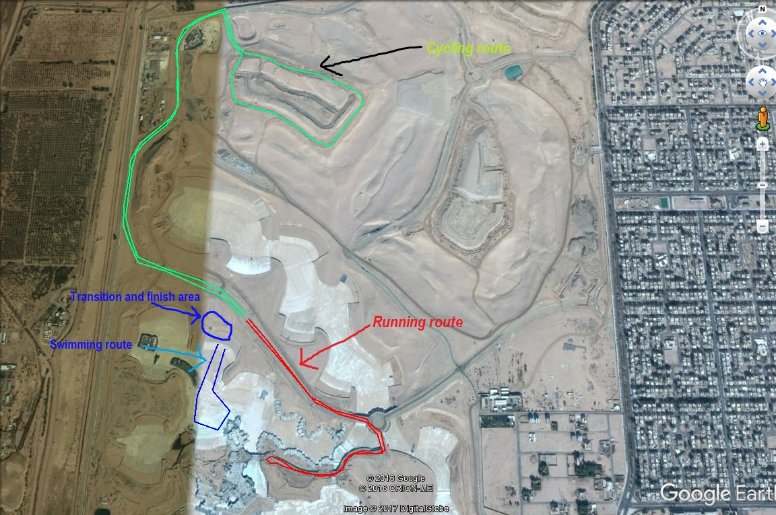

Blue line: Swimming 1 lap. Red line: Cycling 4 laps. Green line: Running 2 laps
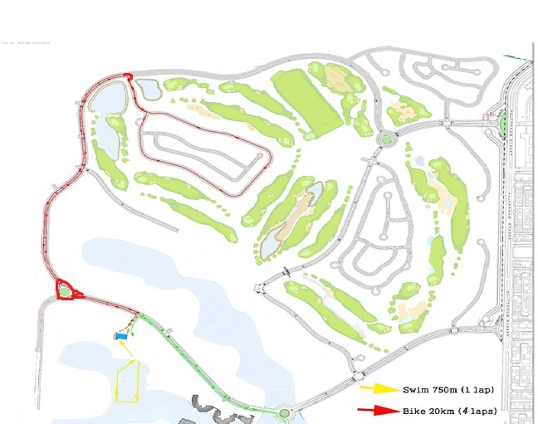

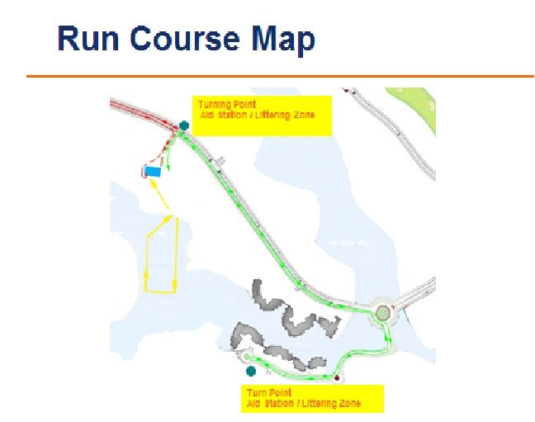

8. RULES

The Championship will be held under ASTC / ITU Rules and Regulations.

9. Judges & Officials

Judges & Official will be approved by ASTC.

10. TEAM LEADERS / MANAGERS and TECHNICAL OFFICIALS MEETINGS

The meetings will be held on the day before the Competition:

Team Leader & Managers Meeting | 5 / OCT | 16:00 P.M

11. Ability Requirement:

The expected finish times are between 1 hour for an Elite athlete and 1 1/2 to 2 hours for Age Group athletes. All competitors must sign a waiver to compete. The swim is in a huge man made pool, with life guards present at all times. The cycle section is on closed roads inside the resort. The cycling route will be two laps, and the elevation is mostly flat. The running is 2 laps on a smooth tarmac taking athletes to the shores of the red sea and back to the finish line. Competitors in the triathlon must be competent swimmers.

12. Cycling:

The route is on smooth fully closed private road, so hopefully there should be no issues with flat tyers. However cyclists will face a number of speed bumps on the route. A wheel station along the route will be provided for athletes who wish to put their spare wheels, if athletes do get a flate tyre they should reach the station to change their wheel.

12. Health and Safety:

We will do our utmost to keep you safe. There will be an ambulance and first aid professionals present at the start area of the course. There will be lifeguards overseeing the water safety, and the run and cycle legs will be lined with marshals to keep an eye on everyone.

13. ACCREDITATION & Numbers

Accreditation Cards will be provided to each athletes, coaches, officials on the 4th & 5th Octobar at the Accreditation center.
Participants Numbers will be provided to each participating athlete on the 5th Octobar at the Accreditation center.

14. TRANSPORTATION

Airport Information: King Hussein International Airport - Aqaba

The Organizing Committee will welcome all members of the participating National Federations at the King Hussein International Airport -Aqaba.

The Organizing Committee will provide local transportation from / to Airport & from / to Hotel and competition venues for Teams / Athletes which are accommodated in hotels thorough the Organizing Committee.

The Organizing Committee will not provide local transportation from / to Airport & from / to Hotel and competition venues for Teams / Athletes which are accommodated in hotels not thorough the Organizing Committee.

Airport Transportation Services:

- From Airport to Hotel - USD 25 per person
- From Hotel to Airport - USD 25 per person

Land Transportation from Queen Alia International Airport ( Amman ) to Aqaba City will be advised as soon as soon as you confirm flight details and number of participants.

To be able to arrange Airport Transportation, the Organizing Committee must receive Travel Information Form and Hotel Reservation form by 10 September 2017.

15. ACCOMMODATION

The Organizing Committee will organize accommodation to all participating Teams. The official hotel for all the participating athletes and officials will be as follows:

Double Tree Hilton (5*) - Aqaba

Room rates Bed & Breakfast are:
Single: 130 USD (BB) per night/per person
Double: 85 USD (BB) per night/per person

Rates per Meal per person ( Dinner ) - USD 30 each

To avoid cancellation charges, the Accommodation section must be notified of any amendments or cancellation latest by 10 September 2017.

16. Entry VISA

For all participants & officials that require an entry visa prior to departing to Jordan, should contact the Jordanian Embassy or Jordanian Consulate in their country in order to obtain entry visa.

The Organizing Committee, can provide an invitation letter, if requested, provided that copies of a valid passport for all athletes & officials are sent with the request.

* For information about which countries and regions need to acquire VISA to enter Jordan and what kind of documents are necessary, please visit the website of the Ministry of Foreign Affairs of Jordan at; http://www.jordan.gov.jo
/Last Date to accept invitation letter request : no later than 10 September 2017

