INFORMATION BULLETIN

Ayla Championship

2019 Aqaba ASTC Triathlon Asian Cup

27th September 2019 Aqaba, Jordan

Welcome to the 4^{th “}Ayla championship” Aqaba ASTC Triathlon Asian Cup.

Following the success of the previous year’s Jordan Triathlon Association (JTA) and the race Local Organizing Committee (LOC) are happy to announce the 4th “Ayla championship” Aqaba Asian Cup with bigger organization and more prize money.

1. HOST, PLACE AND DATE OF COMPETITIONS:

Jordan Triathlon Association have established a Local Organizing Committee, which shall be in charge of the preparation and organization of the competition under the supervision of ASTC.

The events will be held in Aqaba City (Jordan) in AYLA Oasis resort on:

Date of competition: 27 September 2019

2. ORGANIZING COMMITTEE ADDRESS:

Federations & participants should communicate with the Organizing Committee through:

Telephone/Fax:

T: + 962 77 7772777 & + 962 77 6742472
F: + 962 6 4646855
Emails: inaddeh@ten.com.jo & ammarsat@gmail.com

3. PRIZES:

Finishing a Triathlon is an achievement by itself, and as a recognition of the athlete’s hard work Jordan Triathlon Association in cooperation with Ayla Oasis will provide 20000 USD prize money on the following basis:
  - USD 10000 for Men Elite Triathlon
  - USD 10000 for Women Elite Triathlon

4. ENTRY FEES:

The Entry Fee to the event will be US $ 100

5. REGISTRATION, NOTIFICATION AND ENTRY FORMS:

There will be two successive entry forms to provide information to the Organizing
Committee and to enter the Championships. The entry forms are as follows:

The Preliminary Entry Form is for the purpose of registering National Federations & Athletes. This Preliminary Entry Form, attached, must be returned, and received by the Organizing Committee not later than 10th June 2019.

The Final Entry Form will register each athlete by name, indicating the event in which that competitor will be participating, and providing any other information to the Organizing Committee. This form, attached, must be returned and received by the Organizing Committee by 10th August 2019. No late entries will be accepted.

6. JUDGES & OFFICIALS:

Judges & Official will be assigned by ASTC/ITU.

7. RULES:

The Championship will be held under ASTC / ITU Rules and Regulations.

8. DOPING CONTROL:

Doping Control will be performed according to the ITU/WADA/JADA rules.

9. TEAM LEADERS / MANAGERS and TECHNICAL OFFICIALS MEETINGS:

The meetings will be held on the day before the Competition:

Team Leader & Managers Meeting | 26th SEPT | 16:00 P.M

10. ACCREDITATION & NUMBERS:

Accreditation Cards will be provided to each athletes, coaches, officials on the 25th & 26th September at the Accreditation center.
Participants Numbers will be provided to each participating athlete on the 26th September at the Accreditation center.

11. RACE INFORMATION:

The race will be run over the AYLA Course, see below:

Triathlon
Swim course: 1500m Open water (Closed man made resort lagoon)
Number of laps: 2
Water temperature:25℃c
Bike course:40km
Number of laps:8 laps (Fully Closed course)
Run course:10km
Number of laps:4 laps (Fully Closed course)

For the triathlon only and only for age groups, we will also offer a team relay category, for teams of 3 or 2 participants. In this triathlon relay each member must complete at least one of the sections of the race, i.e. the first athlete will cover the swimming session, the second the cycling, and the third the running section.

Race & Location Map:

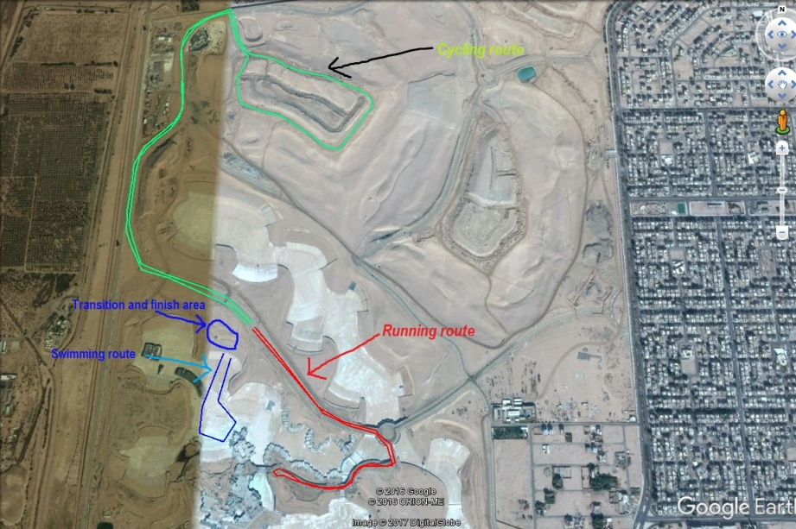

Blue line: Swimming 2 lap. Red line: Cycling 8 laps. Green line: Running 4 laps
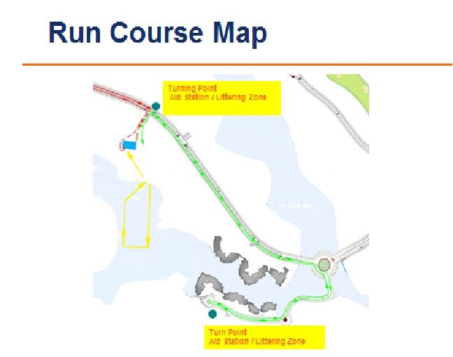
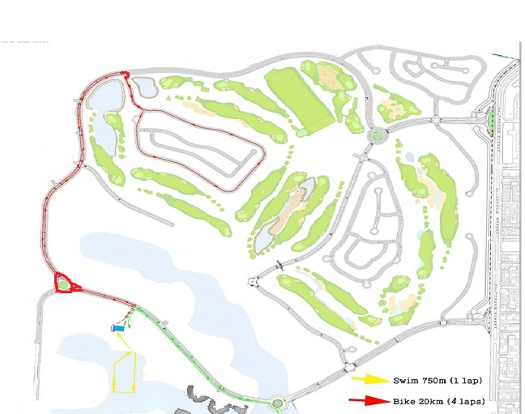

12. ABILITY REQUIREMENT:

The expected finish times are between 1 hour for an Elite athlete and 1 1/2 to 2 hours for Age Group athletes. All competitors must sign a waiver to compete. The swim is in a huge man made pool, with life guards present at all times. The bike leg is on closed roads inside the resort. The bike route will be four laps, on a mostly flat road. The running is 2 laps on a smooth tarmac taking athletes to the shores of the red sea and back to the finish line. Competitors in the triathlon must be competent swimmers.

13. CYCLING:

The route is on smooth fully closed private road, so hopefully there should be no issues with flat tires. However, cyclists will face a number of speed bumps on the route. A wheel station along the route will be provided for athletes who wish to put their spare wheels, if athletes do get a flat tire they should reach the station to change their wheel.

14. HEALTH & SAFETY:

We will do our utmost to keep you safe. There will be an ambulance and first aid professionals present at the start area of the course. There will be lifeguards overseeing the water safety, and the run and cycle legs will be lined with marshals to keep an eye on everyone.

15. ACCOMMODATION:

The Organizing Committee will organize accommodation to all participating Individuals & Teams in Aqaba.

Room rates Bed & Breakfast are:

- Single:100 USD (BB) per night/per person
- Double: 65 USD(BB) per night/per person

To avoid cancellation charges, the Organizing Committee must be notified of any amendments or cancellation latest by 10 August 2019.

16. TRANSPORTATION:

Airport Information: King Hussein International Airport - Aqaba

The Organizing Committee will welcome all members of the participating National Federations at the King Hussein International Airport-Aqaba.

The Organizing Committee will provide local transportation from / to Aqaba Airport & from/to Hotel and competition venues for Teams / Athletes which are accommodated in hotels thorough the Organizing Committee.

The Organizing Committee will not provide local transportation from / to Aqaba Airport & from/to Hotel and competition venues for Teams / Athletes which are accommodated in hotels not thorough the Organizing Committee.

Land Transportation charges from Queen Alia International Airport (Amman) to Aqaba City will be advised as soon as you confirm flight details and number of participants.

To be able to arrange Airport Transportation, the Organizing Committee must receive Travel Information Form and Hotel Reservation form by 10 August 2019.

17. ENTRY VISA:

For all participants & officials that require an entry visa prior to departing to Jordan, should contact the Jordanian Embassy or Jordanian Consulate in their country in order to obtain entry visa.

The Organizing Committee, can provide an invitation letter, if requested, provided that copies of a valid passport for all athletes & officials are sent with the request.

* For information about which countries and regions need to acquire VISA to enter Jordan and what kind of documents are necessary, please visit the website of Jordan Tourism Board at; http://international.visitjordan.com/generalinformation/entryintojordan.aspx

Last Date to accept invitation letter request : no later than 10 August 2019

