Distance

Bike　40kｍ×1

Run

Underpass

Run 1st Lap/2.5km

Run 2nd Lap/1.5km

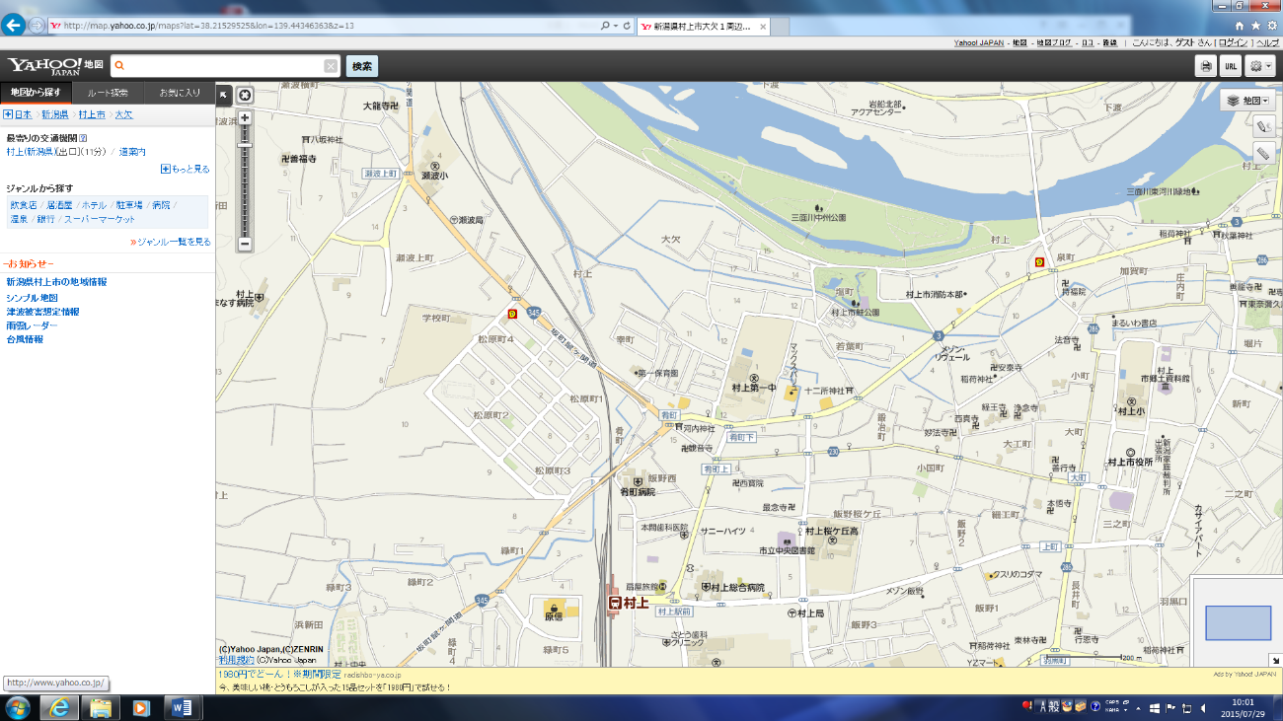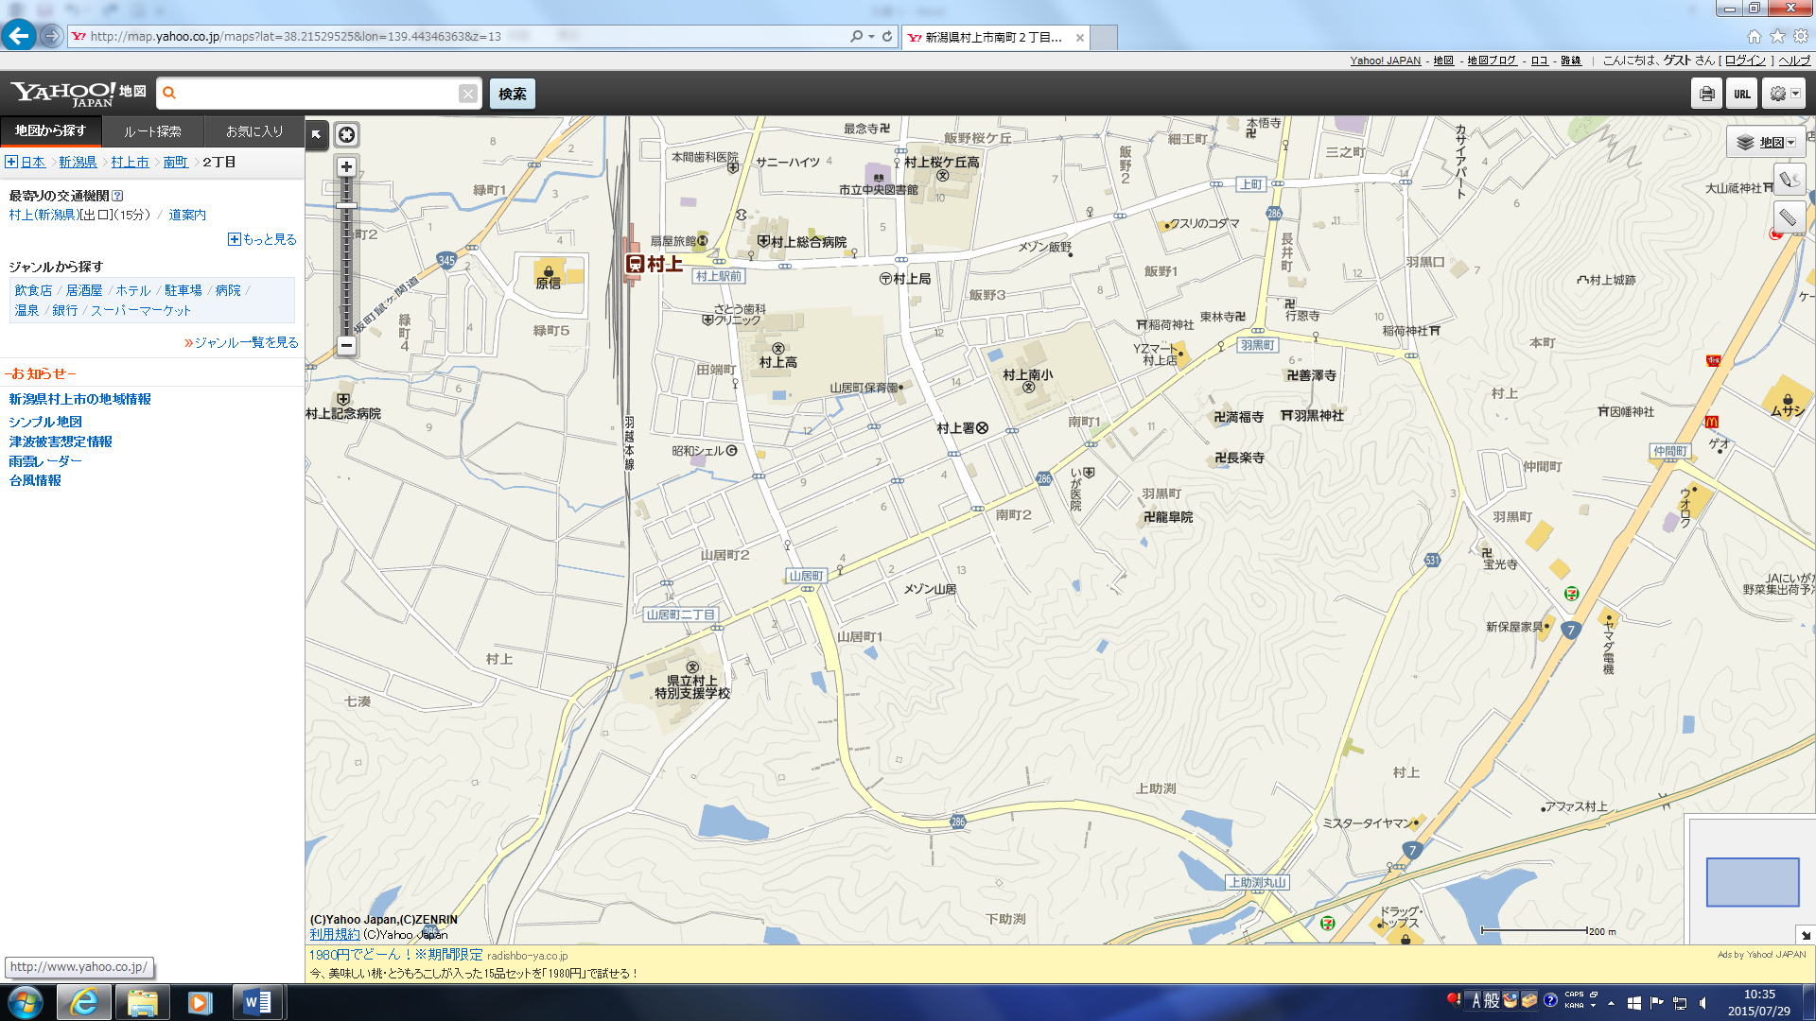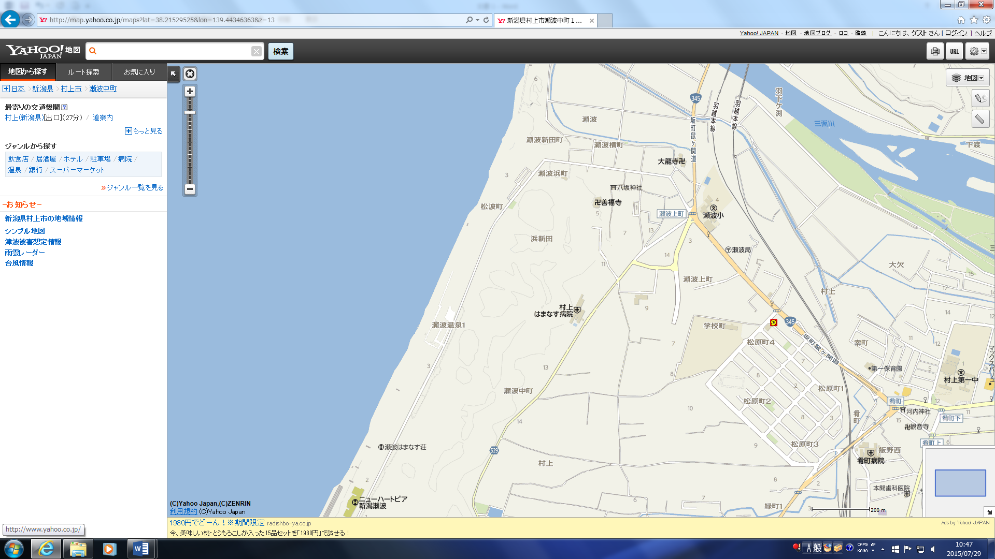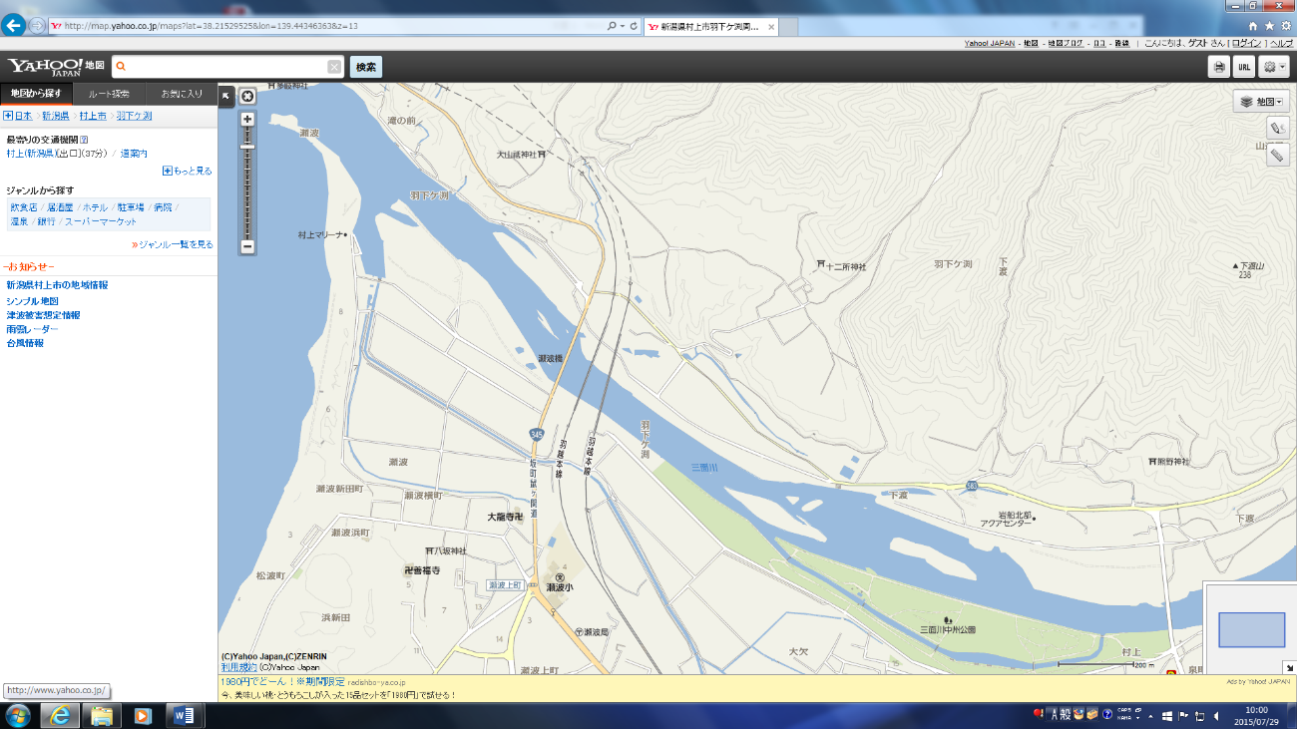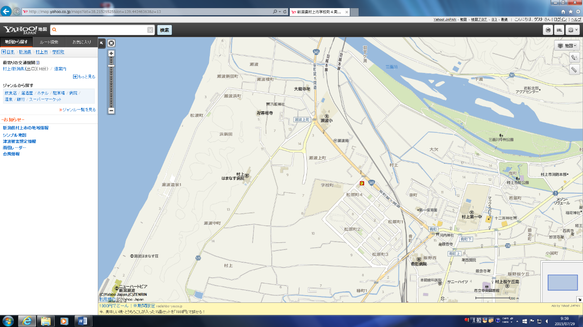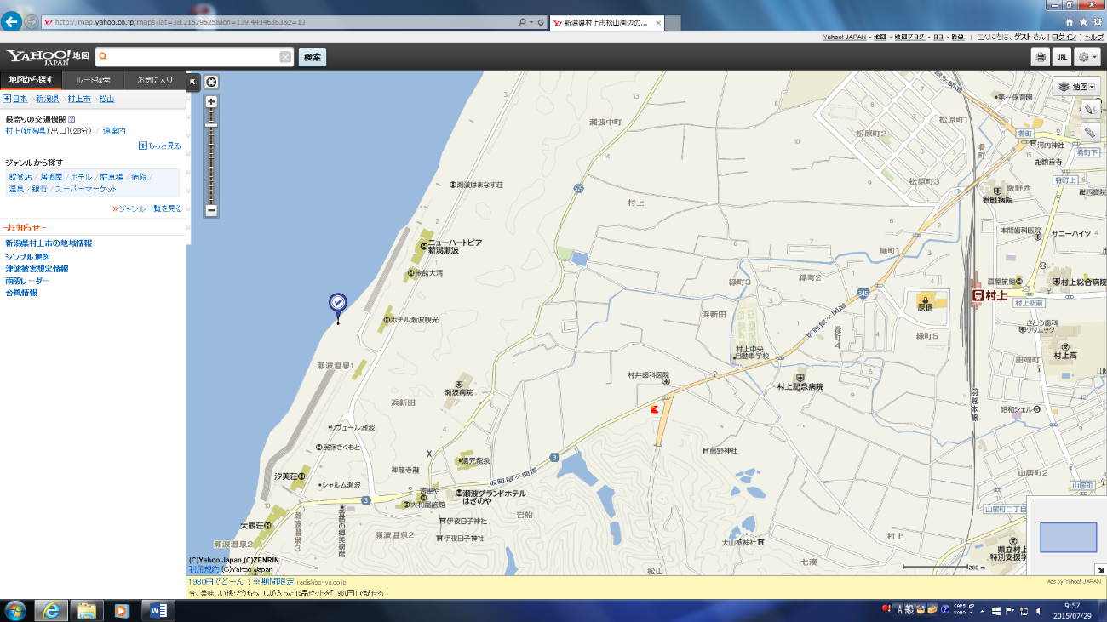

９ｋ

6ｋ

**FINISH**

**↓**

8ｋ

５ｋ

７ｋ

4ｋ

3ｋ

2ｋ

１ｋ

**Swim Start**

**Run Start**

**Bike**