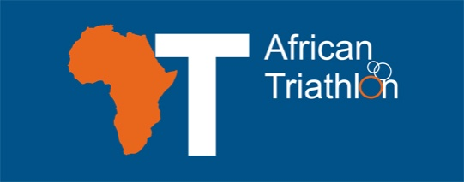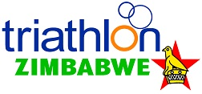

ATU HARARE/ZIMBABWE CAMP 2020
HEAD COACHES
PAMELA FULTON
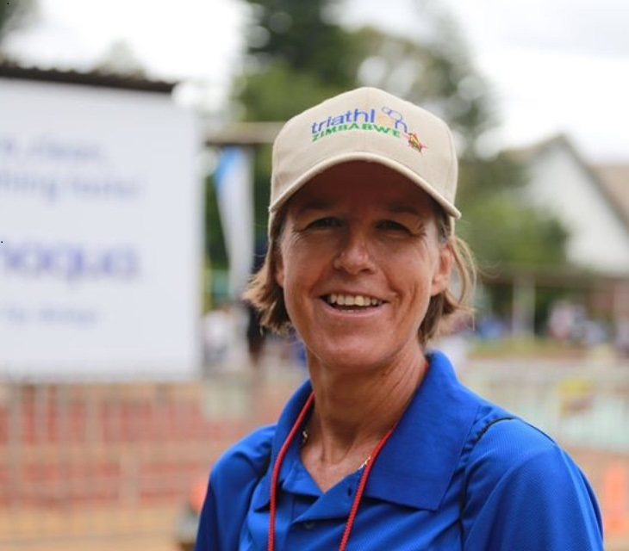
30 YRS INVOLVED IN TRIATHLON, ELITE TRIATHLETE 1991-2013, ITU LEVEL 2 COACH 2017, ITU LEVEL 1 TECHNICAL OFFICIAL, ACE PERSONAL TRAINER 2005, WSLA COURSE 2019
RIANA ROBERSTON
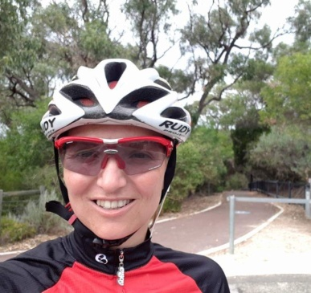
20 YEARS INVOLVED IN TRIATHLON AS AN ELITE AND AGE GROUP TRIATHLETE AND ALSO AS A COACH.
FULL TIME COACH, OPERATING WITH DINAMIC PRACTICE IN GAUTENG SOUTH AFRICA.
ITU LEVEL 2 COACH, TSA LEVEL 2 COACH FACILITATOR, SWIM SMOOTH ACCREDITED COACH, BSC IN SPORTS SCIENCE

FACILITATORS
DEBBIE JEANS
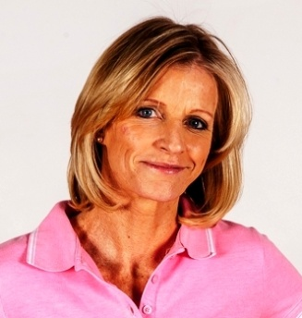
BSc (Hons) Psych, ACSM Exercise Physiologist, CETI Cancer Exercise Specialist, ACE Personal Trainer & Group Fitness Instructor, Group Fitness Director: Innovate Sport & Health
Sporting Career - Judo: 3 time African Champion, 2 time Olympian, World Referee
SESSIONS: “Creative Core & Myofascial Stretching for Peak Performance”
“The mindset of a winner. Lessons from Kobe Bryant.”

DR AUSTIN JEANS
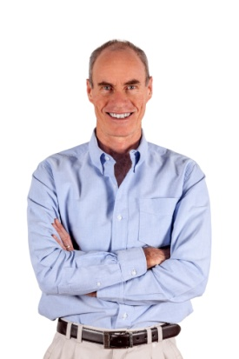
Sports Medicine Physician, Medical Director & CEO Innovate Sport & Health, Zimbabwe Triathlon Selector, Age Group Triathlete, World Rugby Medical Trainer, World Rugby Medical Commission Member, Zimbabwe Olympic Committee Medical Commission Member
SESSIONS: “First Aid for Triathletes”
“WADA awareness”

KEEGAN COOKE
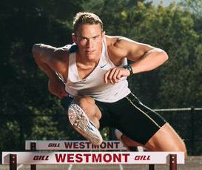
Neuromuscular Systems Intensified Trainer, Sport Science Lab Affiliate and Trainer
SESSIONS: “Run drills WHY-HOW-WHEN”
“Gym-maintaining the body for peak performance"

GIDEON BENADE
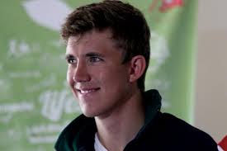
ITU LEVEL 2 Coach, ACE Personal Trainer, Level 1 Group Fitness Instructor, Level 1 Technical Official
SESSIONS: “Pre race cycle”
DIRK VILJOEN
MD SAND Promotions
SESSION: “Facing the media”

