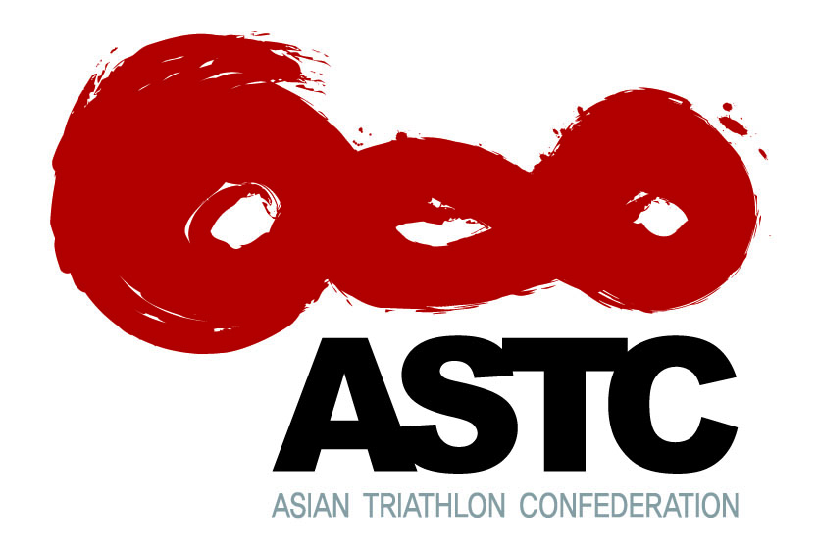
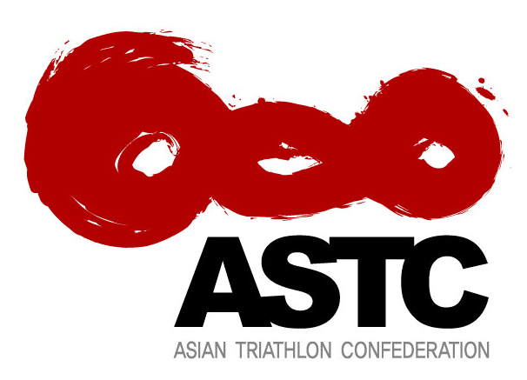
APPLICATION FORM
2014 Kuala Lumpur ITU Technical Official
Level 1 Seminar
5-6 April 2014 – Kuala Lumpur, Malaysia

Full Name (Last Name, First Name)(as worded on passport)
Nationality
Passport Number
Date of Birth(dd/mm/yy)
E-mail address(s)
Phone Number(s)  (home, cell, fax) | Home:
 | Cell:
 | Fax:
Male / Female(please indicate) | Male | Female
Mailing address
Medical Insurance Details (insurance plan and number)Please fax a copy of insurance certificate with this fax
Please indicate if you have any special nutritional requirements.
TO Experience: Must be an Certified NTO. Please list previous coaching experience and certifications obtained.
Please list name and contact phone number and email of at least TWO contacts we can use in the case of an emergency.

Forms emailed to: Ki, Woo Kyong - tri@triathlon.or.kr
Closing date for applications: March 31st, 2014

