BIKE SADDLE POSITION FORM
All requests for a bike saddle position outside the World Triathlon CR 5.2.b) (i) 4th bullet point, must be submitted by the corresponding National Federation in writing for World Triathlon approval at least one (1) month before the event in which the athlete wishes to compete in.
The solicitant will be informed by the World Triathlon on the outcome of the request once the panel has reviewed the information. If accepted, the information will be incorporated to the “Approved bike saddle position in draft legal events” file located on the World Triathlon website under http://www.triathlon.org/about/downloads/category/rules.
Athletes' name
Athletes' gender
Athletes' NF
Value in CM of the requested new bike saddle position measured from the vertical line passing through the centre of the chain wheel axle and the vertical line touching the front-most point of the saddle
REASON for the request
Additional anthropometric measurements  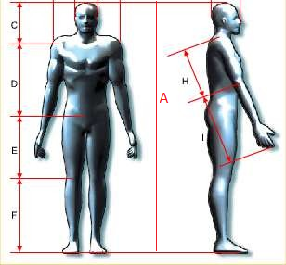 | A |  | F
 | C |  | H
 | D |  | I
 | E
 | Type and size of bicycle frame that the athlete is using:
Submitted by NF’s representative: | Name
 | Position
 | Telephone
 | Email

Please submit the form to  thanos.nikopoulos@triathlon.org | WORLD TRIATHLON APPROVED | YES |  | NO

