**SERBIAN TRIATHLON UNION**

**would like to welcome you to the**

**ETU Junior European Cup, Belgrade 2020**

**ATHLETE’S GUIDE**

Triathlon Junior European Cup Belgrade 2020

SUPER SPRINT

distance

400m – 12km – 2,5km

|  |  |  |
| --- | --- | --- |
|  |  |  |

TABLE OF CONTENTS

|  |  |
| --- | --- |
|  | page |
| 1. GENERAL INFORMATION  1.1 INTRODUCTION  1.2 COVID MEASURES  1.3 KEY DATES  1.4 KEY CONTACTS  1.5 CONTACT DETAILS | 3  4 |
| 2. VENUE  2.1 RACE VENUE  2.2 COURSE FAMILIARIZATION  2.3 ATHLETE’S LOUNGE  2.4 ATHLETES’ RACE PACKAGE  2.5 DOPING CONTROL  2.6 SECURITY  2.7 LOC OFFICE | 4  5 |
| 3. ACCOMMODATION | 5 |
| 4. TRANSFER AND TRANSPORT | 6 |
| 5. ATHELETE’S SERVICES  5.1 SWIM AND BIKE TRAINING  5.2 MEDICAL SERVICES  5.3 BIKE MECHANICAL SERVICE | 7 |
| 6. COMPETITION SCHEDULE  6.1 JUNIOR WOMEN  6.2 JUNIOR MEN  6.3 COMPETITION RULES  6.4 ATHLETE’S BRIEFING  6.5 TIMING CHIPS  6.6 RESULTS  6.7 PROTEST & APPEALS | 8  9 |
| 7. ACCREDITATION | 9 |
| 8. USEFUL INFORMATION  8.1 LANGUAGE  8.2 POPULATION  8.3 CURRENCY  8.4 TIME  8.5 ELECTRICITY  8.6 WATER  8.7 TELEPHONE CONNECTIONS | 10 |
| 9. COURSE MAPS | 10 |

|  |
| --- |
| 1. GENERAL INFORMATION |

**1.1. INTRODUCTION**

Despite the difficult circumstances the organizing committee wishes to welcome all athletes, coaches, team leaders and other people involved to the 2020 ETU Triathlon Junior European Cup in Belgrade.

As known to everyone this has been a very difficult period with a lot of uncertainties. Nonetheless the Serbian Triathlon Federation, the local authorities and last but not least, the organizing team have put in a lot of effort to realize a good event, where the safety of the athletes, volunteers and support can be guaranteed.

Evidently the event comes with quite a few requirements and measures, compared to last year. But we are confident everyone understands the importance of these necessary modifications. Therefore we would like to advice to take note of these facts, as pointed out in this athlete’s guide.

Apart from this guide it is wise to regularly check the website, as details might still change during these last weeks. Should there still be things unclear, the event office is more than happy to provide the information needed.

**1.2. COVID MEASURES**

The following measures must be followed by the athletes, once entering the venue.

In the entire ETU junior cup race zone wearing a safety face mask is mandatory.

Inside the race zone, including registration, the flows to follow are indicated and mandatory. Further below a map with these flows can be found.

Wearing the mask is also required during line up in the pre-start zone. Once the announcer calls on the athlete to enter the starting mat, the competitor takes off the mask and deposits this in a safe garbage bag.  
Post finish protocol:  
After entering the finish zone, the competitor is led further to the recovery zone, where a protective face mask is given, which the athlete has to wear inside the race zone.  
Medal award ceremony:  
Competitors who are called to the podium for the announcement of the winner of the ETU Junior Cup race in Belgrade, are required to wear the branded face masks provided by the LOC at the registration.

**1.2. KEY DATES**

|  |  |
| --- | --- |
| **19.9.2020 Saturday** |  |
| 18:00 | Race briefing: Live streaming / on-line presentation |
| **20.9.2020 Sunday** |  |
| 9:00 | Athletes’ Lounge open |
| 9:20 – 10:00 | Registration, package pick up & check in Junior men |
| 10:40 | Start presentation - junior men – in the start area |
| **10:50** | **START**–ETU Junior Cup race man |
| 10:10 - 10:50 | Registration, package pick up & check in for Junior female |
| 11:20 | Start presentation - junior women – in the start area |
| **11:30** | **START**–ETU Junior Cup race woman |
| 12:10 – 12:30 | Medal ceremony |
| 12:00 - 12:45 | Transition Area Check–out |
| 12:45 | Athletes’ Lounge close |

**1.3. KEY CONTACTS**

*Race director* Ivan Budja [ivanbudja@gmail.com](mailto:ivanbudja@gmail.com), +381 63 335 722

*Technical delegate* Michiel van Niekerk vanniekerk@casema.nl, +316 26978686

*Ass. Technical delegate* Ljudmila Medan [ljudmila.medan@gmail.com](mailto:ljudmila.medan@gmail.com), + 381 64 150 56 51

Athlete Services Ljudmila Medan [ljudmila.medan@gmail.com](mailto:ljudmila.medan@gmail.com), + 381 64 150 56 51

*NF General Secretary* Simo Cickovic [simo.cickovic@gmail.com](mailto:simo.cickovic@gmail.com), +381 637060345

**1.4. CONTACT DETAILS**

Local Organizing Comittee: Belgrade Triathlon Union (Triatlon Savez Beograda).

Address: Ariljska 2, 11000 Belgrade, Serbia.

President Darko Savic, darkossa@gmail.com, tel

General Secretary Ivan Budja, [ivanbudja@gmail.com](mailto:ivanbudja@gmail.com)

Web page: [www.triazavas.rs](http://www.triazavas.rs)

|  |
| --- |
| 2. VENUE |

**2.1. RACE VENUE**

Ada Ciganlija, recreational center (coordinates): 44.787190, 20.415047

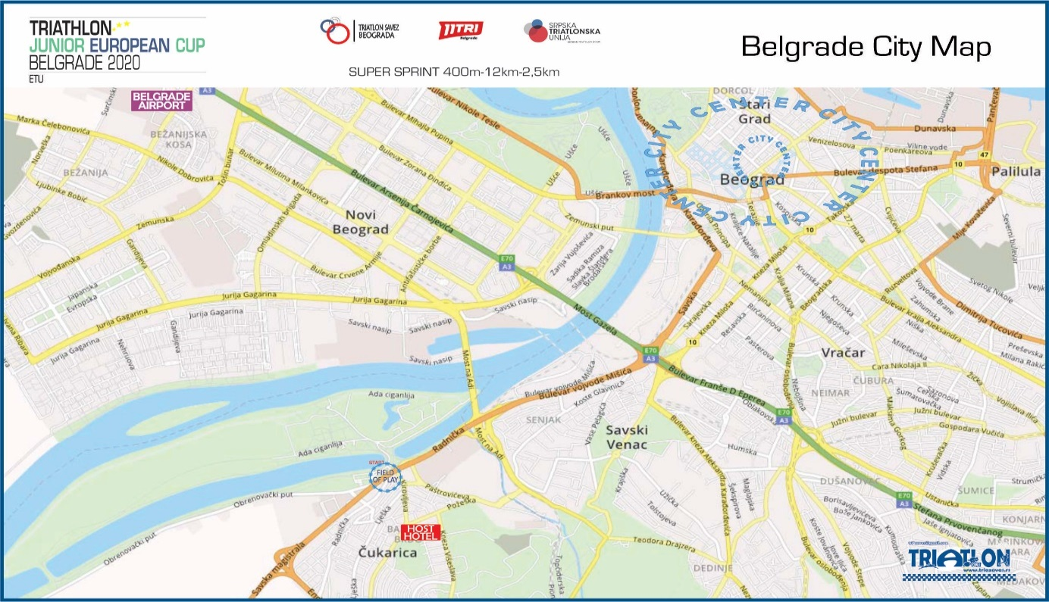

Just a few kilometers from the center of Belgrade, there is a former island in the Sava River, and today a large recreational town center: ADA CIGANLIJA. Today, it is connected by dikes with a coast for easy access and use. A large lake, surrounded by beaches, forest and sport fields, combining unspoiled nature and sports grounds. Ada Ciganlija offers the opportunity to engage in sport at all levels. A large number of swimming beaches and beach restaurants provide the opportunity for a good time.

More about Ada Ciganlija on:www.adaciganlija.rs/en/

From the city centre it is easy to reach Ada Ciganlija by publik transportation: info

If you are coming by car it is easy to find, from Radnicka street there are 2 parking lots: parking on the island for (eq) 3Eur/day, and near the transition area “Fast parking”(eq) 1,2Eur/day.

**2.2 COURSE FAMILIARIZATION**

According to the requirements of the ITU Covid 19 security protocol no course familiarization will be organized.

**2.3. ATHLETE’S LOUNGE**

The Athletes’ Lounge is near to the transition area.

20.9.2020 Sunday morning, arrival by car on Ada Lake parking is possible until 6:45 a.m. (coordinates parking place 44°47'08.4"N 20°24'44.6"E). Departure from parking is possible after 12:00 a.m. Parking cost per day is 150 din / eq. € 1,20 per day.

Between 6:45 - 12:00 a.m. public parking along the street.

**2.4. JUNIOR ATHLETES’ RACE PACKAGE**

## The race package is delivered during registration prior to the race, on Sunday 20 September, from 9:00 am in [The ETU Junior Cup Race Zone](https://www.google.com/maps/place/%D0%9F%D0%B0%D1%80%D0%BA%D0%B8%D1%80%D0%B0%D0%BB%D0%B8%D1%88%D1%82%D0%B5+%D0%BD%D0%B0+%D0%90%D0%B4%D0%B8/@44.7863948,20.4135945,18.75z/data=!4m14!1m8!3m7!1s0x0:0x0!2zNDTCsDQ3JzExLjMiTiAyMMKwMjQnNTAuMyJF!3b1!7e2!8m2!3d44.7864676!4d20.4139676!3m4!1s0x475a6fc44c9c0595:0x9fe29a0a5d480897!8m2!3d44.7867172!4d20.4145872) (adress: Ada Ciganlija Fast parking, Belgrade, Serbia).

The package can only be handed out when the entry fee has been received by the LOC. Payment on the spot can only be done in cash (EUR or Din).

**2.5. DOPING CONTROL**

The location of the doping control is on the Field Of Play, in a separated part in the recovery area. Doping tests will be conducted according to ITU/WADA rules. The Athletes must carry their identification to the doping control facilities.

**2.6. SECURITY**

A Private Company ensures the security of the event and the Police will manage the Road Closures and the traffic around the course.

**2.7. LOC OFFICE**

Monday – Friday 11:00- 14:00, Bulevar umetnosti 27, 11000 Belgrade.

Contact: Simo Cickovic [simo.cickovic@gmail.com](mailto:simo.cickovic@gmail.com), +381 637060345

Friday – Saturday 11:00 – 18:00 on the FOP

Contact: Ljudmila Medan, [etucupbelgrade@gmail.com](mailto:etucupbelgrade@gmail.com), + 381 64 150 56 51

|  |
| --- |
| 3. ACCOMMODATION |

Because of the COVID circumstances, the LOC will not arrange the accommodation for Athletes this year. It is strongly recommended to arrive for the competition on race day in the morning and when possible, to return on the same day.

Therefore athletes who need accommodation have to make arrangements themselves..

Any help or information can be obtained by mail: [etucupbelgrade@gmail.com](mailto:etucupbelgrade@gmail.com),

|  |
| --- |
| 4. TRANSFER AND TRANSPORT |

**REACH BY CAR OR BUS**

Belgrade is well connected by a network of highways with European cities:

Zagreb – E 70 = 394km

# Budapest – A1/E75 и M5 = 379 km

Temisoara – 593, R129, R130, E70 = 150km

Sofia – E80 A1(E75) = 390km

Skoplje – A1 = 430km

Thessalonik – A1 = 633 km

Sarajevo – E761, E70 = 294 km

Special notice for all competitors and teams coming to the ETU Junior Cup race on Sunday, September 20, 2020 in their vehicle:  
Due to the 11TRI half distance race taking place, the access and main roads for entering the event area will be completely closed from 7 am.

|  |  |
| --- | --- |
| For all triathlon participants in Belgrade who plan to arrive at the scene with their vehicles, it is important to enter the specified race zone by 6.45 am and it is recommended to use the official parking lot. After 6:50 the vehicles can be parked in the public parking lot next to the bike course. See for Parking on the map: |  |

**NEAREST AIRPORT**

The nearest airport is [Nikola Tesla Airport](https://beg.aero/eng) Belgrade

From airport to town:

- By public transportation: bus No:71, A1; taxi (from official taxi desk); rent-a car etc.

- The LOC will provide transfer from Belgrade Airport to Host hotel for the Athletes’ and their Team members/officials, including bike boxes and luggage.

Price per person: - €40, transfer in both directions. Pay in advance or in cash(EUR).

You can order transport on the following email: [etucupbelgrade@gmail.com](mailto:etucupbelgrade@gmail.com)

Please send us: your name, contact details, arrival time, arrival airport, flight number, number of people, number of bikes, contact person of your team … …

|  |
| --- |
| 5. ATHELETE’S SERVICES |

**5.1. TRAINING FACILITIES**

SWIM

* Swimming pool Košutnjak (outdoor pool, 50m),http://www.rzsport.gov.rs/ Address: Blagoja Parovića 150 street, Belgrade. Opening hours 10:00 –19:00, Pool reservations – not possible.
* Lake Ada Ciganlija

 BIKE

* Safe bike ride locations. Ada Ciganlija.
* If you are riding on the streets, please be careful, car drivers tend to overlook cyclists.

 RUN

* Ada Ciganlija, any time.
* Trim track Košutnjak, any time.

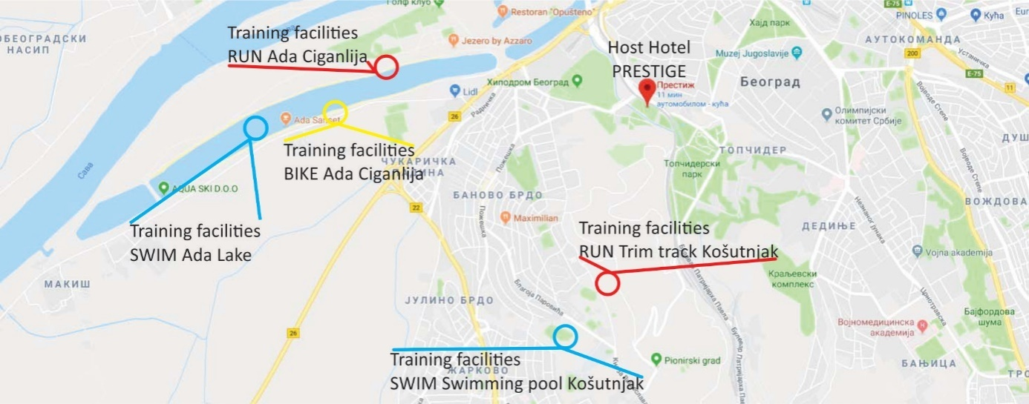

**5.2. MEDICAL SERVICES**

First Aid and Emergency Medical Services will be available at the Registration area before and during the training sessions and during the race. There will be First Aid and Emergency Medical Services at the Race Village on competition day.

Medical and Paramedical personnel will be available throughout the race. Several ambulances will be available to provide emergency transfers to a nearby hospital. A medical area will be provided on site at the finish area.

Medical services at the venue are free of charge. Treatment in private hospitals are to be paid by participants. Athletes / teams should make sure that they have appropriate medical insurance.

Emergency telephone numbers:

|  |  |  |  |  |
| --- | --- | --- | --- | --- |
| Medical 194  Fireman 193  Police 192 |  | Emergency Medical Center of the Clinical Center of Serbia  Pasterova 2, Beograd  Telephon: [011 3618444](https://www.google.com/search?client=firefox-b-d&channel=trow&q=urgentni+centar+beograd) |  | Anlave Clinic  Vase Pelagića 68, Senjak, Beograd  Telephon: +381 11 2 650 950  +381 63 35 12 35 |

For any advice, contcact Mr. Dr. Lazar Ivanović +381 63 20 12 02

**5.3. BIKE MECHANICAL SERVICE**

[Bike servis & shop SPORTOFICE](https://www.google.com/maps/place/Sportofis/@44.785551,20.4149923,18.5z/data=!4m5!3m4!1s0x0:0xdbf843d53bf3c27f!8m2!3d44.7849191!4d20.4146569)

Address: Radnicka 39, Beograd 11030

Phone: +381 (0) 65 3552976

|  |
| --- |
| 6. COMPETITION SCHEDULE |

**6.1. JUNIOR MEN**

|  |  |  |  |  |  |  |
| --- | --- | --- | --- | --- | --- | --- |
|  | DAY | START | END | ACTIVITY |  | LOCATION |
| **19.9.2020** | Saturday | 18:00 | 18:30 | Athlete’s briefing |  | On line |

|  |  |  |  |  |  |  |
| --- | --- | --- | --- | --- | --- | --- |
| **20.9.2020** | Sunday | 9:00 | 12:45 | Athlete Lounge open |  | Ada Ciganlija |
| **20.9.2020** | Sunday | 9:20 |  | Registration, ID required, bike check, numbers & decol ON, **Check IN** | 1 - 10 | G1-G2 -  G3-G4 |
|  |  | 9:30 |  | 11 - 21 |
|  |  | 9:40 |  | 22 - 31 |
|  |  | 9:50 |  | 32 - 41 |
|  |  | 10:00 |  | 42 - 51 |
| **20.9.2020** | Sunday | 10:00 | 10:25 | Swim warm-up | All |  |
| **20.9.2020** | Sunday | 10:35 |  | Calling area | All | SA |
| **20.9.2020** | Sunday | 10:40 |  | Athletes’ introduction | All | SA |
| **20.9.2020** | Sunday | 10:50 |  | **START Super SPRINT** | All | SA |
| **20.9.2020** | Sunday | 12:10 |  | Award Ceremony |  |  |
|  |  | 12:00 |  |  | 1 - 10 |  |
|  |  | 12:05 |  |  | 11 - 21 |  |
| **20.9.2020** | Sunday | 12:10 |  | CHECK OUT | 22 - 31 | G3-G4 |
|  |  | 12:15 |  |  | 32 - 41 |  |
|  |  | 12:20 |  |  | 42 - 51 |  |

**6.2. JUNIOR WOMEN**

|  |  |  |  |  |  |  |
| --- | --- | --- | --- | --- | --- | --- |
|  | DAY | START | END | ACTIVITY |  | LOCATION |
| **19.9.2020** | Saturday | 18:00 | 18:30 | Athlete’s briefing |  | On line |

|  |  |  |  |  |  |  |
| --- | --- | --- | --- | --- | --- | --- |
| **20.9.2020** | Sunday | 9:00 | 12:45 | Athlete Lounge open |  | Ada Ciganlija |
| **20.9.2020** | Sunday | 10:10 |  | Registration, ID required, bike check, numbers & decol ON, **Check IN** | 1 - 10 | G1-G2 -  G3-G4 |
|  |  | 10:20 |  | 11 - 21 |
|  |  | 10:30 |  | 22 - 31 |
|  |  | 10:40 |  | 32 - 41 |
|  |  | 10:50 |  | 42 - 51 |
| **20.9.2020** | Sunday | 10:40 | 11:10 | Swim warm-up | All |  |
| **20.9.2020** | Sunday | 11:15 |  | Calling area | All | SA |
| **20.9.2020** | Sunday | 11:20 |  | Athletes’ introduction | All | SA |
| **20.9.2020** | Sunday | **11:30** |  | **START Super SPRINT** | All | SA |
| **20.9.2020** | Sunday | 12:20 |  | Award Ceremony |  |  |
|  |  | 12:25 |  |  | 1 - 10 |  |
|  |  | 12:30 |  |  | 11 - 21 |  |
| **20.9.2020** | Sunday | 12:35 |  | CHECK OUT | 22 - 31 | G3-G4 |
|  |  | 12:40 |  |  | 32 - 41 |  |
|  |  | 12:45 |  |  | 42 - 51 |  |

**Venue map – important flows:**

|  |  |
| --- | --- |
| G1 – Entrance to triathlon zone (TZ): registration, athletes lounge, preparation area.  G2 – Exit form TZ  R – Registration  AL – Athletes Lounge  TA – Transition Area  G3 – Entrance to Transition Area  G4 – Exit from TA  W – Wardrobe (window)  SA – Start Area |  |

**6.3. COMPETITION RULES**

The event will follow the latest published Competitions Rules of the International Triathlon Union. [ITU Competitions Rules](https://www.triathlon.org/about/downloads/category/rules)

**6.4. ATHLETE’S BRIEFING**

19.9.2020, time: 18:00 You can see the presentation on [www.triatlon.org.rs](http://www.triatlon.org.rs) or ITU web site.

**6.5. TIMING CHIPS**

On race day the athletes will be given a timing chip and a cap in the Athletes lounge. The chip should be worn on the athletes’ left ankle. Athletes will pick up the timing chips before the competition, during their check-in procedure. These timingchips have to be returned at the end of the race.

**6.6. RESULTS**

Results will be uploaded live at the RaceResult Event website: …

Immediately after race on the ITU official website: www.triathlon.org

**6.7. PROTEST & APPEALS**

Standard procedures will be followed according to the ITU Competition Rules

|  |
| --- |
| 7. ACCREDITATION |

The LOC will provide to all the Organizing Committee Members, ITU Technical Officials, Athletes’, media, technical staff, court personnel, volunteers, etc. with an official Accreditation Card.

Only accredited people will be allowed to access certain venue areas. Accreditation Cards provide access to specific areas of the competition areas.

All accredited people are requested to carry their Accreditation Cards with them at all times and to show them upon request. Accreditation Cards are mandatory to enter the venue.

IMPORTANT: Coaches can only obtain an accreditation when applied for through official channels. This application can be done until a week before the race. No accreditation will be handed out without previous written or emailed request. The accreditations will be distributed on Sunday 20.9.2020 beafore the registration in the ETU Junior cup triathlon Zone.

|  |
| --- |
| 8. OTHER USEFUL INFORMATION |

8.1 LANGUAGE: Serbian official, English, Croatian, Montenegrian…

8.2 POPULATION: Serbia 7 million, Belgrade 2 million.

8.3 CURRENCY: Serbian Dinar (rsd)

1 USD = 105 din

1 EUR = 118 din

8.4 TIME: Central European time.

8.5 ELECTRICITY: 220V, similar sockets and plugs as in EU.

8.6 WATER: tab water drinkable.

8.7 TELEPHONE CONNECTIONS: +381 (0)

8.7.1 Mobile providers: Telenor, Telekom,VIP.

|  |
| --- |
| 9. COURSE MAPS |

**SWIM START**

SWIM COURSE: 400m

1 lap = 400m

Start procedure: water start, 200m distance to the first buoy.

The Race Referee with assistance of Technical Officials, who are assigned to the start, will start each race. Expected water temperature: 19-22oC

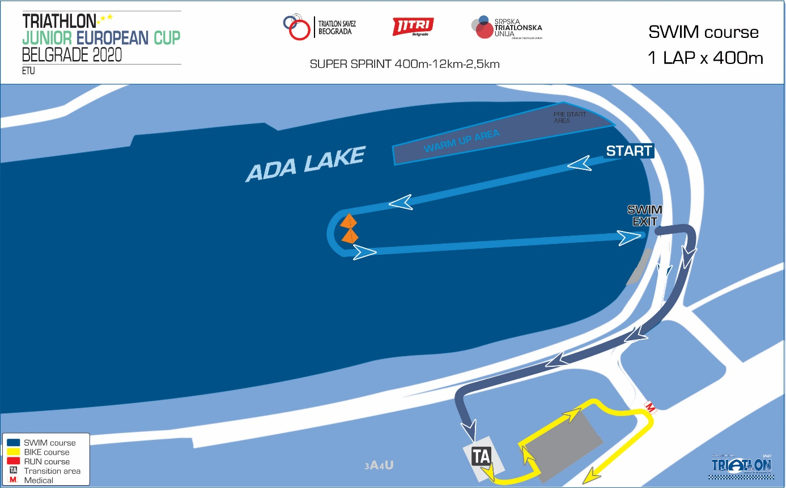

TRANSITION 1

A flow through transition has been developed to keep Athletes’ moving forward. Athletes enter the transition and must deposit their swim gear in a bin placed beside the bike racks. Athletes’ names and/or numbers are displayed on the top of each bike rack. After the helmet is secured, athletes unrack the bike and move forward into the centre lane and towards the mount line.

 BIKE COURSE: 12km

1lap =12km

One lap on one side of the Motor way road. Flat asphalt surface.

A wheel station is 50m from the transition area.

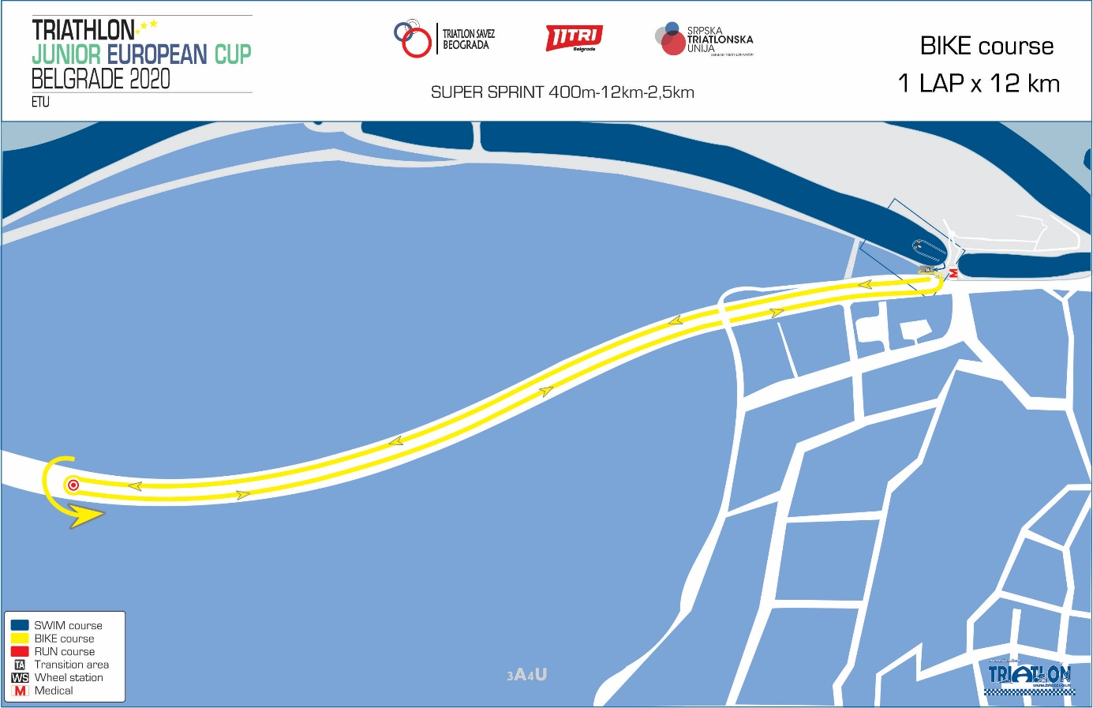

TRANSITION 2

Athletes enter to the same transition area. The dismount line is clearly marked and has cones with the STOP mark on either side. The helmet has to be placed into the bin beside the bike racks. Running shoes may be placed beside the rack or in the bin.

RUN COURSE – 2,5km,

2 laps =1250m

Description: flat, asphalt, street

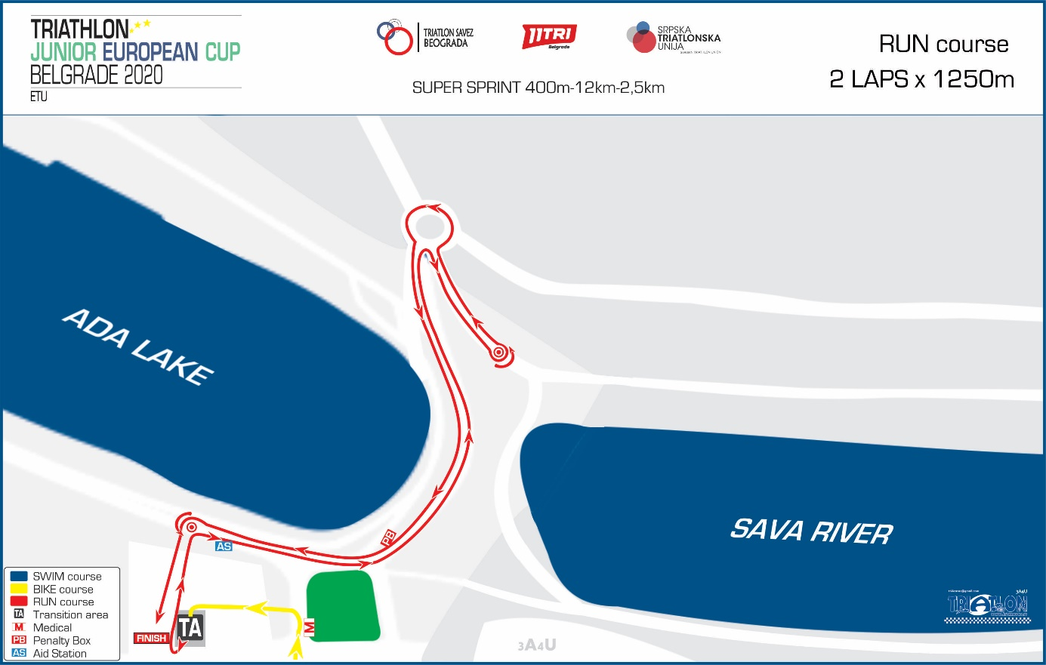

# **AIDSTATION:**

In the beginning of run lap there will be an aid station with clean water. In the recovery zone, after finish area, further aid is provided: water, isotonic drinks, fruit and biscuits…

***Welcome to Belgrade***

***Be healthy and stay safe***

***Good luck on the race!***