**ATHLETE’S GUIDE**



TABLE OF CONTENTS

1. GENERAL INFORMATION

1.1. INTRODUCTION

1.2. KEY DATES

1.3. KEY CONTACTS

1.4. CONTACT DETAILS

2. VENUE

2.1. RACE VENUE

2.2. COURSE FAMILIARIZATION

2.3. ATHLETE’S LOUNGE

2.4. ELITE ATHLETES’ RACE PACKAGE

2.5. DOPING CONTROL

3. ACCOMMODATION

4. TRANSFER AND TRANSPORT

5. ATHELETE’S SERVICES

5.1. SWIM AND BIKE TRAINING

5.2. BIKE MECHANICAL SERVICE

6. COMPETITION SCHEDULE

6.1. ELITE WOMEN

6.2. ELITE MEN

6.3. COMPETITION RULES

6.4. ATHLETE’S BRIEFING

6.5. TIMING CHIPS

6.6. RESULTS

6.7. PROTEST & APPEALS

7. ACCREDITATION

8. USEFUL INFORMATION

8.1. LANGUAGE

9. COURSE MAPS

|  |
| --- |
| 1. GENERAL INFORMATION |

1.1. INTRODUCTION

The purpose of the Athlete’s Guide is to ensure that all athletes, coaches and Team Leaders are well informed about all procedures concerning the Event. The LOC ensures that the information contained in this Guide is correct and up‐to‐date as of the production date. However, athletes, coaches and Team Leaders are advised to check with the event office regarding any changes in information included in this guide.

1.2. KEY DATES

**Saturday 18.04.2020**

|  |  |  |
| --- | --- | --- |
| **times** | **Event** | **Venue Alsdorf** |
| 10:00 – 15:00 Uhr | Issuing of race numbers (EC uniform check) AG | Sportsfreund Alsdorf, Bahnhofstraße 56 |
| 16:00-16:30 Uhr | Elite/Para sign-in for the briefing  **mandatory for all elite and Para athletes** | Autohaus Zittel, Linnicher Str. 203 |
| 16:30 – 17:00 Uhr | Race briefing Elite/Para English  **mandatory for all elite and Para athletes** | Autohaus Zittel, Linnicher Str. 203 |
| 17:00 -17:30 Uhr | uniform & license check Race pack hand out **mandatory for all elite and Para athletes** | Autohaus Zittel, Linnicher Str. 203 |
| 17:30 – 18:00 Uhr | Race briefing AG English | Autohaus Zittel, Linnicher Str. 203 |
| 18:00 – 18:30 Uhr | Race briefing AG in German | Autohaus Zittel, Linnicher Str. 203 |
| 18:30 Uhr | Opening Ceremony & Pasta Party | Autohaus Zittel, Linnicher Str. 203 |

**Sunday 19.04.2020**

|  |  |  |
| --- | --- | --- |
| **Start times Sunday** | **Group** | **Venue Alsdorf** |
| 08:00 Uhr | Elite Women | Denkmalplatz |
| 08:05 Uhr | Elite Men | Denkmalplatz |
| 08:45 Uhr | AG Men 20-54 | Denkmalplatz |
| 09:15 Uhr | AG Men 55-85 | Denkmalplatz |
| 10:00 Uhr | Para | Denkmalplatz |
| 10:02 Uhr | AG Women | Denkmalplatz |
| 11:00 Uhr | Open race / Team relay | Denkmalplatz |
| 12:20 Uhr | Sprint Distance | Denkmalplatz |
| **Cut off times** |  |  |
| 13:15 | Last bike lap | Denkmalplatz |
| 14:00 | bike | Denkmalplatz |
| 15:30 | Last run lap | Denkmalplatz |

**BIKE CHECK-IN, OUT**

|  |  |  |
| --- | --- | --- |
| **Check IN** | **Check Out** | **Klasse/Strecke** |
|  |  |  |
| 7:00-8:00 | 14:30 | Elite women |
|  |  |  |
| 7:00-8:00 | 14:30 | Elite men |
|  |  |  |
| 07:00-8:30 | 14:30 | AG Men-55 (MK20-MK50) |
|  |  |  |
| 07:00-8:30 | 14:30 | AG Men +55 (MK55-MK85) |
|  |  |  |
| 07:00-8:30 & 9:30-9:50 | 14:30 | Para |
|  |  |  |
| 07:00-8:30 & 9:30-9:50 | 14:30 | AG Women |
|  |  |  |
| 07:00-8:30 & 9:30-9:50 | 14:30 | Open race / Team relay |
|  |  |  |
| 11:00-12:00 | 14:30 | Sprint |

**Medal Ceremony**

|  |  |  |
| --- | --- | --- |
|  | **Group** | **Venue Alsdorf** |
|  | Flower ceremonies 1-3 men women elite | Denkmalplatz |
| Ab 16:00 Uhr | Elite | Stadthalle Alsdorf |
|  | EC Para + Age group | Stadthalle Alsdorf |
|  | DM Age group | Stadthalle Alsdorf |
|  | Powerman Sprint | Stadthalle Alsdorf |
|  | Powerman open | Stadthalle Alsdorf |

1.3. KEY CONTACTS

Name and contact details of:

- Race director Patrick Thevis, Tel. 0151/50739664 [thevis@freenet.de](mailto:thevis@freenet.de)

- technical delegate Thomas Klingler [Thomas.klingler@swisstriathlon.ch](mailto:Thomas.klingler@swisstriathlon.ch)

1.4. CONTACT DETAILS

Patrick Thevis, Tel. 0151/50739664 [thevis@freenet.de](mailto:thevis@freenet.de)

|  |
| --- |
| 2. VENUE |

2.1. RACE VENUE Denkmalplatz, 52477 Alsdorf

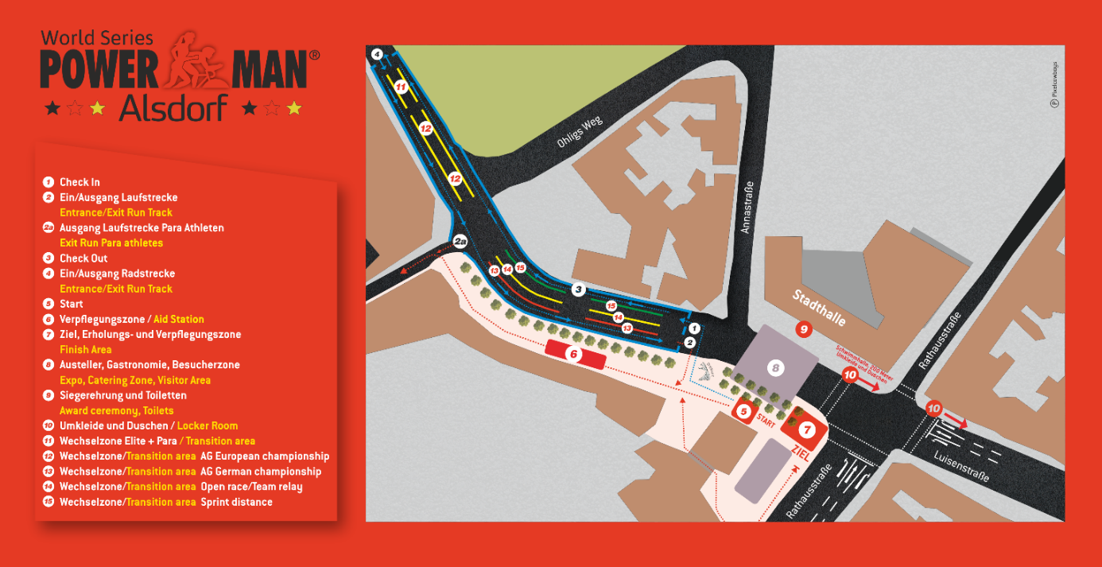

Parking

Parking close to venue. Kaufland Alsdorf, Bahnhofstr. 37, 52477 Alsdorf

Be care full this parking looked form 8:00- 16:00

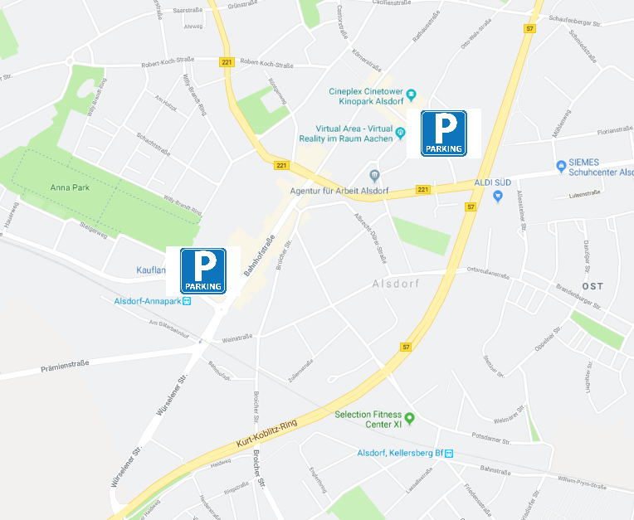

2.2 COURSE FAMILIARIZATION

We have no familiarisation.  
Be careful it not allowed to ride bikes on the roads L240 and on the 57n. They can only use when they are closed for the race.

2.3. ATHLETE’S LOUNGE

The bag drop of is in the city hall, there are also toilets

A recovery area is behind the finish, showers are in the Luisenbad

2.4. ELITE (and/or other categories) ATHLETES’ RACE PACKAGE

The Elite/para get the race pack after the briefing in the Autohaus Zittel, Linnicher Str. 203

AG Race pack pick with the uniform check is located at the Sportsfreund Alsdorf, Bahnhofstraße 56

2.5. DOPING CONTROL

The doping control will be located in the town hall. Doping tests will be conducted according to ITU/WADA rules. The athletes must carry their identification to the doping control facilities.

|  |
| --- |
| 3. ACCOMMODATION |

 Book your hotel room as soon as possible (in2 Boarding House, City Hotel Alsdorf and Hotel Gloria Alsdorf). Camping facilities are 2 km from the race site.

|  |
| --- |
| 4. TRANSFER AND TRANSPORT |

 Closest airports from the event: Maastricht/Aachen Airport at 40 km, Cologne Airport at 70 km and Düsseldorf Airport at 70 km with well working railway connection to Alsdorf

|  |
| --- |
| 5. ATHELETE’S SERVICES |

5.1. TRAINING FACILITIES

Showers at the completion days are near the TA in **Luisenbad**

 BIKE

The bike course can not be used for training, most of the road`s are normally closed for bikes

 RUN

The run course can uses all time

5.2. BIKE MECHANICAL SERVICE

Bike Shop: bestbike Radsport, Bahnhofstraße 43, 52477 Alsdor

|  |
| --- |
| 6. COMPETITION SCHEDULE |

6.1. ELITE WOMEN

|  |  |  |  |  |
| --- | --- | --- | --- | --- |
| DAY | START | END | ACTIVITY | LOCATION |
| 18.04.2020 | 16:30 | 17:00 | Athlete’s briefing | Autohaus Zittel, Linnicher Str. 203 |
|  |  |  | Press Conference |  |
| 18.04.2020 | 17:00 | 17:30 | Athlete registration | Autohaus Zittel, Linnicher Str. 203 |
| 19.04.2020 | 7.00 | 8:00 | TA check in | Denkmalplatz |
| 19.04.2020 | 7:50 |  | Calling area | Denkmalplatz |
| 19.04.2020 | 7:55 |  | Athletes introduction | Denkmalplatz |
| 19.04.2020 | 8:00 |  | Start | Denkmalplatz |
| 19.04.2020 | 16:00 |  | Award Ceremony | Town hall |

6.2. ELITE MEN

|  |  |  |  |  |
| --- | --- | --- | --- | --- |
| DAY | START | END | ACTIVITY | LOCATION |
| 18.04.2020 | 16:30 | 17:00 | Athlete’s briefing | Autohaus Zittel, Linnicher Str. 203 |
|  |  |  | Press Conference |  |
| 18.04.2020 |  |  | Athlete registration | Autohaus Zittel, Linnicher Str. 203 |
| 19.04.2020 | 7.00 | 8:00 | TA check in | Denkmalplatz |
| 19.04.2020 | 7:55 |  | Calling area | Denkmalplatz |
| 19.04.2020 | 8:00 |  | Athletes introduction | Denkmalplatz |
| 19.04.2020 | 8:05 |  | Start | Denkmalplatz |
| 19.04.2020 | 16:00 |  | Award Ceremony | Town hall |

6.3. COMPETITION RULES

The event will follow the latest published Competitions Rules of the International Triathlon Union.

6.4. ATHLETE’S BRIEFING

**Saturday 18.04.2020**

|  |  |  |
| --- | --- | --- |
| 16:00-16:30 Uhr | Elite/Para sign-in for the briefing  **mandatory for all elite and Para athletes** | Autohaus Zittel, Linnicher Str. 203 |
| 16:30 – 17:00 Uhr | Race briefing Elite/Para English  **mandatory for all elite and Para athletes** | Autohaus Zittel, Linnicher Str. 203 |
| 17:00 -17:30 Uhr | uniform & license check Race pack hand out **mandatory for all elite and Para athletes** | Autohaus Zittel, Linnicher Str. 203 |
| 17:30 – 18:00 Uhr | Race briefing AG English | Autohaus Zittel, Linnicher Str. 203 |
| 18:00 – 18:30 Uhr | Race briefing AG in German | Autohaus Zittel, Linnicher Str. 203 |

6.5. TIMING CHIPS

At the registration athletes will be given a timing chip, to be worn on the athletes’ ankle.

6.6. RESULTS

Results will be uploaded live at the ITU official website www.triathlon.org.

Please inform if there is any live coverage.

All the Results information will be distributed to the Team Leaders at the Information Centre (location?).

6.7. PROTEST & APPEALS

Standard procedures will be followed according to the ITU Competition Rules

|  |
| --- |
| 7. ACCREDITATION |

The LOC will provide to all the Organizing Committee Members, ITU Technical Officials, Athletes, VIPs, media, technical staff, court personnel, volunteers, etc. with an official Accreditation Card.

Info on when and where the accreditations will be distributed

Only accredited people will be allowed to access certain venue areas. Accreditation Cards provide access to specific areas of the competition areas.

All accredited people are requested to carry their Accreditation Cards with them at all times and to show them upon request. Accreditation Cards are mandatory to enter the venue.

|  |
| --- |
| 8. OTHER USEFUL INFORMATION |

8.1. LANGUAGE is english

|  |
| --- |
| 9. COURSE MAPS |

All maps can be found as google earth file under:

<https://1drv.ms/u/s!AsE__1QSu5E-gYQ1Ezs4SaoknQdxsw?e=fIYuQu>

TRANSITION 1

Ein Bild, das Text enthält.

 BIKE COURSE 3 laps

Ein Bild, das Text, Karte, Baum enthält.

* RUN COURSE

Ein Bild, das Elektronik enthält.

Good luck, and thanks to your sponsors