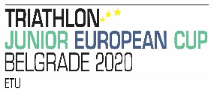

Place: BELGRADE
Date : 20.09.2020

I

 | member of
(name & surname) |  | (National team)

D E C L A R E

THAT IN THE PERIOD OF 10 DAYS BEFORE THE DAY OF THE COMPETITION I WAS NOT IN CONSCIOUS CONTACT WITH A PERSON WHO WAS CONFIRMED HAVING OR HAVING HAD THE COVID-19 DISEASE.

SIGNATURE: _______________________________________

NOTE:

The completed and signed statement form should be submitted IN THE ORIGINAL FORM on the day of the competition when registering the competition numbers and reviewing the competition IDs. Competitors who do not sign this statement will NOT BE ADMITTED TO PARTICIPATE in the competition.

The statement can be submitted ONLY by the competitor in person with the personal document, prior to the registration process.

