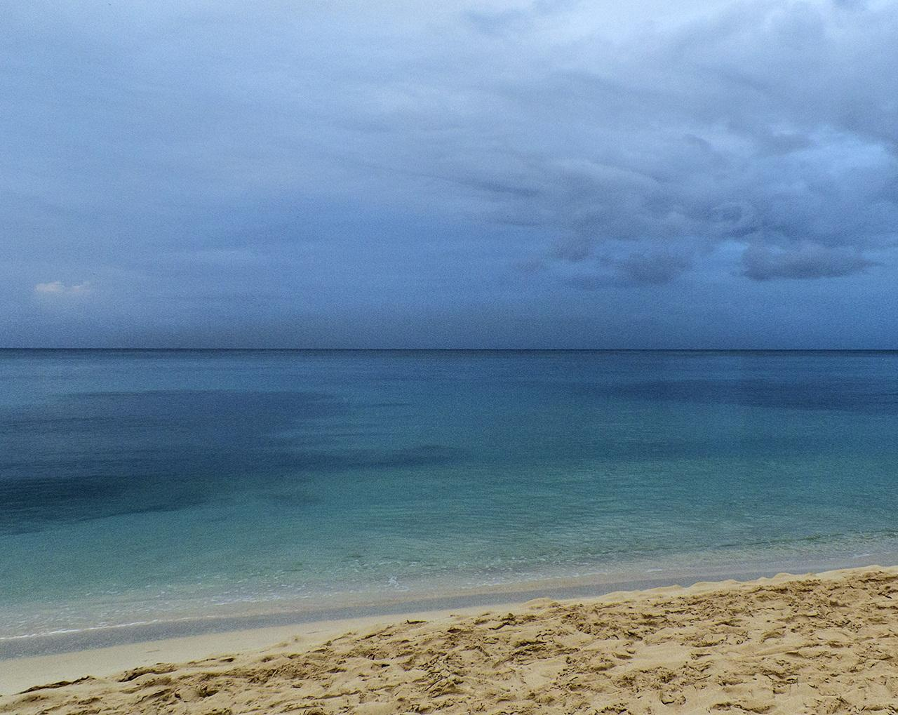
Athletes Guide-Bridgetown
Sunday April 21st, 2019
Table of Contents

Race Schedule 3
Race Briefing 3
Venue 4/5
Elite Athletes Lounge 6
Doping Control 6
Medical Services 6
Bike Mechanic Service 6
Security 7
Information 7
Accommodation 7
VISA requirements 8
Bank 8
Grocery Stores 8
Transportation 8
Training 8
Public Transportation 8
Taxi 9
Bike Training 9
Run Training 9
Bike / Run Course Familiarisation 10
Swim Course Familiarisation 10
Competition Information & Rules 10
Information about the FOP 10
Start 10
Transition Area Map 11
Swim Course Map 12
Bike Course Map 13
Run Course Map 13
Wheel Stations 14
Penalty Box 14
Aid Stations 14
Litter Zones 14
Weather Conditions 14
Results 15
Protests & Appeals 15

Race Schedule
Saturday 20th April 2019:
3:30PM (1530 Hrs) Briefing & Race Kit pickup at Barbados Olympic Centre, Garfiled Sobers Sports Complex
Wildey, St. Michael, Barbados

Sunday 21st April 2019:
5:30am | Athlete Lounge open and Equipment Check (Female)
7:15 am | Athlete Lounge open and Equipment Check (Male)  Transition open
6:00am – 6:45am | Swim Warm-up (Female)
6:45am  7:00am | Transition closed  Female Sprint Start
7:45am – 8:30am | Swim Warm-up (Male)
8:45am  8:30am  8:45am | Transition open  Transition closed  Male Sprint Start
10:30am | Awards ceremony at the race venue
TBD | After party

Monday 22nd April 2019
8:00 am – 3:00 pm | Island tour including lunch, this will be subsidized by the LOC. Tour operated by Williams Tours for an approximate cost of US $75 (before subsidy).

Race Briefing
Venue: Barbados Olympic Centre, Garfiled Sobers Sports Complex
Wildey, St. Michael, Barbados
Date: Saturday 20th April 2019
Start time: 3:30pm (1530 Hrs)
Uniform checks will be conducted prior to the briefing.
Transportation will not be provided.
NB: There are NO credit card facilities at the Briefing site. Please pay in US$ cash.
Race Fee: USD $125 Prize Purse : USD $10,000

Venue

The Spring Garden course is situated on one of the calmest coasts in Barbados, situated a stone’s throw out of the capital, Bridgetown. The crystal clear Caribbean Sea gives triathletes the opportunity to view beautiful coral reefs while swimming and the chance to spot a turtle, very likely.

The Bike & Run courses share the same tarmac with almost zero elevation except for a small incline at the north turn on the Bike.

Barbados also boasts some of the best weather conditions in the world with an average yearly temperature of 28 degrees C and water temperature of 26 degrees C at race time.

This beautiful island provides the perfect opportunity for competitors and non-competing partners and families to stay and enjoy the relaxed environment and attractions.

The race venue is located on the Western side of Bridgetown. Most south coast hotels are a 15 to 20 minute drive from the venue depending on traffic.

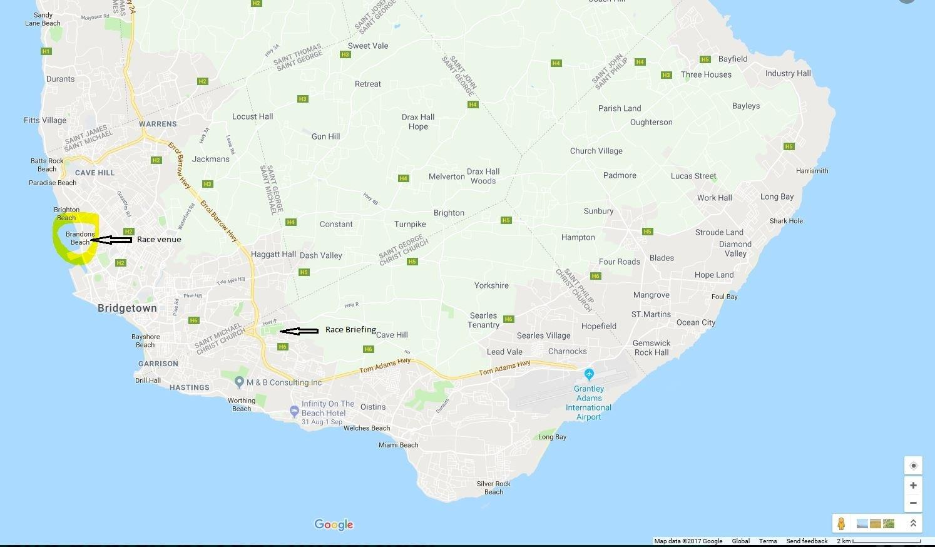

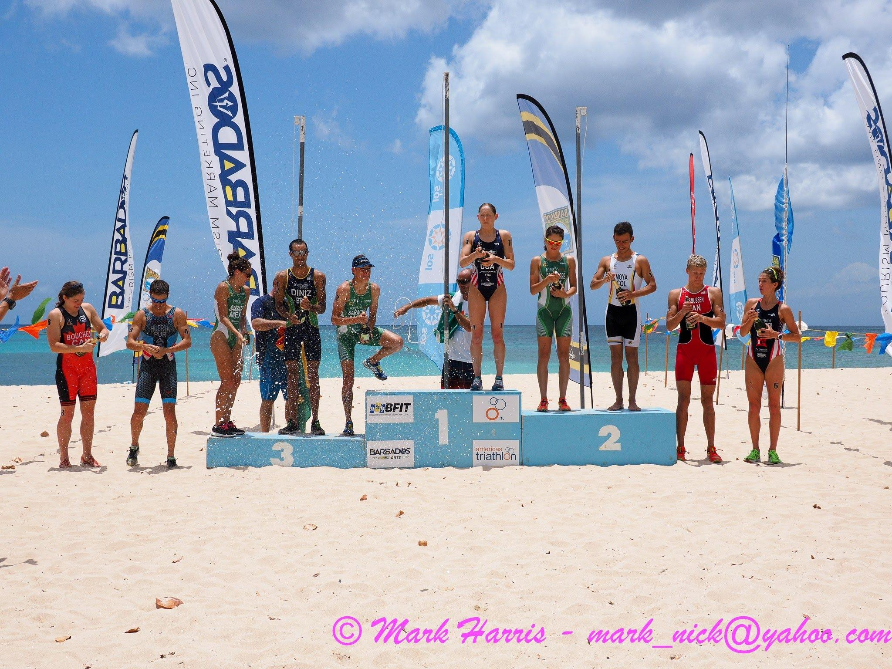

Elite Athletes Lounge

The Athletes Lounge area, under tents, and toilets will be adjacent to the transition area.

Doping Control
Doping Control will be performed according to ITU/WADA rules. They will be located adjacent to the transition area next to the Athletes Tents. Two triathletes of each gender will be tested.

Medical Services

First Aid will be available throughout the event and located next to the Athletes Tents. There will be two Ambulances on the course during the races.

Required medical services at the venue are free of charge. Treatment in clinics and at private offices is to be paid by the participants. Athletes / teams should ensure that they have appropriate medical insurance.

For any other medical attention needed outside of the competition, please contact the front desk of your Hotel for a local doctor’s details.

Bike Mechanic Service

Taylor’s Cycle Centre (246-426-3421) – closed on weekends

Mechanic (Private) Michael Thorpe (246-820-5533 or 438-2453)

Mechanic (Private) Junior Proverbs (246-572-2453)

Mechanic (Private) Leslie Ward (246-625-2453)

Security
There will be security personnel in the event area overnight and throughout the event. Marshals will assist and
patrol the Field of Play on race day and Traffic management services will be employed in conjunction with the Royal Barbados Police Force.

Information
Contact Numbers for key persons on the Organising Committee: [ Area Code: 246 ]
Derek Wilson: 243-8382 (Cell)
Christine Choy: 239-5955 (Cell); 416-9238 (Home)
Darren Treasure: 230-0724 (Cell), 228-0586 (Home)
Lynne Wright: 230-6314 (Cell), 228-4460 (Home)
Peter Gibbs: 840-1233 (Cell), 428-3211 (Home)

Accommodation

There is no official hotel for the Event. The recommended hotels are:

Plum Tree Resort, http://plumtreeclub.com/
Rostrevor Hotel, http://www.rostrevorbarbados.com/
Coconut Court, http://www.coconut-court.com/
Worthing Court Hotel, https://www.worthingcourt.com/
Infinity on the Beach, http://www.infinityonthebeach.com/
Time Out in the Gap, https://www.timeoutbarbados.com/
Blue Horizons, http://www.intimatehotelsbarbados.com/content/blue-horizon-hotel
Meridian Inn, http://www.meridianinn.com/
Paradise Villas, http://www.funbarbados.com/Lodgings/paradisevilla.cfm
Dover Beach Hotel, http://www.doverbeach.com/
Pirates Inn, http://www.piratesinnbarbados.com/
Sunbay Hotel, http://www.sunbayhotel.com/
Courtyard Marriott, http://www.marriott.com/hotels/travel/bgicy-courtyard-bridgetown-barbados/
Radisson Hotel, https://www.radisson.com/st-michael-hotel-bb/brbbbds
Hilton Hotel, http://www.hiltonbarbadosresort.com/

VISA Requirements

Some countries will require VISA to enter Barbados. See below site for details

https://www.visitbarbados.org/plan-your-trip/visa-and-entry-requirements

Bank

There are various ATM facilities across the island. Main Banks are Bank of Nova Scotia, CIBC FirstCaribbean, Republic Bank, Royal Bank of Canada, & First Citizens Bank.

Note: US$1 = 2 Barbados Dollars

Grocery stores
http://massystores.com/bb/

Transportation

No transportation will be provided other than to/from race briefing as detailed in race briefing section.

Training

The Barbados Aquatic Centre is located at the Garfield Sobers Sports Complex, Wildey, St. Michael. A pay-to-swim fee of US$10/day is the usual charge. We are trying to negotiate a special rate for visiting triathletes. The facility has a 50m x 25m pool (10 lanes) and a smaller 25m x 10m shallow pool. Opening hours are: 9:00am – 7:00pm (Note: 3:00pm – 6:30pm is reserved for local Age-Group clubs only). Tel: 429-SWIM.

Public Transportation

All public transport on the island is US$1 per trip.

Taxi
See below guide for prices

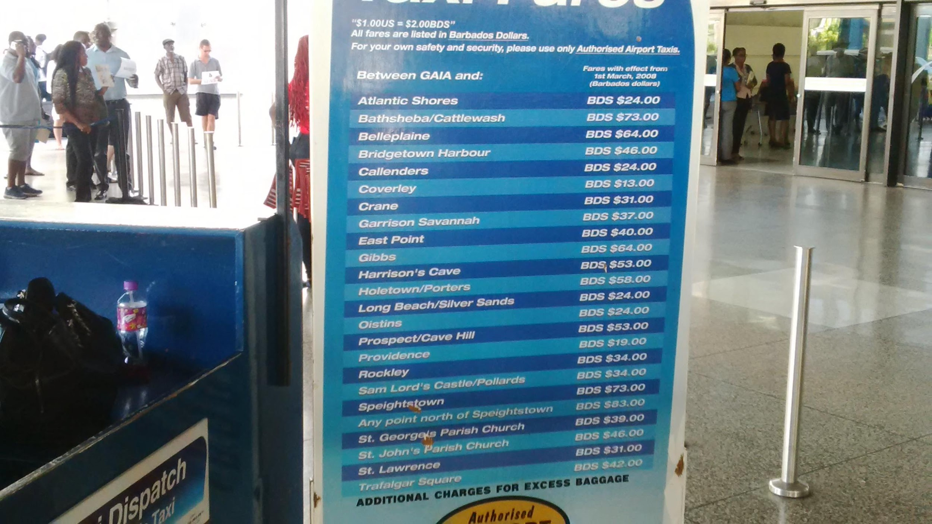

Bike Training

The roads are used by cyclists, but are narrow and may be bumpy! Roads are not closed to traffic, so you will be riding at your own risk. It is best to avoid early morning and late evening traffic (rush hours: 7:00am – 9:00am & 3:00pm – 6:00pm). Less traffic will be outside of town areas.

Riding the course prior to the event is not permissible by Law. If you choose to do so at your own risk.

Run Training

Running on our roads is not recommended. It is best to seek a traffic-free area close to where you are staying. Consult with your hotel Front Desk or one of the members of the Organising Committee.

Bike / Run Course Familiarisation

There are no official familiarisations for the bike and run courses as the race-site is an open and busy highway and will not be closed prior to race day. The course cannot be ridden during normal operation as bikes are not allowed on the Spring Garden Highway and may result in a fine.

The Swim course can be used at any time at your own risk.

Swim Course Familiarisation

You will be able to familiarize yourself with the swimming course on Saturday 20th April (9:00am – 12 Noon).

Competition Information & Rules

The race will follow the latest published competitions rules of the International Triathlon Union.

Elites should be aware that uniforms and bikes will be checked according to ITU specifications. Please come with "legal" gear accordingly.

Information about the FOP
Start
A Start Platform will be located along the beach, approximately 10m from the sea and visible from the Transition Area and the Athletes Lounge/Tent. Access will be via the swim exit chute located on the beach.
Athletes will be required to leave their last minute gear under the Athletes Tent, approximately 20m from the Start Platform. Security will be assigned.

Transition Area Map
Athletes will need to run approximately 100m – 150m to reach their bike. They must exit and enter the TA zone heading North. Most of the surface of the path from the swim exit to the TA Zone will be covered with Astroturf/carpet.

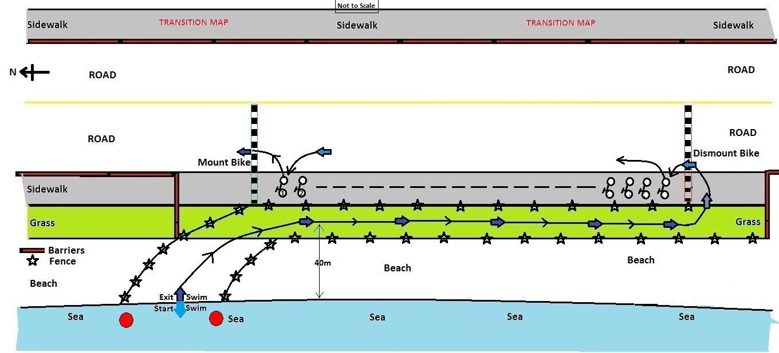

Swim Course Map (See below)
The swim course is a triangular shaped course that runs in a clockwise direction. The course starts and ends directly in front of the tents on the beach. The first turn buoy (#3, right) is at 300 metres. There will be 2 additional right-handed turns (#4 & #5) and the final turn is a left-handed turn (#7), before returning to shore between two #1 buoys. Note: Buoys #2 and #6 are for guidance & safety only and may be passed on either side. It is recommended however, that you pass them on your left shoulder to avoid the coral reefs.
The complete perimeter of the course will be patrolled by marshals on SUP boards, surf boards, kayaks, and there will also be a boat on the course.
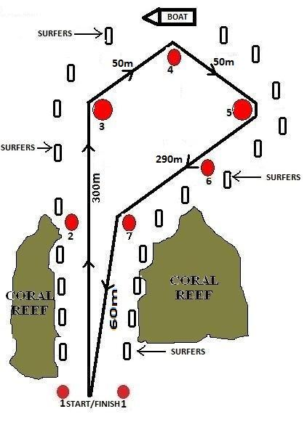

Bike Course Map
The bike course is a 5 lap, 4km long course. The course follows a flat portion of the Spring Garden Highway (SGH) with a small hill/incline (approx. 25m above sea-level) at the North turn.
The “first runner, last rider” scenario is applicable for this event. In this case, the rider will be taken off the course.
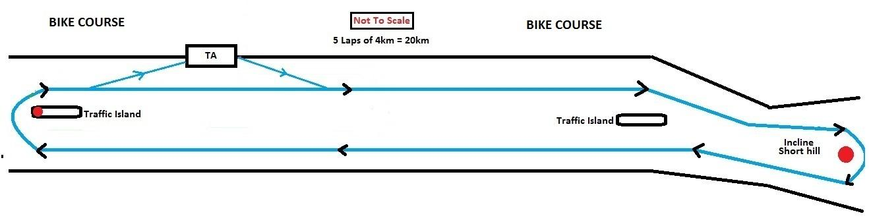
Run Course Map
The course is a flat 2-lap course on the same portion of the SGH as the bike course. Each lap is 2.5km. There will be distance markers indicating the distance “to the Finish”.
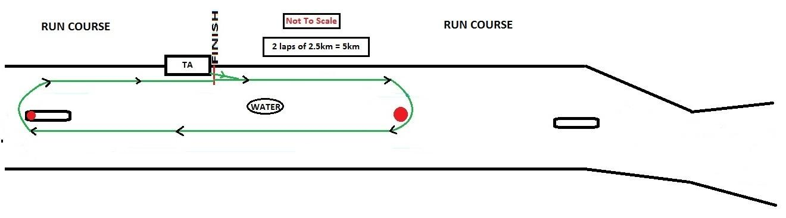

Wheel Stations
There will be one wheel station on the bike course which will be located approximately 100m after passing the TA zone. You must provide your own wheel(s) suitably labelled.
Penalty Box
The penalty box will be situated approximately 150 metres before the TA zone.
Aid Stations
There will be two water stations (bottle water) on the course (during the run) that will be situated approximately mid-point on the loop. Another Water station may be added, depending on conditions. Bottle Water & Gatorade/Powerade will be available also at the Finish Line. Fruits & food will also be available to athletes in the Athletes Tent after the race.
Litter Zone
A litter zone will be implemented around each aid station. The litter zone will begin 80m before the aid station and end 80m after the aid station. Dropping litter outside the litter zone can result in a penalty.
Weather Conditions
Expected weather conditions – Sunday 21st April 2019
The sun will rise in Bridgetown at 5:42 am and sunset will be at 6:11 pm.
The first High tide will be at 4:49 am and the next High tide at 5:59 pm
The first Low tide will be at 11:32 am and the next Low tide at 11:34 pm??\\
There will be 12 hours and 29 minutes of sun.
https://www.timeanddate.com/sun/barbados/bridgetown?month=2&year=2019
Results
Unofficial Results will be posted under the Athletes Tent, as soon as possible, after each race.
Official Results will be uploaded at the ITU’s official website: www.triathlon.org
Protests & Appeals
Standard procedures will be followed according to the ITU Competition Rules.

