2022 Americas Triathlon Cup La Paz
Concept Paper

INDIVIDUAL RESPONSIBILITY
The event will follow the latest published Prevention guidelines for Event Organizers for COVID-19 of the World Triathlon.

Also, the event is under the LOCAL/REGIONAL AUTHORITY regulations, which is the authority with competencies in terms of health . https://asdeporte.com/evento/triatlon-astri-la-paz-2022-umw5

PROCEDURES TO ENTER MEXICO.
https://www.travelvisitmexico.com/authorization?utm_source=google&utm_medium=cpc&gclid=EAIaIQobChMItPaJhNzw9QIVRZFbCh1vBgqjEAAYASAAEgLdcfD_BwE

COVID Coordinator: For any questions related to COVID restrictions and travel details, please contact Mauricio Alvarez Martinez ,malvarez@asdeporte.com

RISK ASSESSMENT AND MITIGATION
The Local Organizing Committee used the WHO risk assessment and risk prevention checklist for "mass gatherings" in the framework of the covid-19 document to design the event.

The LOC is implementing its activities to comply with the local health authority protocols and minimize the risk of pandemic spread, keeping participants and the public safe and healthy.

Careful management of the schedule and access times of the athletes will be implemented to access the competition areas with adequate social distancing and an immediate exit once finished. The waiting areas will be restricted and controlled by volunteers or security personnel.

Data collection systems will manage the contacts of everyone involved in the event. This includes athletes, technical officials, coaches, volunteers, staff, authorities. This would ensure that we can trace back to the people potentially involved in a suspicious case is identified. It is confirmed the protocol established now by the health authorities will be executed.

PARTICIPANTS’ HEALTH SCREENING
Athletes must continuously monitor their health status (including temperature detection and monitoring of any symptoms) from 14 days before and during the event.

See the “TRAVEL" chapter of this guide for information about traveling to COUNTRY.

Temperature checks will be carried out every day at the venue entrance.

Temperature higher than 37.5°C will be reported to the event’s Medical Director and Medical Staff.

A health coordinator will be appointed within the medical team. He will be responsible for coordinating and monitoring compliance and enforcement of health safety regulations.

Registration procedure: Athletes, coaches, and technical officials, will follow WORLD TRIATHLON procedures.

Due to the current situation of the COVID-19, the World Triathlon Medical Committee has made mandatory for all athletes to submit a pre-event medical certificate for participating in the event:
- All individuals (except for the LOC, its volunteers and contractors) applying for an accreditation must fill in the online pre-event questionnaire through the link that is provided by the LOC
- Additionally, to this, all elite/u23, para triathletes, coaches, team medical and support NF personnel must perform an Antigenic pre-race test at the arrival in the hosting city. In case of a positive result, a PCR swab test must follow. Time and place for these tests will be determined by the LOC.
- We will continue to respect the decision/rules of the local public health of the host country
- All the specific measures can be found in the table below:
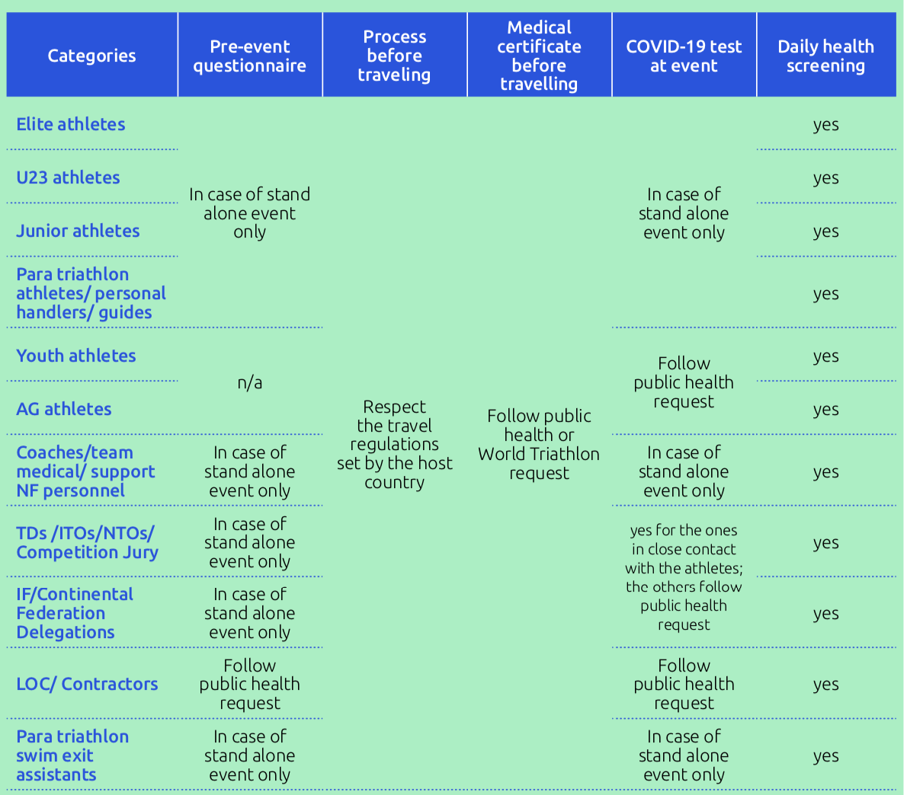

CLOSE CONTACT DEFINITION AND PROCESS TO FOLLOW IN CASE OF POSITIVE CASE
Dra Yadhira Espinoza: 52 + 5541891686
USE OF MASK/MOUTH-NOSE FACE COVERING AND RUBBER/DISPOSABLE GLOVES

According to World Triathlon the use of a mask is mandatory for all athletes, technical officials and team support (except, for the athletes during the competition). Country laws will determine the use of mask for the LOC staff, volunteers and each contractors.
The use of rubber gloves is not mandatory.

ISOLATION TENT AND SUSPICIOUS CASE

During the event, if a Suspicious Case is identified:
- A surgical mask will be applied (provided or used?), preferably by the own Suspicious Case (need to clarify if athletes/team members must have their own and spares);
- That person will be taken to the Isolation Tent by a staff member;
- The Doctor in charge of the Isolation Tent will call the National Health Service 52+5541891686 and follow the given procedure;
- The Isolation Tent will be provided with exclusive bathroom, sealed water and food, surgical masks, hand sanitizers and alcohol solution wipes.

The definition of suspicious case is in Mexico is:

VENUE AND EVENT STRUCTURE
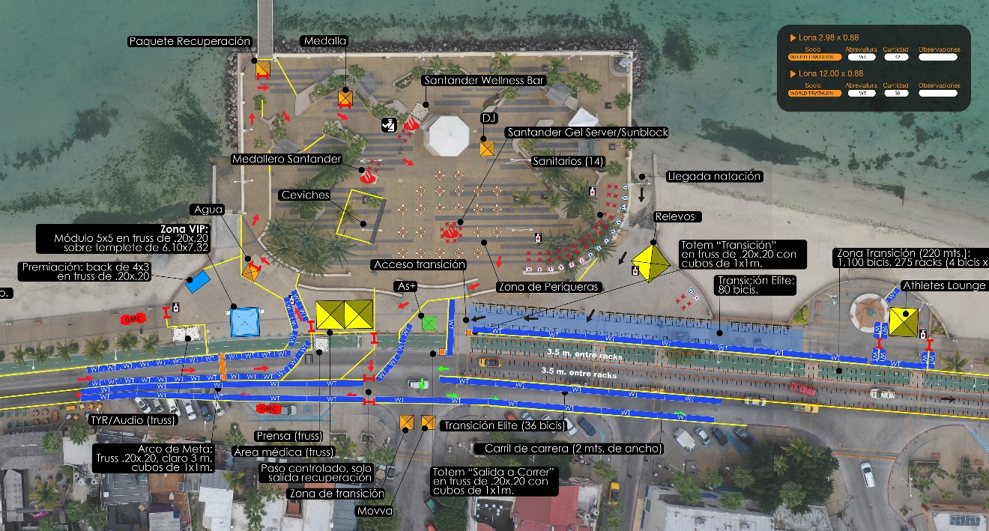

CLEANING AND SANITATION

In addition to the cleaning and sanitization measures already in place in common workplaces, further cleaning and sanitization of surfaces that most commonly come into direct contact with people are planned.
In specific entrance areas, products (disinfectant and paper) are supplied to perform self-sanitization of vehicles and workstations.

ATHLETES’ SERVICES

AIRPORT TRANSFER

Airport Local Transportation

TRAINING FACILITIES

NA

ATHLETES’ AND COACHES’ BRIEFING

At World Triathlon events, all coaches’ briefings are cancelled. The athletes' briefing is not mandatory.

All information about the race will be provided through WORLD TRIATHLON website.
Special rules for the 2022 Americas Triathlon Cup La Paz race:
- The online briefing will be held on a date and time consistent with the World Triathlon Competition Rules and will either pre-recorded and available only on the events’ website or take place online.
- If live, participants will attend the TD presentation and can contribute questions or feedback through the online Q&A function. If people cannot attend the session in real time, the presentation will be recorded and published on the World Triathlon website for later viewing.
- There are no penalties for those who arrive late or miss the online briefing.
- The race briefing will be available on the events’ website.
- The TD will be available for any clarifications: Bobbie Solomon, tribobbie@yahoo.com

RACE PACKAGE DISTRIBUTION
The athlete must pick up the race pack in person at the venue. The schedule will be communicated in the week of the event.

COURSE FAMILIARISATIONS
Swimming Practice, Friday March 11, 14:00 - 14:45 hrs on Malecon Beach, after registration on the T1.
COVID Guidelines
ENG:
https://www.triathlon.org/uploads/docs/20210422_Covid19_Guidelines_5.1_v2.pdf
EVENT FORMAT
TRANSITION AREA: Bike racks will be individual, and the distance between them will be 2 meters.

AID STATIONS: Only water will be provided at the aid stations. Volunteers will distribute the water to the athletes as usual.

PENALTY BOX: It will be organised in such a way as to ensure social distancing.

FINISH AREA: The finish tape will be disinfected between races. Photographers, TV, and Media will stay 20 m from the finish line. After crossing the finish line, the athletes will be directed to a first recovery area, and after they will continue to the athletes’ lounge. At the recovery area the athletes will take the water themselves. Next to the finish area the medical area will be located.

SPECIFIC RISK MITIGATION PLANNED
Arrival at the venue:
- All the accredited people will access to the venue, through the security gate, to warranty the control of the people that is inside the venue.
- All people will access to event with temperature log, access time, mask detection, and photo log.
- Everything is stored in a file so that the data is available to the health authorities.
- Venue and courses will be completely closed with fences and authorized personnel.
- In the case of any suspicious case, the medical services will be notified.

Non-Essential Services: There will be no massage service.

Technical Officials: The event will follow the latest published Prevention guidelines for Event Organizers for COVID-19 of the World Triathlon.

Seating Areas: There will be no spectators during the competition.

Social Distancing: The recommendations of the health authorities, World Triathlon and MEXICAN FEDERATION OF TRIATHLON in their protocols will be followed.

Races & Sport Presentation: The event will follow the latest published Prevention guidelines for Event Organizers for COVID-19 of World Triathlon.

