2022 Europe Triathlon Junior Cup Haugesund
25. June

Concept Paper

INDIVIDUAL RESPONSIBILITY
The event will follow the latest published Prevention guidelines for Event Organizers for COVID-19 of the World Triathlon.

Also, the event is under the LOCAL/REGIONAL AUTHORITY regulations, which is the authority with competencies in terms of health https://www.fhi.no/en/

PROCEDURES TO ENTER NORWAY
The travel-restrictions upon entry into Norway have been lifted. The same rules as prior to the corona pandemic now apply. For more information about traveling see here:
https://www.helsenorge.no/en/coronavirus/international-travels/
https://www.udi.no/en/corona/about-the-corona-situation/
Entry restrictions discontinued!
The statutory requirement to obtain a negative test prior to travel and the requirement to register entry into Norway upon arrival have both been discontinued. For more information click here:https://www.regjeringen.no/en/topics/koronavirus-covid-19/travel-to-norway/id2791503/
If u are a citizen of the EU/EEA you do not need a visa to enter/visit Norway. For more information click here: https://www.udi.no/en/want-to-apply/visit-and-holiday/to-visit-norway-without-a-visa/
Special passports
- If you are from Albania, Georgia, Macedonia, Moldova, Montenegro or Ukraine, you must have a biometric passport
- If you are from Serbia you must have a biometric passport. The passport cannot be issued by MUP R Srbije, Koordinaciona Uprava.
- If you are from Hong Kong, you must have a Hong Kong SAR passport or BN (0) passport
- If you are from Macao, you must have a Macao SAR passport
- If you are from Taiwan, you must have a passport that contains an ID card number.
N.B.: If you are from one of these countries, but do not hold the special passport, you must apply for a visitor's visa.

COVID Coordinator: For any questions related to COVID restrictions and travel details, please contact: Alf Reksten, Alfreksten@gmail.com

RISK ASSESSMENT AND MITIGATION
The Local Organizing Committee used the WHO risk assessment and risk prevention checklist for "mass gatherings" in the framework of the covid-19 document to design the event.

The LOC is implementing its activities to comply with the local health authority protocols and minimize the risk of pandemic spread, keeping participants and the public safe and healthy.

Careful management of the schedule and access times of the athletes will be implemented to access the competition areas with adequate social distancing and an immediate exit once finished. The waiting areas will be restricted and controlled by volunteers or security personnel.

Data collection systems will manage the contacts of everyone involved in the event. This includes athletes, technical officials, coaches, volunteers, staff, authorities. This would ensure that we can trace back to the people potentially involved in a suspicious case is identified. It is confirmed the protocol established now by the health authorities will be executed.

PARTICIPANTS’ HEALTH SCREENING
Athletes must continuously monitor their health status (including temperature detection and monitoring of any symptoms) from 14 days before and during the event.

See the “TRAVEL" chapter of this guide for information about traveling to Norway.

Temperature checks will be carried out every day at the venue entrance. Temperature higher than 37.5°C will be reported to the event’s Medical Director and Medical Staff.

A health coordinator will be appointed within the medical team. He will be responsible for coordinating and monitoring compliance and enforcement of health safety regulations.

Registration procedure: Athletes, coaches, and technical officials, will follow WORLD TRIATHLON procedures.
Athletes have to have their ID card or passport.
Coaches that are registered and approved on the World triathlon page will be given accreditation.

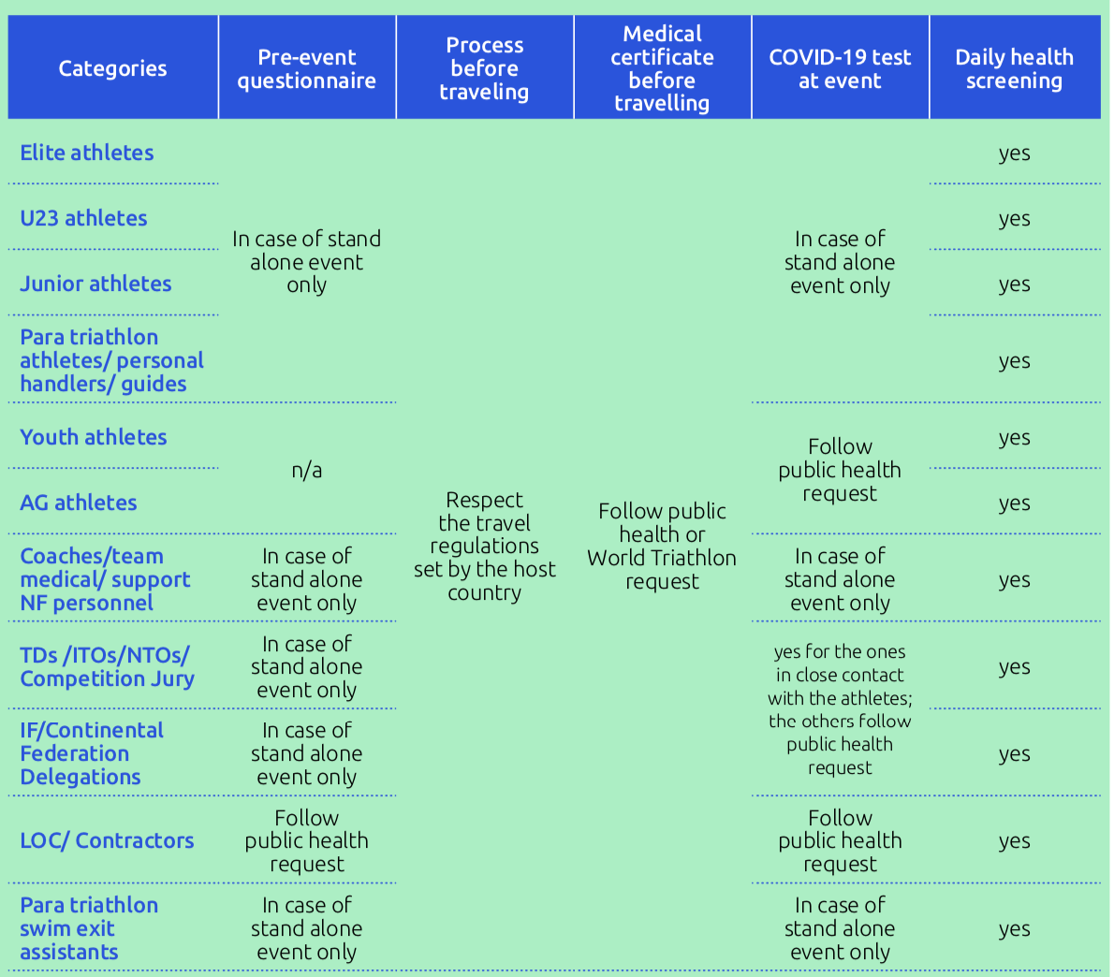

CLOSE CONTACT DEFINITION AND PROCESS TO FOLLOW IN CASE OF POSITIVE CASE

Local recommendations in case of a positive test
If you have symptoms of a coronavirus infection, you should stay at home at least 4 days have passed from the time the symptoms started and you have not had a fever for at least 24 hours, without using antipyretic medication. This applies regardless of whether you are vaccinated or not.
If you do not have any symptoms, you should stay at home until 4 days have passed since you tested positive for the coronavirus. This applies regardless of whether you have been vaccinated or not.
A test for the coronavirus (self-test) might be positive also for a couple of days following these first 4 days.
If someone experiences symptoms, fever, chills, cough, sore throat, shortness of breath, runny nose, loss or changes in sense of smell or taste, and tests positive for Covid-19 they will be placed in quarantine, at their own cost, for a period of 4 days according to the recommendations of the Norwegian government and will be unable to leave the country.
https://www.helsenorge.no/en/coronavirus/stay-at-home-if-you-are-ill/
USE OF MASK/MOUTH-NOSE FACE COVERING AND RUBBER/DISPOSABLE GLOVES
According to World Triathlon the use of a mask is mandatory for all athletes, technical officials and team support (except, for the athletes during the competition).
Country laws will determine the use of mask for the LOC staff, volunteers and each contractors. The use of rubber gloves is not mandatory.

ISOLATION TENT AND SUSPICIOUS CASE

During the event, if a Suspicious Case is identified:
- A surgical mask will be applied (provided or used?), preferably by the own Suspicious Case (need to clarify if athletes/team members must have their own and spares);
- That person will be taken to the Isolation Tent by a staff member;
- The Doctor in charge of the Isolation Tent will call the National Health Service
and follow the given procedure telf: +47 97518672
- The Isolation Tent will be provided with exclusive bathroom, sealed water and food, surgical masks, hand sanitizers and alcohol solution wipes.

CLEANING AND SANITATION
In addition to the cleaning and sanitization measures already in place in common workplaces, further cleaning and sanitization of surfaces that most commonly come into direct contact with people are planned.
In specific entrance areas, products (disinfectant and paper) are supplied to perform self-sanitization of vehicles and workstations.

ATHLETES’ SERVICES

AIRPORT TRANSFER

HAUGESUND airport 14km out of town, most flights are via OSLO, BERGEN or STAVANGER.
Second airport is STAVANGER. 2.5hours from Haugesund, there is a bus connection.
Contact for airport transfer to Haugesund:
Haugaland taxi
Mail: bestilling@08181.no
Telf: +47 52 81 81 81
The trip has to be booked beforehand for the price to be valid
Prices:
650 NOK , 4 people + baggage
From Haugesund airport to Sentrum hotel

TRAINING FACILITIES

Haugesund Triatlon Klubb (HTK), in collaboration with Norway international triathlon invites the contestants to a week of camp in advance of the competition the 25.06.2022. The camp will be held from the 19.06.2022 to the 26.06.2022 in Haugesund, Norway. The whole camp will be arranged at HTG, which is located directly next to the swim venue. Start-area, T1 and swimming pool in walking distance. Stay and 3 meals a day included (breakfast, lunch and dinner).
There will be access to a swimming pool (25m) the whole week. The athletes are offered low cost accommodation and much more. See the link for more information: https://htri.no/norway-international-tri-camp/
Address: Haugesund Toppidrettsgymnas, Hanne Kroghs Veg 6 , 5518 Haugesund
Contact person for the Training camp and other training facilities:
Marlene Wulst, +47 41366226, marlene@norwayinternationaltriathlon.com

Access to training facilities will strictly follow the local health regulations and the World
Triathlon COVID Guidelines rules.

ATHLETES’ AND COACHES’ BRIEFING

At World Triathlon events, all coaches’ briefings are cancelled. The athletes' briefing is not mandatory.

All information about the race will be provided through WORLD TRIATHLON website.
Special rules for 2022 Europe Triathlon Junior Cup Haugesund
:
- The online briefing will be held on a date and time consistent with the World Triathlon Competition Rules and will either pre-recorded and available only on the events’ website or take place online.
- If live, participants will attend the TD presentation and can contribute questions or feedback through the online Q&A function. If people cannot attend the session in real time, the presentation will be recorded and published on the World Triathlon website for later viewing.
- There are no penalties for those who arrive late or miss the online briefing.
- The race briefing will be available on the events’ website.
- The TD will be available for any clarifications:
Ivan Mihajlovski
telf: +389 70363958
email: ivanmihajlovskiswim@gmail.com

RACE PACKAGE DISTRIBUTION
The athlete must pick up the race pack in person at the venue.

Race package will be given from 13:00-19:00 at this location: Haraldsgata 131, 5527 Haugesund

COURSE FAMILIARISATION
The bike familiarisation for the junior athletes will be on Friday evening from 1800-1900h, this is the only time the venue will be closed for traffic before the competition.

We are following up local health authority protocols during the familiarisation.

EVENT FORMAT
START OF THE RACE: There will be more then 1 hour in between the races to warranty a proper time difference, to minimize the time that men and women are together at the venue.
TRANSITION AREA: Bike racks will be individual, and the distance between them will be 1.5 meters.
AID STATIONS: Only water will be provided at the aid stations. Volunteers will distribute the water to the athletes as usual.
PENALTY BOX: It will be organised in such a way as to ensure social distancing.
FINISH AREA: The finish tape will be disinfected between races. Photographers, TV, and Media will stay 20 m from the finish line. After crossing the finish line, the athletes will be directed to a first recovery area, and after they will continue to the athletes’ lounge. At the recovery area the athletes will take the water themselves. Next to the finish area the medical area will be located.

SPECIFIC RISK MITIGATION PLANNED
Arrival at the venue:
- All the accredited people will access to the venue, through the security gate, to warranty the control of the people that is inside the venue.
- All people will access to event with temperature log, access time, mask detection, and photo log.
- Everything is stored in a file so that the data is available to the health authorities.
- Venue and courses will be completely closed with fences and authorized personnel.
- In the case of any suspicious case, the medical services will be notified.

Provisional pre race and race day schedule

Friday 24. June 2022
13:00 - 19:00 race package pick up
17:00 - 18:00 swim familiarisation
18:00 - 19:00 bike familiarisation
20:00 - 20:30 Race briefing (online zoom meeting)

Saturday 25. June 2022
15:00 - 16:00 Junior Women Athletes Lounge Check-in
15:30 - 15:45 Junior Women Transition 2 Check-in
15:45 - 16:45 Junior Women Transition 1 Check-in
16:15 - 16:45 Junior Women Swim Warm Up
16:50 Athletes' Introduction
17:00 Junior Women START
17:30 - 18:30 Junior Men Athletes Lounge Check-in
17:30 - 18:15 Junior Men Transition 2 Check-in
18:15 - 19:15 Junior Men Transition 1 Check-in
18:45 - 19:15 Junior Men Swim Warm Up
19:20 Athletes' Introduction
19:30 Junior Men START
21:30 Europe Triathlon Junior Cup Award Ceremony

Non-Essential Services: There will be no massage service.

Technical Officials: The event will follow the latest published Prevention guidelines for Event Organizers for COVID-19 of the World Triathlon.

Seating Areas: There will be spectators during the competition next to the course, but no designated seating areas.

Social Distancing: The recommendations of the health authorities, World Triathlon and Norges Triatlon Forbund in their protocols will be followed.

Basic infection control recommendations remain important, and will limit the spread of infectious diseases, including COVID-19.
https://www.fhi.no/en/op/novel-coronavirus-facts-advice/facts-and-general-advice/infection-control-advice-for-the-population/#general-infection-control-advice-that-applies-to-all

Races & Sport Presentation: The event will follow the latest published Prevention guidelines for Event Organizers for COVID-19 of World Triathlon.

Tourist information

Welcome to Haugesund and Haugalandet, the viking destination of Fjord Norway, and a region full of contrasts. Åkrafjord, Langfoss waterfall, coastal culture, the unique Viking history at Avaldsnes, idyllic island communities such as Utsira and Røvær and charming small town life are a few of the highlights

This exciting Haugesund region extends from the open sea in the west to the fjord and mountain landscape in the east. A host of nature-based adventures await visitors who want to experience the contrasts in the fantastic scenery of Western Norway. You can walk in the Vikings’ footsteps, visit the islands of Røvær and Utsira and see perpendicular mountains and cascading waterfalls in the beautiful Åkrafjord.
Haugesund, which is the regional centre for more than 100,000 people, has everything you need for a blast of urban life; culture, shopping, restaurants and charming cafés. Festivals and cultural events are organised all year round for people of all ages. The two biggest festivals, Sildajazz jazz festival and the Norwegian International Film Festival Haugesund are held every August.

For more information on activities and tourist attractions in the area for your stay in Norway click on the link below:

https://www.fjordnorway.com/no/destinasjoner/haugesund-haugalandet

Other triathlon races in the area

Ironman Sandnes 03.07.2022
https://www.ironman.com/im703-sandnes

2022 World Triathlon Cup Bergen 27-28.08.2022
https://en.visitbergen.com/whats-on/2022-world-triathlon-cup-bergen-p6083063

