ATHLETE’S GUIDE
2018

Greetings and welcome to the 2018 Salinas ITU World Cup
It is with great pleasure that we return to Ecuador for the penultimate stop on the 2018 World Cup circuit. Salinas has firmly established itself on the ITU calendar since making its debut back in 2016, the beautiful coastal setting providing an ideal backdrop for some typically fast and inspiring racing.
The athletes will start with a 750m swim off Ecuador’s westernmost tip before four laps of the largely flat, 5km bike course and out onto the 3-lap, 5km run along the Malecon boulevard with its views out across the Pacific Ocean. Last year we saw Mexico's Crisanto Grajales and home favourite Elizabeth Bravo take the tape for hard-earned golds, and we look forward to another weekend of high quality action this time around.
I would like to extend my thanks to the Ecuador Triathlon Federation, the organisers, volunteers and the city of Salinas for all their hard work and collaboration in staging this event. ITU and triathlon continue to grow and reach new audiences every year, and that success would not be possible without the support of our host cities.
It is occasions such as this and the quality of the competition that makes the ITU World Cup so exciting, and I wish everybody the best of luck for what is sure to be an action-packed weekend. I urge you all to enjoy the weekend, achieve your goals and get to experience all that this wonderful city has to offer as it hosts the spectacle of an ITU World Cup.
Sincerely,

Marisol Casado
President, International Triathlon Union
IOC Member

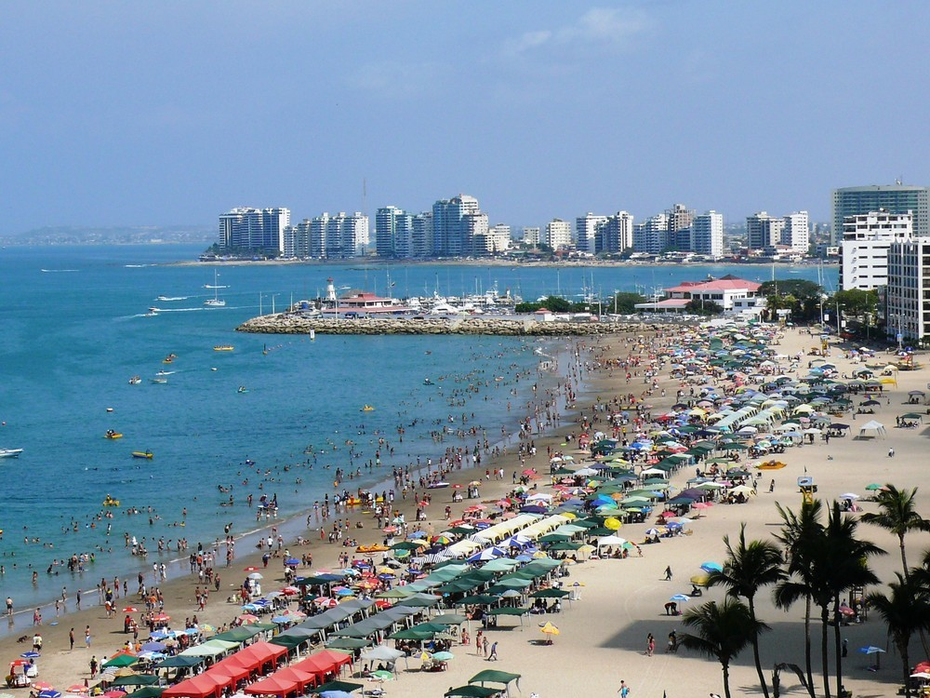
SALINAS, ECUADOR - HOST CITY
Salinas is the most important coastal beach-town on the coast of Ecuador. It lies on a peninsula called Santa Elena in the province of the same name. This beautiful city, progressive and modern, sits on the outmost point in the Pacific from Panama to the southern tip of the continent.
Salinas has ground transportation access through first class highways, and you can fly internationally to the nearest airport in Guayaquil, airport code GYE. With its hotel infrastructure always under development, its nationally and internationally recognized gastronomy, touristic services, climate and location: Salinas is host to several international events, and now has the honor to host the SALINAS ITU WORLD CUP 2018 for the third year in a row.

GENERAL INFORMATION
The purpose of the Athletes Guide is to ensure that all Elite Athletes and Team Leaders are well informed about all procedures concerning the 2017 Salinas ITU World Cup. Please keep in mind that this information can change and the final race information will be provided to the athletes and the team managers at the athlete’s briefing.
KEY DATES
LOC TECHNICAL DIRECTOR – Pedro Vera +59-3990-992353, pvera@trisalinas.com

Federacion Ecuatoriana de Triatlon - TRIFED
President – Julio Ramirez
Juramo51@yahoo.es
+593-0992685017

LOC EVENT DIRECTOR - Julio Ramirez juramo51@yahoo.es

LOC MEDICAL DELEGATE – Dr. Tyrone Flores Tyroneflores_pavon@hotmail.com
ITU TECHNICAL DELEGATE - Leslie Poujol Brown Lesliepoujol@gmail.com

ITU TEAM LEADER – Enrique Quesada enrique.quesada@triathlon.org

KEY CONTACTS

ELITE MALE COMPETITION - Sunday, Oct. 21 – 9:45 AM – Venue

ELITE WOMEN COMPETITION - Sunday, Oct. 21 – 8:00 AM – Venue

SWIM FAMILIARIZATION -Saturday, Oct. 20 – 11:30 – 12:30 AM – Venue

BIKE FAMILIARIZATION - Saturday, Oct. 20 – 11:00 – 11:30 AM – Venue

ELITE ATHLETES BRIEFING - Friday, Oct. 19 – 6:00 PM – Hotel Blue Bay

VENUE and TRANSITION AREA
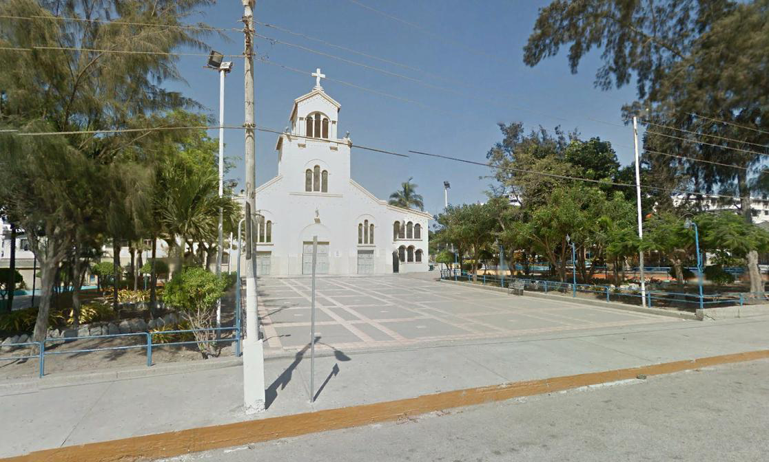
Chipipe Church on Avenida Malecon

The Venue and Transition area are located in front of Chipipe Church and plaza in Chipipe Beach, on Ave Malecon. Athlete’s Services, and Athlete’s Lounge will be ACROSS the street from Chipipe Church, inside the Municipal Grounds on the same avenue. This area will be open starting FRIDAY morning. Athletes will go through transition on every lap of the bike course and run course.

ELITE ATHLETES LOUNGE and ATHLETE’S SERVICES
Facilities including athletes’ lounge and toilets are provided to the athletes at the finish area. Sealed bottles of water, fruit and snacks will be offered to the athletes before and after the race in the Athletes’ Lounge. The Athlete’s Lounge is located inside the municipal grounds across the church on Ave. Malecon, directly in front of the Finish Line.

DOPING CONTROL
Doping Control will be performed according to the ITU /WADA rules. Doping Control will be under the supervision of Dr. Tyrone Flores. Tests will be performed at the Caridi Chipipe Hotel, only 2 blocks South from transition area.

MEDICAL SERVICES
First Aid and Emergency Medical Services will be available at the venue on Oct. 20th and 21st before and during the competition hours.
Medical and paramedical personnel from Cruz Roja (Red Cross) will be available throughout the competition . Two ambulances will be available to provide emergency transfer to the hospital. A medical tent will be provided on site at the post finish area.

BIKE MECHANIC SERVICE
The LOC will have bike mechanics starting Thursday morning at the host hotel, Blue Bay Hotel. General bike services are free of charge for ELITE athletes, and packing or unpacking of bikes are available for a fee. Bike Services at the venue on Friday are subject to a fee.
BIKE SERVICES
Oct 18th | Blue Bay Hotel | 10:00- 17:00
Oct 19th | Venue | 10:00-17:00
Oct 20th | Venue | 10:00 – 12:00

INFORMATION CENTRE / LOC OFFICE
The LOC Office will be located at the Hotel Caridi Chipipe on Ave. Jose Luis Tamayo, 2 blocks South from the venue, and open from Thursday October 18th, after lunch.
Kerly Mora Perez +593-969-502525. Email: Presidencia.Trifed@gmail.com
LOC OFFICE
Oct 18th | Hotel Caridi Chipipe | 14:00 – 18:00
Oct 19th | Hotel Caridi Chipipe | 09:00-18:00 (Closed 12:30 – 13:30)
Oct 20th | Hotel Caridi Chipipe | 09:00-18:00 (Closed 12:30 – 13:30)

HOST HOTEL
ACCOMODATION
Blue Bay Hotel, located in Malecón of Salinas, on the main beach of Salinas about 15 minute walk from the venue.
Price: $ 60
http://www.bluebayhotelsalinas.com – ventas@bluebayhotelsalinas.com - +593979548755
Partner Hotels:
Chipipe Caridí Hotel, located 200 mtrs. from transition zone.
Price: $ 40
http://www.facebook.com/hotelcaridi - 593-42770554 - 593-994361983
El Marinero Hotel, located 400 mtrs. from transition zone.
Approximate price: $ 35
http://www.hotelelmarinero-salinas.com/ - +59399952748
Amira Hotel, located 300 mtrs. from transition zone.
http://www.hotel-amira.com/ - +59342770701 - 0980875453
TRANSPORTATION

The LOC will provide free airport transfers for elite athletes and their team officials from Guayaquil Airport to Salinas and back. In order to guarantee your transfer, please forward your arriving and departure information to:
Julio Ramirez, juramo51@yahoo.es.

A chart will be posted outside the Elite Athlete’s Briefing on Friday, October 19th. Please make sure you check this information and let us know if there are any changes.

Bike/Swim Familiarization
Bike Familiarization meeting point: 11:00am in front of Chipipe Church on Avenida Malecon, on Saturday, Oct. 20th.
Swim Familiarization meeting point: On Chipipe Beach. Walk from Chipipe Church towards the beach on Ave. Luis Tamayo (Los Almendros). You should find us there from 11:30 am to 12:30 am, Saturday Oct. 20th.
Please be aware that the age group race will be on-going, and we have a short window of time for this activity.
COACHES BRIEFING:
There will not be Coaches Briefing.

COMPETITION SCHEDULE

Friday Oct. 19th

18:00 pm – Elite Athletes Briefing – Hotel Blue Bay, Host Hotel on Salinas Bach, Ave. Malecon

6:45 am - 7:45 am – Swim warm up Opens/ Close
8:00 am - Elite Women race START
7:50 am Elite Women line up
11:00 – 11:30 am - Bike course familiarization 3 laps with police escorts – Meet at Chipipe Church.
11:30-12:30 am - Swim course familiarization Chipipe Beach in front of venue.
Saturday Oct. 20th
6:15 – 7:15 am - Athlete Lounge Opens/Close for Elite Women
7:00 am – 7:45 am - Transition Opens/Close for Bike Check-in - Elite Women
7:45 am - Transition for Elite Women closed
SUNDAY OCT 21st – ELITE WOMEN
TH

SSUNDAY OCT 21ST - ELITE MEN
8:45 – 9:30 am - Transition Opens/Close for Bike Check-in - Elite Men
8:00 – 9:00 am - Athlete Lounge Opens/Close for Elite Men
8:30 - 9:30 am – Swim warm up Open/Close
9:30 am - Transition for Elite Men closed
9:35 am – Elite Men line up
9:45 am – Elite Men race START
11:00 am – Awards Ceremony Men and Women

COMPETITION RULES

http://www.triathlon.org/about/downloads/category/competition_rules

INFORMATION ABOUT THE FOP
START
The Start area is at Chipipe Beach off the beach access closest to Chipipe Church on Avenida Jose Luis Tamayo (Los Almendros).
SWIM COURSE
The course consists of 1 lap of 750 meters in a rectangular shape. The water temperature during the first weeks is expected to be between 20 – 23 C.
BIKE COURSE
Generally flat. There are 4 laps of 5km each. Somewhat technical as athletes approach transition and go past the finish line area. Athletes who are lapped are taken out of the race. The “First runner, last biker” scenario is possible for this event. In this case the biker will be taken off the course.
WHEEL STATION
Two wheel stations will be provided, the first one is for team wheels located at the corner of Ave Eloy Alfaro and Ave. Jose Luis Tamayo (Los Almendros) just outside Transition Area. Team wheels will be dropped at the Athlete’s lounge appropriately marked. The Neutral Wheel station will be located close to the turn around on the bike on Avenida Malecon on the far end of Salinas Beach.

PENALTY BOX
The penalty box will be located close to the exit of transition area on Ave. Eloy Alfaro.
RUN COURSE
Completely flat, with 2 LAPS. It starts on Ave. Eloy Alfaro (the same avenue used for the bike course), and makes a sharp RIGHT turn into Ave. Malecon with great views of Chipipe Beach and the ocean. The Turn-around is close to the intersection of Ave. Malecon and Avenida 12.
AID STATIONS
There are 2 aid stations, both will be double aid stations. Sealed water will be provided at each station. Please note the littering zones which will be enforced.

WEATHER CONDITIONS
The weather conditions expected in late October range usually around 18 to 25 degrees Celsius, with water temperatures of 20 to 23 degrees.
PROTESTS AND APPEALS
Standard procedures will be followed according to the ITU competition rules.

ACCREDITATION
LOC will provide all athletes, coaches, technical officials, and journalists with an official accreditation card according to the ITU Event Operational and Technical Requirements.
Accreditation cards for athletes and coaches will be handed out during the official registration on Friday, Oct. 19th after the Race Briefing at Blue Bay Hotel. Only accredited persons will be allowed to access certain venue areas.
All accredited persons are requested to carry their accreditation cards with them at all times and to show them upon request.
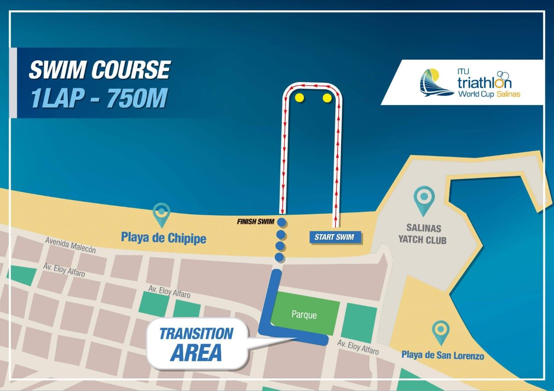
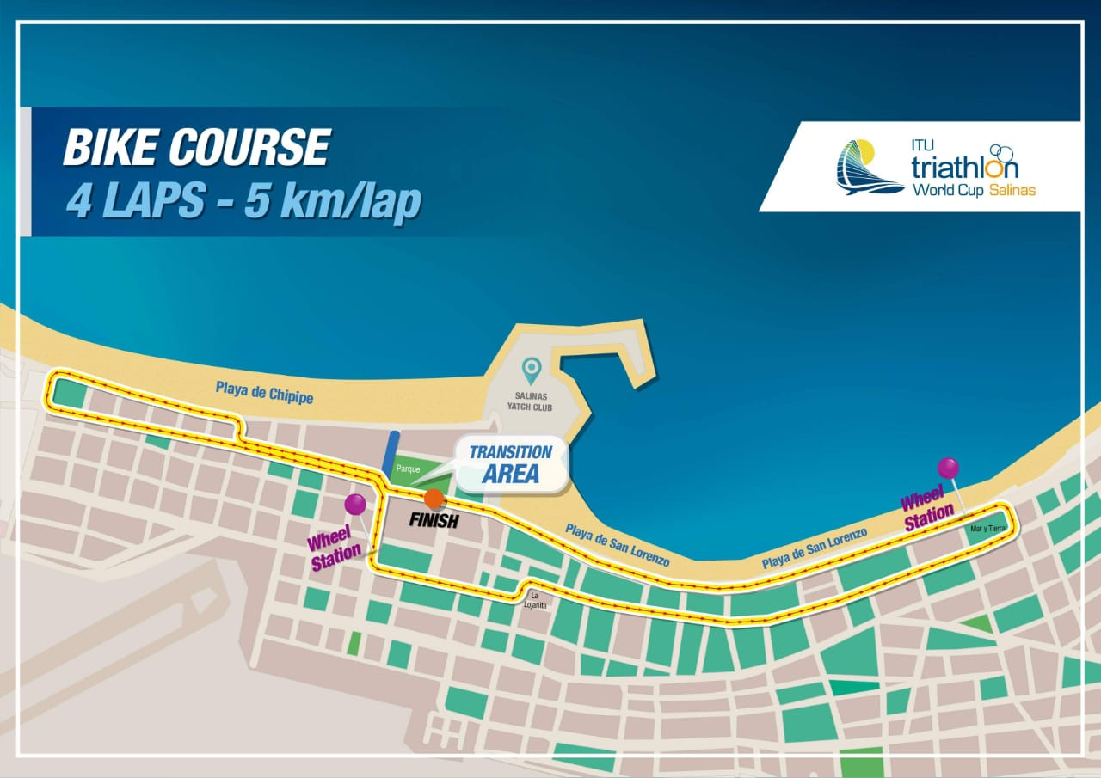

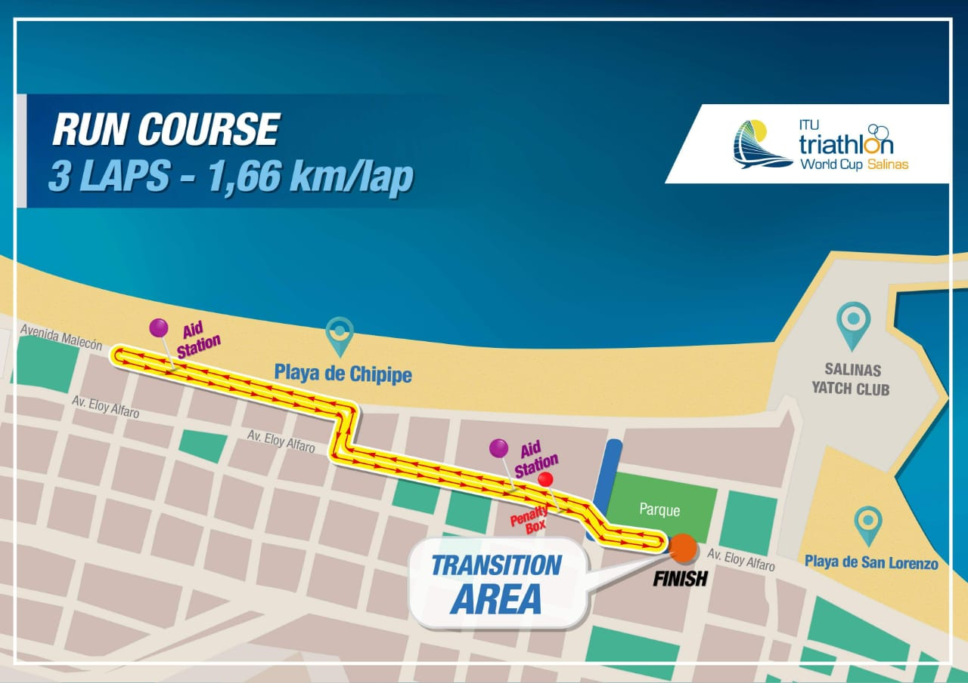

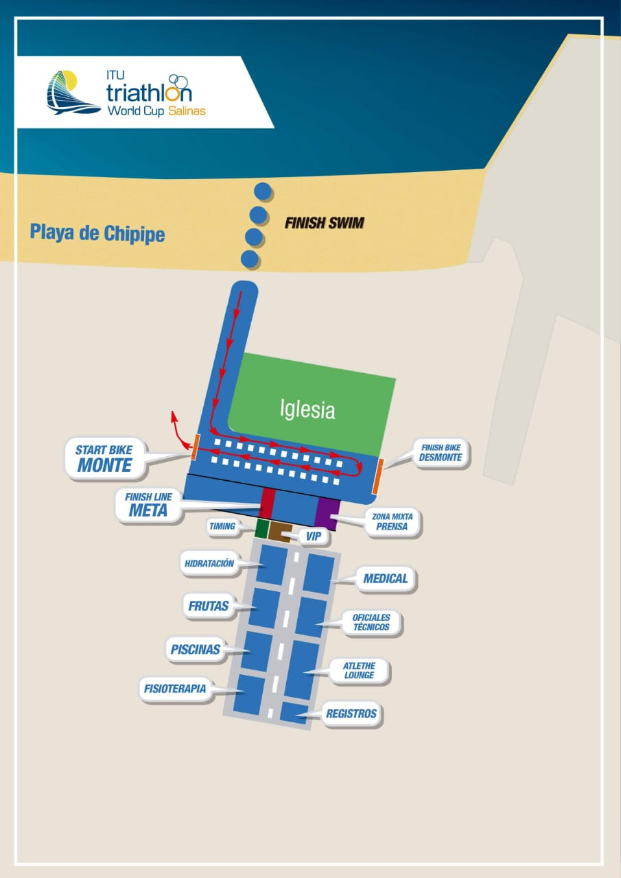
RACE SAFE AND HAVE FUN!!!
Salinas is waiting for you…

