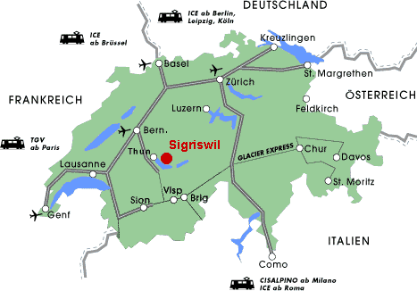

Bern Airport: less 1 h
Zurich Airport: about 2 h
Basel Airport: about 2 h

